introduction

‘C’ is a procedural programming language. it was initially developed by Dennis Ritchie between 1969 and 1973. it was mainly developed as a system programming language to write operating system. The main features of C language include low-level access to memory, simple set of keywords, and clean style, these features make C language suitable for system programming like operating system or compiler development.
Many later languages have borrowed syntax/features directly or indirectly from C language. Like syntax of Java, PHP, JavaScript and many other languages is mainly based on C language. C++ is nearly a superset of C language (There are few programs that may compile in C, but not in C++).

The Structure of C Program is shown below:

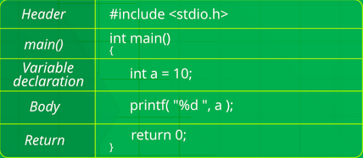

1.header File:

Every C Program start with inclusion of Header File. These Header File include the definitions of the common functions such as “printf “, “scanf “etc. Without inclusion of these header files your compiler will not be able to understand the common function that you might have use in program.

<b>Syntax</b>

#include<name of the header file>

Some common header files are:

a. stddef.h: Defines several useful types and macros.
b. stdint.h: Defines exact width integer types.
c. stdio.h: Defines core input and output functions.
d. stdlib.h: Defines numeric conversion functions, pseudo-random network generator, memory allocation.
e. string.h: Defines string handling functions.
f. math.h: Defines common mathematical functions.

2. Main Method Declaration:

After including header files now we declare a “main function “which will include all the code which compiler will execute.

<b>Syntax</b>

return_type main ()
{
All the code inside curly braces
}

<b>Example:</b> int main () , void main ()

3. Variable Declaration:

Now every program needs variables to store data. Therefore, we should declare the variables at the start of the program inside main function. We cannot use any variables without declaring it in C and variables should be declared before operation is performed on it.

<b>Syntax</b>

data_type name_of_the_variable ()

<b>Example:</b> int a = 10;

<b>Note:</b> inside the main function every variable declaration line, every logical line which perform any mathematical operation should end with semicolon (; ) otherwise while compiling program compiler will throw a compilation error.

4. Body:

After declaring variables now it’s time to write code which will generate the desire output. it can be anything such as mathematical manipulation, searching, sorting etc.

<b>Example:</b>

printf (“Hello “); // it will print “Hello “on screen.

5. Return:

The last part in any C program is the return statement. The return statement refers to the returning of the values from a function. This return statement and return value depend upon the return-type of the function. For example, if the return type is void, then there will be no return statement. in any other case, there will be a return statement and the return value will be of the type of the specified return-type.

<b>Example:</b>

int main
{
printf (“Hello “);
return 0;
}

<b>Note:</b> We can use any integer at place of “0 “in return statement but it’s a good coding practice to use “0 “that’s why i have used it.

This is how every C program is written.

6. Comments:

Let’s Also talk about comments here Many people underestimate comments. Comments are one the best resources to understand what the code will do. A good program is well commented out. Comments don’t affect the functionality of code. it is not executed by the compiler.

in a C program we can give comments in two ways:

1. Single line comment: They are generally written in single line as the name suggest.
To write these comments just start the comment statement with two forward slashes (“// “).

<b>Example:</b> // This is a comment.

2. Multiple line comment: They are generally written in multiple line.
To write a multiple line comment syntax followed is:
/* This is
a multiple
line comment. */

Now let’s write our first C program which is a simple program to print “Hello World” on screen:

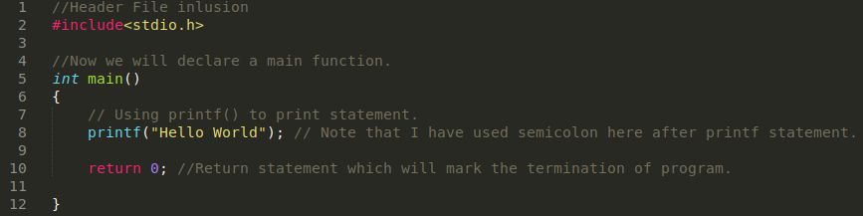
Line 2

[#include<stdio.h>]: All the line that start with # in C are processed by preprocessor which is a program invoked by the compiler. Preprocessor takes the C program that is made by the user to produce another C program this C program will not contain any line starting with # and comments. All these things are happening behind the scenes when we are compiling the program. in the above example preprocessor copies the preprocessed code of stdio.h to our file. The ‘.h’ files are called header files in C. These header files generally contain declaration of functions. We need ‘stdio.h’ for the ‘printf’ function used in the program.

Line 5

[int main ()]: The code written inside main function is the code which contain all the logic and all the important code which will produce our desire output.

Line 6

[{ }]: Curly braces define the scope and are mainly used in functions and control statements like if, else, loops. All function starts and end with curly brackets.

Line 8

[printf (“ “)]: it is a standard function which is used to print a string on to the screen.
“; “Semicolon marks the ending of the statement here.

Line 10

[return 0]: it will return the value from main ().

Now after making our first program it’s time to compile it and understand what does compiling means. But before we go and compile our program, we need to see the use of a very important function: “scanf “.

scanf ()

scanf () function stands for scan formatting, suppose if we need to take input from the user then in such type of cases, we use scanf () function, the header file needed for scanf (), and printf () function is ‘#include<stdio.h>’. This function is also terminated by a semicolon (;).

<b>Syntax</b>

1. Single Variable:

<b>Example:</b>

scanf (“%format_specifier “, &variable_name_where_you_want_to_store_the_user_input);

2. Multiple Variable:

<b>Example:</b>

scanf (“%d%f%c “, &a,&b,&c);

Format Specifiers:

a. %d for integers.
b. %c for characters.
c. %s for strings.
d. %f for float values and many more which are explained in the form a table in later section which will be used later.

Compiling:

Compiling is the process to convert the code written by us humans to convert it into machine level language because in the end computer only understand 0’s and 1’s.
They don’t understand what does printf means or any other thing that you write in the text editor. To convert our written code into machine level language a program is used which is called Compiler.

Let’s see the steps to compile a program:
These steps are followed on Ubuntu GCC compiler

1. Save your C program with file extension. c.

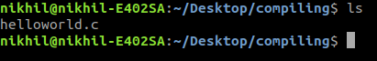

helloworld. c already exist in my machine in as you can see.

2. Then compile it using below command.

Gcc -Wall filename. c -o filename

-Wall enables all compilers warning messages.
-o is used to specify output file name. if we do not use this option, then an output file name is a. out by default.

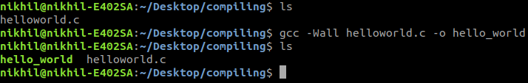
Program has been successfully compiled and an executable have been formed with a name hello_world

3. After compilation executable is generated and we run it by using following command

. /filename

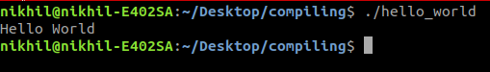

After running the executable, we can see “Hello World “on the terminal.

Now let’s take a look inside the compiling process and understand what are the different process involved.

Compiling have 4 process mainly:
1. Pre-Processing
2. Compilation
3. Assembly
4. Linking

Now after running the following command we can get all the files that are involved int the compilation process

“gcc -Wall -save-temps filename. c -o filename “

1. Pre-Processing:

a. This phase includes a Removal of comments
b. Expansion of Macros
c. Expansion of included files.

2. Compiling: The next step is to compile filename. i and produce filename. s. This file is assembly level instructions.

3. Assembly: in this step filename. s is converted into fileame. o by assebler. This file contain machine level instructions. The function call like printf () are not resolved.

4. Linking: This is the final step. in this step all function are linked with their definitions. Linker knows where all these function are implemented. Linker all add some extra code which required when the program end or start. And the final product after all these step is
the executable file which we run to get the desired output.

Conclusion:

in this chapter we have learnt
a.history of C.
b. Structure of C Program.
c. We learnt Compiling Process.
d. We also wrote our first C program “Hello World “.

Variables and Data Types

Now after learning the structure of C Programming and writing our first C program which was a simple Hello World Program. We should move on to an important topic of programming i in general which is Variables and Data types. Knowledge of Variables and Data is important because most of the times we need to take input from user for taking input from user we should also know what the user would be entering that is the data type of the user input. Therefore, in this chapter we will learn variables which would help us to store different things in program and also data type in C.

Variables

Consider Variables as a box in which you keep anything and name it. So that if you need anything you can open the box and use it. While 7aking input from user we can think it in this way that we are providing an empty box to the user the box have a name and it have been mentioned on the box that what are things it can store i. e. an integer, a name, a float (decimal number) etc.

More technically, A variable is a storage place which has some memory allocated to it. A variable is used to store some form of data. Different types of variables require different amount of memory, and have some specific set of operations which can be applied on them.

Variable Declaration:

single variable: data_type variable_name;
<b>Example:</b> int number, char name, long salary etc.

multiple variables but of same data type: data_type variable_name1, variable_name2;
<b>Example:</b> int phone, age, roll_no;

A variable name can consist of alphabets, numbers and underscore (_).
Name of a variable cannot start with a number.

How to assign a value to a variable ?

it is simple we just use equal ( = ) to sign to assign value to a variable. We can only assign value to those variables which are already declared if the variable is not declared already compiler will throw an error on compiling the program.

<b>Example:</b>

int a; // variable declaration
a = 10; //assigning value 10 to variable a
or
int a = 10; // declaration and assigning both on the same line

Keywords:
Keywords are specific reserve words in C each of which has a specific feature associated with it. Almost all of the words which help us use the functionality of C language are included in list of keywords. There are total of 32 keywords in C:

auto, break, case, char, const, continue, default, do, double, else, enum, extern, float, for, goto, if, int, long, register, return, short, signed, sizeof, static, struct, switch, typedef, union, unsigned, void, volatile, while

Scope of Variables:

Scope of Variables is a region in program where the variable can be accessed to perform operation on it.

There are mainly two types of Scope:

Global Scope: This kind of variables can be accessed anywhere in the program without any problem.

Local Scope: This kind of variable can only be accessed locally only.

Trick is variable declared inside curly braces can only be accessed inside those curly braces only.

For <b>Example:</b>
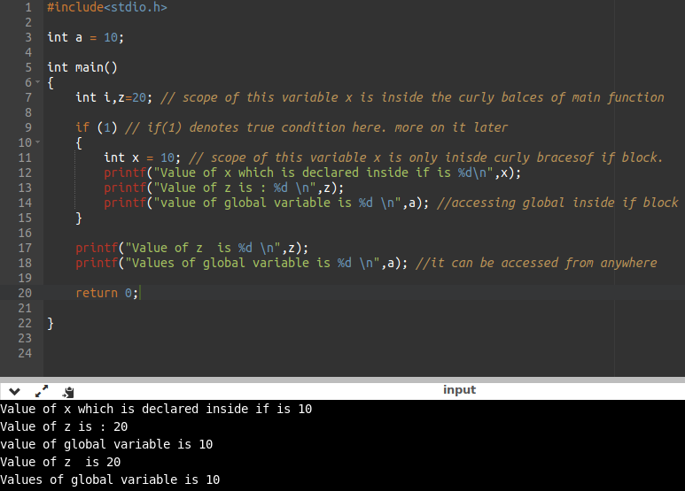
Data Types:

We can say variables have 3 properties its name, data type and value. Now variable can store different things. These different things can be anything such as an integer, a decimal value or a character. in C we have to specify data type to each variable according to what it will be storing. if the variable is going to store an integer its data type will be int, if the variable is going to store a character its data type will be char.

Each data type requires different amount of memory and has some specific operations which can be perform on it.

Following are some commonly used data types in c:

char: it stores a single character in C and require a single byte of memory.

int: A int variable is used to store an integer.

float: it is used to store decimal numbers with single precision.

double: it is used to store decimal numbers with double precision.

Here is a simple program with output Which shows us the use of printf (), scanf () statements, which takes ‘int’ as the preferable data type and ’num’ as the variable:

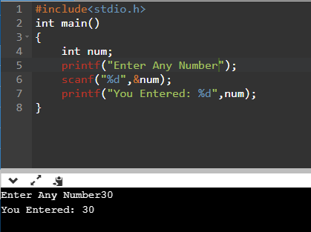

Different data types have different ranges up to which they can store numbers. These may vary from compiler to compiler. Below is the list of ranges along with memory requirement and format specifiers on 32-bit gcc compiler.

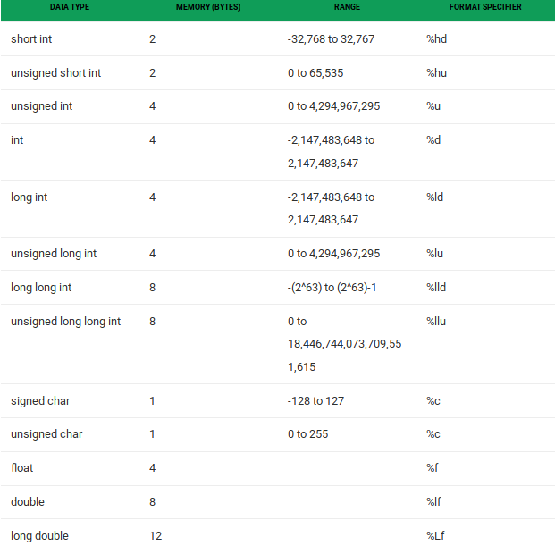

<b>Note:</b> We can use sizeof (data_type) operator to check size of the data types.
Format specifier is used to specify which data type will appear at place of it.
For <b>Example:</b> %d: specify int will appear here, %f specify float will appear here.

Operators in C:

1. Arithmetic Operators:
Arithmetic Operators are used to solve the mathematical equations and problems, using the simple basic operators which we have studied earlier in school. Result of the calculation can either be directly displayed or stored in a user defined variable.

Modulus (%) may be new for so me of you, this operator helps us in finding remainder of the division between the two numbers.

For <b>Example:</b> 5 % 2 = 1.

<b>Note:</b> Using a variable with datatype int to store result of a division may not give you an exact answer, using float as the datatype will work fine.

For <b>Example:</b> 5 / 2 = 2. 5 but the compiler will show you 2 because it will round off the float value into the integer value, since we are using int as its datatype.

Operation | Operator | Syntax
Multiply | * | c=a*b;
Addition | + | c=a+b;
Division | / | c=a/b;
Subtraction | - | c=a-b;
Modulus | % | c=a%b;

<b>Example:</b>
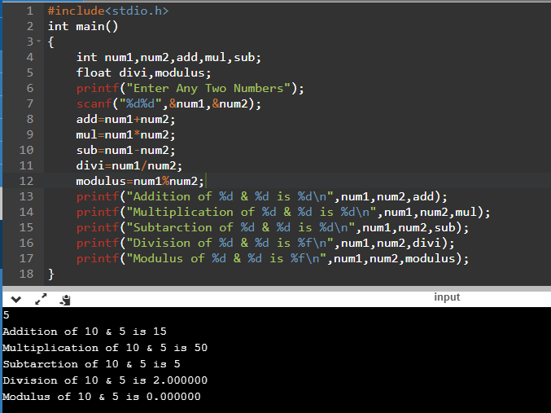

<b>Note:</b> To roundoff the result of the float datatype we can use “%. ’n’f “, where n is the number of places up to which you want to roundoff and display the result.

2. Relational Operators:
Relational operators tell us about the relation between two or more numbers, and statements. it helps us comparing between the values.

Operation | Operator | Syntax
Less than | < | a<b;
Greater than | > | a>b;
Less than or equal to | <= | a<=b;
Greater than or equal to | >= | a>=b

<b>Example:</b>

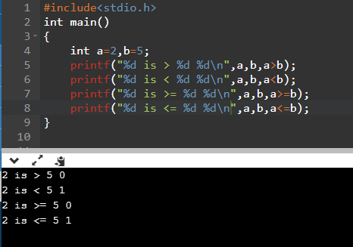

<b>Note:</b> Here, 0s and 1s signify the trueness of the statements, if the statement holds true program will return 1 and if statement does not hold true program will return 0.

3. Equality Operators:
Equality operators helps in determining the equality, Checking the value of the two or more variables or statements. They make program chose between the statements on the basis of equality of the different statements.

Operation | Operator | Syntax
Equal to | == | a==b;
Not Equal to | != | a!=b

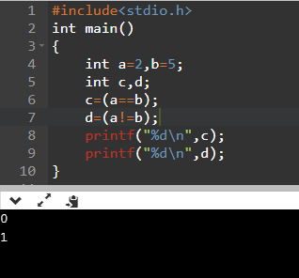

4. Logical Operators:
Suppose if we need to choose between two statements, choose both the statements or decide whether the two values are equal or not in all such cases logical operators are used.

There are three types of logical operators which are explained below:

Operation | Operator | Syntax
AND | && | (a=b&&c=d)
OR | || | (a=b||c=d)
NOT | ! | a!=b

<b>Example:</b>
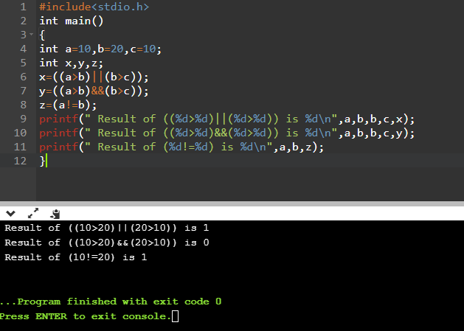

5. increment & Decrement Operators:

These Operators are used to increase and decrease the value stored in variables, there are two types of increment/decrement:

a. Pre-increment/Decrement:
Here, the value is first increased/decreased and then printed/stored.

For <b>Example:</b>

a=5;
b=++a;

So, the value of ‘b’ will become 6.

b. Post-increment/Decrement:
Here, the value is first printed/stored and then increased/decreased.

For <b>Example:</b>

a=5;
b=a++;

So, the value of ‘b’ will become 5.

Operation | Operator | Syntax
Pre-increment | ++a | X=++a
Post-increment | a++ | Y= a++
Pre-decrement | --a | P= --a
Post-decrement | a-- | Q= a--

<b>Example:</b>

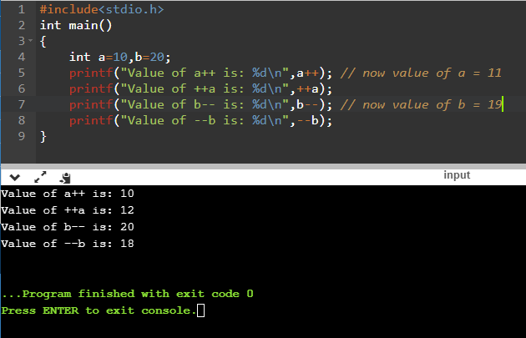
6. Conditional Operator:

Operation | Operator | Syntax
Ternary | ?: | (a>b)?condition1:condition2

<b>Note:</b> in Ternary expression ( (a>b)?condition1:condition2) it means that if (a>b) then execute condition 1 or else execute condition 2.

<b>Example:</b>

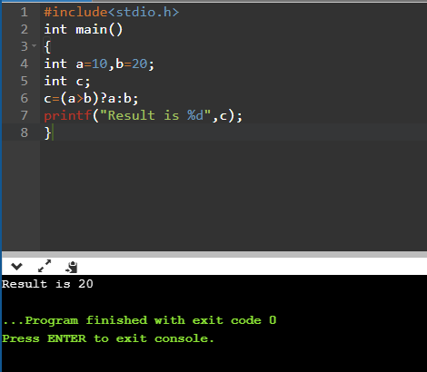

7. Assignment Operator:

Operation | Operator | Syntax
Assignment of value | = | a=b

<b>Note:</b> it is used for assigning certain value to the variable, whereas (==) is used for checking and comparing the equality of the two values.

<b>Example:</b>
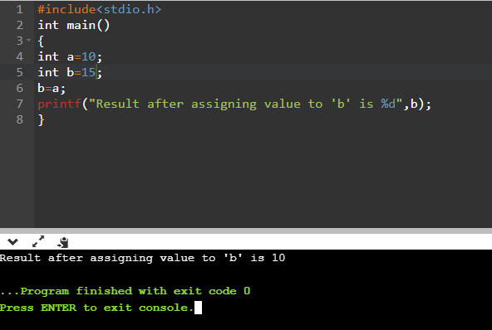

8. Sizeof Operator:

Operation | Operator | Syntax
Obtaining the Size | Pre-Defined Function | sizeof (variable_name)

<b>Example:</b>

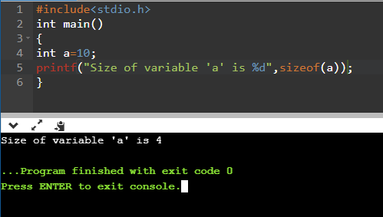

Decision Control Statements

There are few types of statements which are responsible for decision making. These Statements are used when we have to choose between few conditions, When the program needs to make decision on its own as per specified statements & conditions stated by the user. These decision control statements are used. There are mainly four types of decision control statements:

1. if Statement:

<b>Syntax</b>

if (condition)

{

Statement 1;

Statement 2;

}

<b>Example:</b>

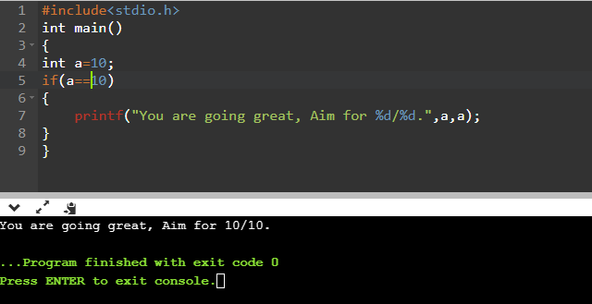

2. if-else Statement:

<b>Syntax</b>

if (condition)

{

Statement 1;

Statement 2;

}

else

{

Statement 1;

Statement 2;

}

<b>Example:</b>

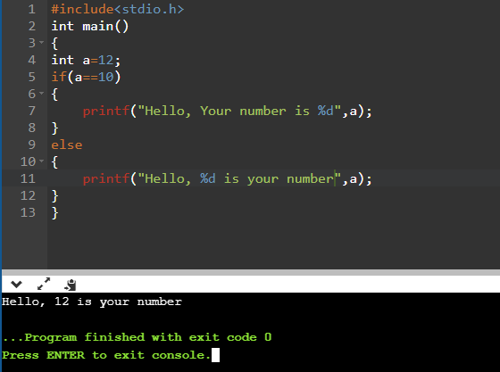

3. if-else-if Statement:

<b>Syntax</b>

if (condition)
{
Statement 1;

Statement 2;
}
else if (condition)
{
Statement 1;

Statement 2;
}
else
{
Statement 1;

Statement 2;
}

<b>Example:</b>

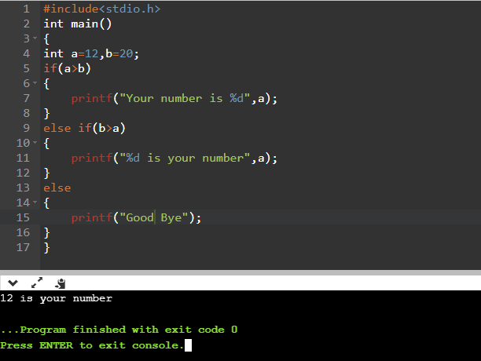

4. Switch Statement:

Switch Statement is used for case specific problems, where we define few certain cases and give statements to execute while they hold true, and a basic default condition is used to define ‘what to do if no case matches the input’, in such a case statements written beneath ‘default:’ are executed.
<b>Note:</b> Here Break; is used after every statement to ensure that if a case holds true then program has to be stopped then and there itself.
Here, the datatype of variable used within the switch statement must be same as the datatype of the case values.

<b>Syntax</b>

switch (variable)
{

case 1:
statement;
break;

case 2:
statement;
break;
.
.
.

case ‘n’:
statement;
break;

default:
statement;
break;

}

<b>Note:</b> The expression in the switch () statement (in our case variable) must have a constant value otherwise it will become invalid.

<b>Example:</b>
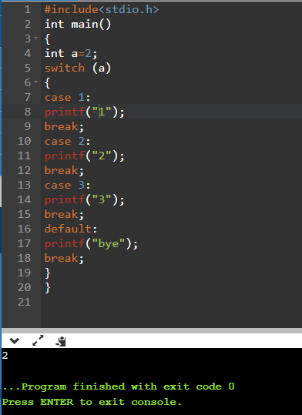

<b>Note:</b> Now before we go and study more advance topics let us first solve problems, which will give you a detailed insight about the concepts which we have studied till now. The Aim of solving more and more problems is to improve problem solving concepts, developing fast and efficient approach as well as getting feel in the topics. While solving the problems you may think that how can we think like that? But in beginning its like that only for everyone but gradually when you solve more and more problems critical thinking is developed and a better approach is established. Believe in Yourself!

Basic Programs:

Q. Write a program to print values by taking input from the user using int datatypes.

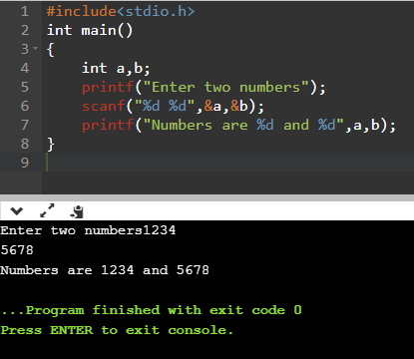

<b>Note:</b> Similarly, we can do this with using different datatypes like float, char, long etc. Remember that while using ‘string’ we don’t use address of (&) function in scanf ().

Q. Write a program to calculate the area of rectangle using float datatype.

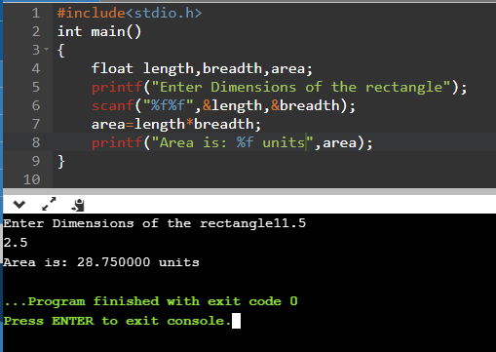

Q. Write a program in long datatype using ternary operator to find the largest of the three numbers.

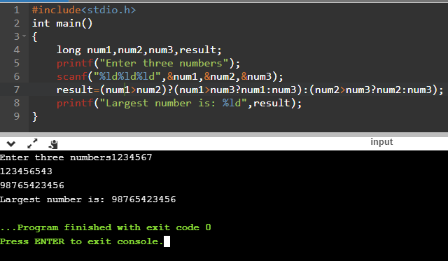

Q. Write a program to convert upper case character into lower case and also print its ASCii value.

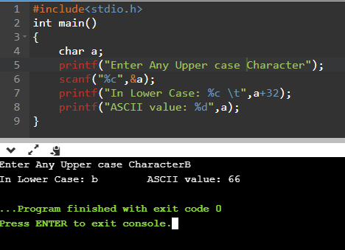

Q. Write a program to swap two numbers.

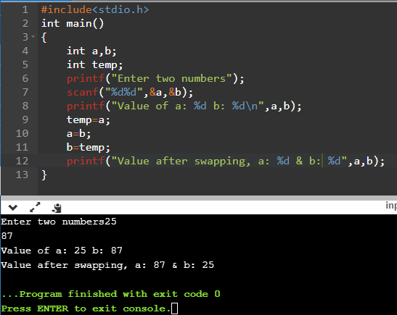

Q. Write a program to print last two digits of a number.

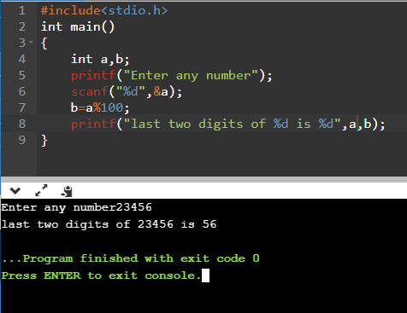

Q. Write a program to calculate the bill amount of a store by taking inputs like discount rate, quantity, price.

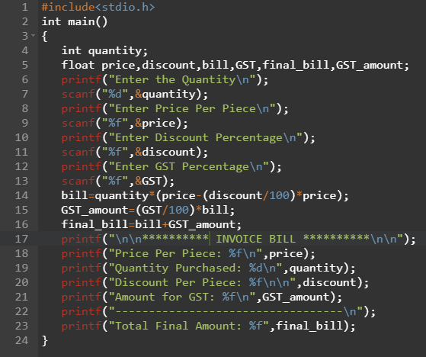

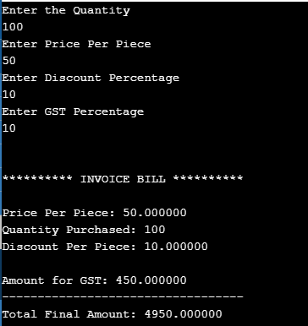

Q. Make a simple calculator using the switch statement.

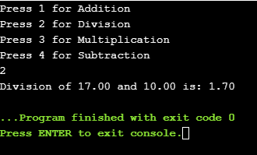

<b>Note:</b> Modulus operator only accepts ‘int’ as the datatype.

Q. Write a program to find if a number is divisible by 5 or not.

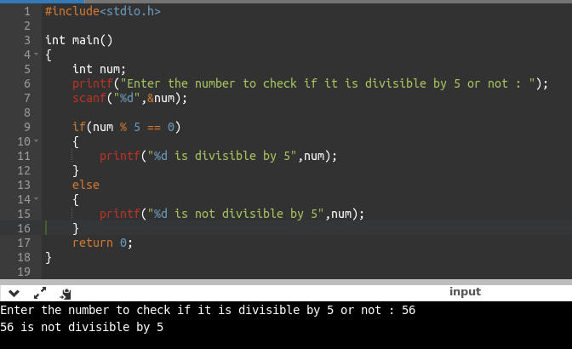
Q. Write a program to check if a year is leap or not.
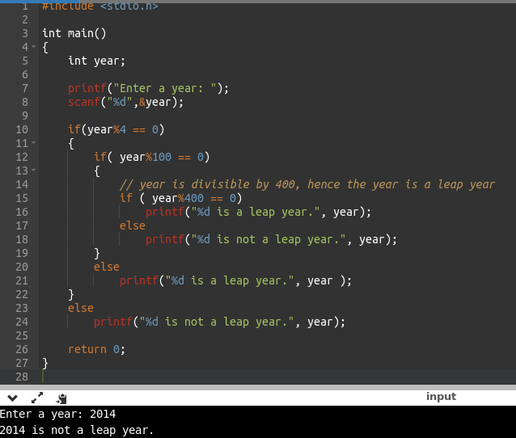

Q. Write a program using switch statement to calculate roots of quadratic equation.
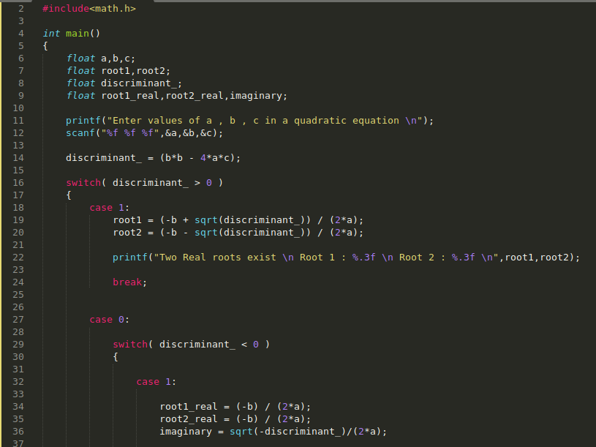
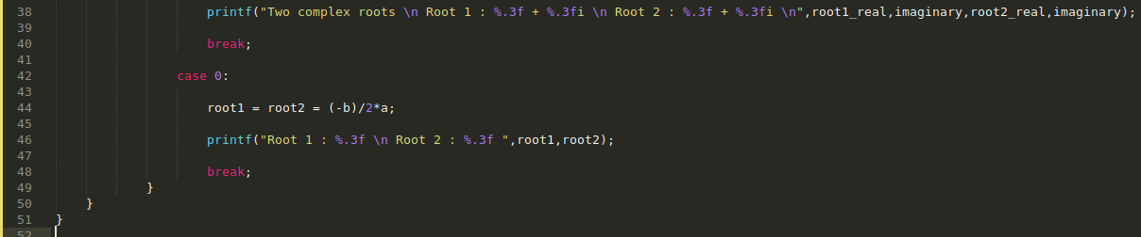

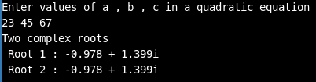

Explanation: on line 16 switch (discriminant > 0) here if the expression is true it will return 1 else it will return 0. in every programming language 0 and 1 have very great significance 0 means false and 1 means true.

Looping

in the previous chapter we have learnt about conditional statements, how they can be useful to make choices within the program. Now after learning about conditional statements we should move forward to “Looping Statements “.

Looping as the name suggests is to make loop of something do something again and again. But why do we need looping statements let’s take an example suppose i want to print “Hello World “7 times on screen what will i do a very basic approach would be to use printf commands seven times each time printing “Hello World “. image 1 show the corresponding code.

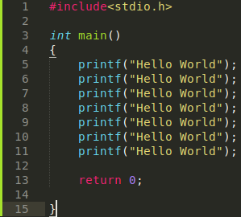
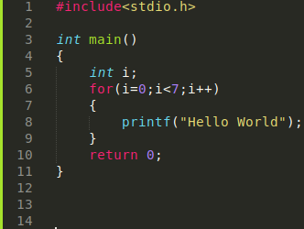
image 1 image 2

As we can see here what we are doing here is repeating same thing again and again which is not a good way of writing code now a better approach would be to use a loop which can do same thing again and again “n “number of times ( in this case n is 7 ) or till the condition which we are providing is true.here i have achieved the same thing of printing “Hello World “7 times using a “for “loop with very less efforts.

Let’s understand what i have done here i have defined a integer i with an initial value of 0 then i have provided a condition i<7 which means code will only execute till i is less than 7 as soon as “i “becomes 7 the code inside “for “block will not execute and to increase the value of “i “every time i have used increment operator “i++ “which will increase the value of “i “by 1 each time the code goes inside “for “block.

Now suppose you want to print “Hello World “1000 times you will not copy printf (“ “Hello World “) 1000 times that’s also a bad way of writing code. By using a for loop you just have to change the condition here just update the statement to i < 1000 instead of i < 7 ( remember initial of i is zero therefore we are taking i < 7 in case of 7 “Hello Word “or i < 1000 in case of 1000 “Hello world “).

Looping also follows a common code practice which is “DRY “which means
“Don’t’ Repeat Yourself “in the code of copy pasting 7 printf statements we are copying and pasting the same thing which is we are again and again
writing same line of code and repeating same line but in looping we are not doing this we are providing a variable, a condition to check to achieve the same and not repeating our self.

This was a very basic example of printing “Hello World “many a times we want to loop over different things in different scenarios to make our program read-able and easy to write. Don’t worry if this sound all gibberish to you we will understand each and every thing when we will deal with them individually.

Now after understanding the what is looping and how it can be useful let’s dive into different looping statements which is provided in C language.

There are 3 looping statements provided in C: -
a. for
b. while
c. do-while

We can use any of these in our program to achieve our target (Don’t get me wrong we can use all three in same program also). i could have used any of them to print “Hello World “specific number of times. i prefer ‘for’ loop most of the times over other two.

FOR LOOP
Syntax

The syntax of “for “loop is:

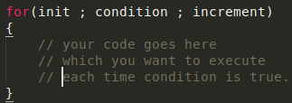

a. init / initialization: init execute only execute one time i. e. when “for “loop initialize this generally consist of variable with its initial value so when for loop initialize the variable in place of inti initialize with its initial value.

b. Condition: After initialization of variable condition is checked if it the condition is true the code inside for loop will execute otherwise it will not execute. Condition is checked every time after the execution of code inside for loop finishes executing if again the condition is true code will execute again making a loop.

c. increment: After the condition is checked value of variable is incremented so as to not stuck in the for loop forever if we will not update the value of the initialised variable condition will always be true creating an infinite loop.

<b>Note:</b> Suppose after running the program you are stuck in an infinite loop press Ctrl + C to force stop the program.

Flow-Diagram of “for “loop:
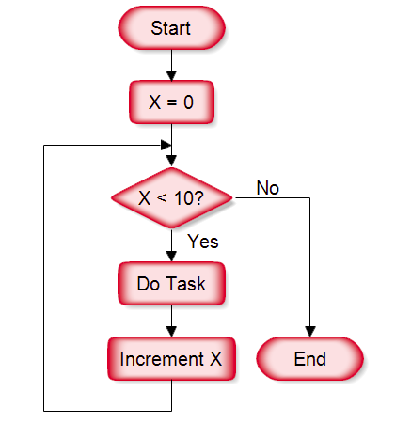

Notes:
1. You can increment x (initialised variable) by any number by x++ you are incrementing it by 1, by x += 2 you can increment in steps of 2 also.

For <b>Example:</b> if you will increment x by steps of 2 using x +=2 the above code in flow diagram will execute only 5 times (x=0,2,4,6,8) because after 5 times value of x will become 10 which will make the condition false.

Don’t worry you will understand its significance later on for time being just keep this point in mind.

2. You can set value of x anything initially for example set x = 5 the above code in flow diagram will execute only 5 times (x=5,6,7,8,9). Set x = 9 the above code in flow diagram will only execute 1 time.

Some programs using for loop:

Q.Write a program to print first 10 natural numbers using for loop.

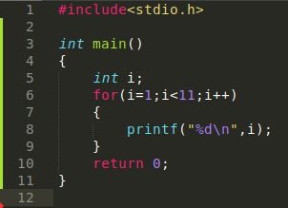
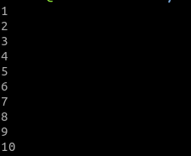

Explanation: After reading the question we knew that we have to print continuous numbers up to 10 so what we did was we declared a variable name i with data type int set its initial value equal to 1. Since we want numbers till 10 only then we defined a condition which will result me the desired output the condition appropriate will be i < 11 then incremented the value of i each time the code will execute. (Remember increment in for loop occur after the code inside the “for “block has been executed once refer flow-diagram to understand what does it mean). Now inside for loop we printed value of “i “each time code was executed.

How will you print first 10 even numbers?
By setting initial value of i = 2 then providing condition i <= 20 and incrementing value of i by 2 each time. To increment value of i by 2 we use i +=2 (i = i+2)

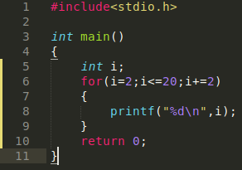
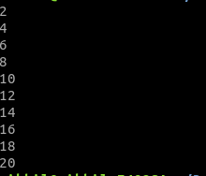

Q.Write a program to print table of any number n up to 10.

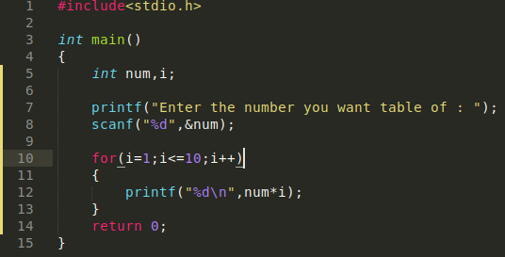

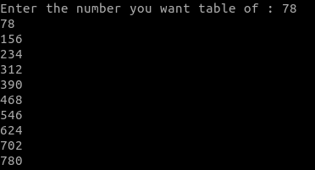

Explanation: First step is to take input from use and store it in a variable. Then using for loop with a variable i giving a condition i <= 10 so that for loop will only work till i becomes 10 and incrementing value of i by 1 each time the code inside for loop executes. inside for loop using formula of n*i so that we can get the desired output.
WHiLE LOOP
<b>Syntax</b>
The syntax for “while “loop is:

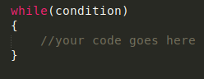

if condition inside brackets is true then the code inside “while “loop will execute.

Flow-Diagram for while loop:

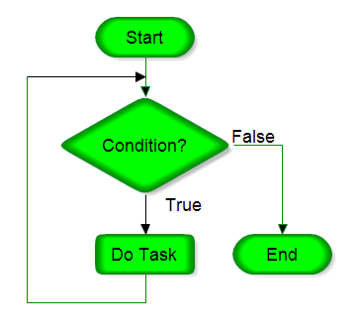

Let’s convert
“for “loop into a “while “loop:
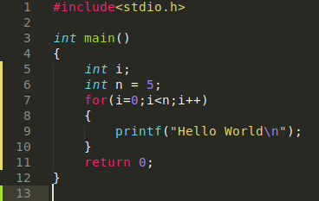
This is a for loop to print “Hello World “statement 5 times as we can see here initialisation of variable with value, condition and increment of variable value all are written inside for syntax brackets here (on line 7).

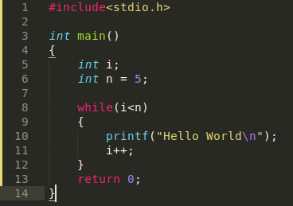
This is a while loop which will do the same thing i. e. it will also print “Hello World “5 times.here variable initialisation is done before while loop syntax (on line 5), condition is checked inside while loop brackets (on line 8) and increment is done inside while loop curly brackets (on line 11).

What we should note here is that both loops have three things to consider:
a. initialisation of variable
b. Condition and
c. increment

and they are in the exact same order in both the loops. Which means first initialisation is done (this is done only one time), then condition is checked each time after code inside loop executes and then finally increment is done.
initialisation of Variable

Condition
increment of value
Code is executed inside loop

Examples “while “loop:

Q.Write a program to print first 10 natural numbers.

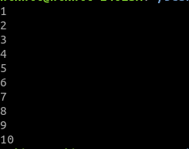
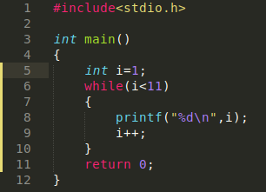

Explanation: First initialised variable i = 1 on line 5 then made an appropriate condition on line 6 to get the desired output inside while loop printed value of i each time condition is true then finally incremented value of i.
Similarly, we can also do for first 10 even numbers with each time incrementing value of i by 2.

Can you be able to write program to print table of any number n up to 10 using while loop?
Hint: We have done this program earlier using for loop just convert for loop into while loop.

<b>Note:</b> As we know under the hood it’s just zero’s and one’s which is processed by our computers 1 means “True “or “Yes “and 0 means “False “or “No “. So, think what will happen if we used 1 at place of condition in while loop or for loop. Condition will always be true (as for compiler 1 means true) and loop will go on forever hence creating an infinite loop. what if we use 0 (zero) in place of condition code inside loop will not execute because for compiler 0 means “false “.
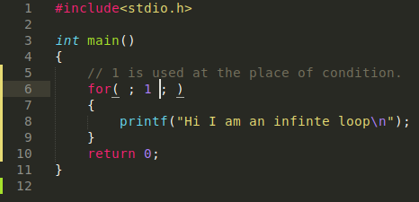

infinite for loop

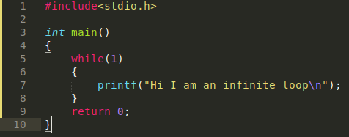

infinite while loop

if we will use 0 (zero) at place of 1 then code inside loop will not execute. Try it if we will use any non-zero number in place of condition then compiler will consider it as true and will execute the code inside loop.
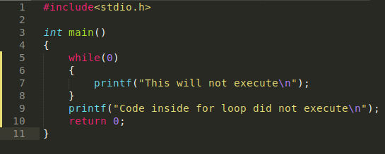

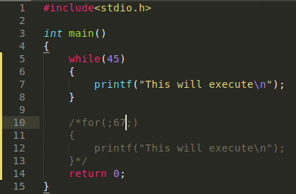

DO WHiLE
<b>Syntax</b>
The syntax for “do while “loop is:

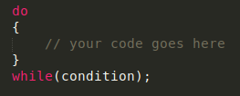

What set this loop apart from for loop and while loop. in for loop and while loop first the condition was checked then the code was getting executed (only if condition was True) but in “do while “loop first code gets executed then condition will be checked this is the only difference.
Let’s see an example to prove this: (Refer comments in code for explanation. )
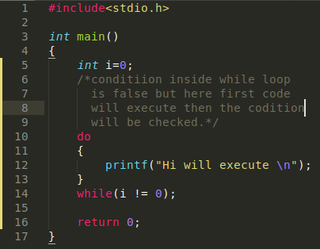

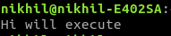

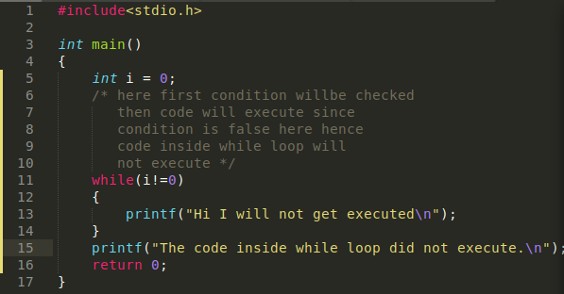

Flow-Diagram for “do while “loop:

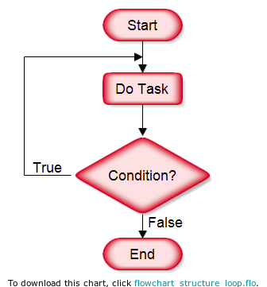

As we can see here first the task is done then the condition is checked unlike for loop or while loop where condition is checked first then the task is executed.

Can you convert a for loop into do while loop?

Q. Write a program to print “Hello World “5 times using “do while “loop.

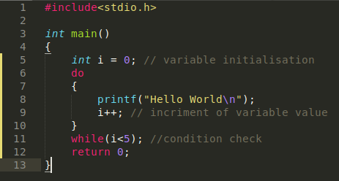
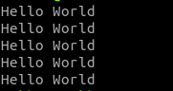

Compare it will for loop and while loop example you will know that principle behind each loop is same and we can use any loop to achieve our target.

Q. Write a table of any number n till 10th digit.

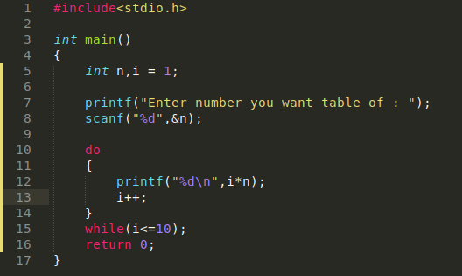
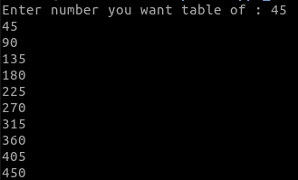

NESTED LOOP’s
<b>Syntax</b>

The syntax for nested loops is:

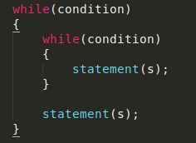
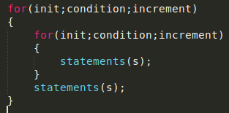
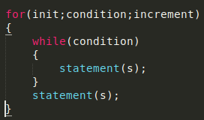

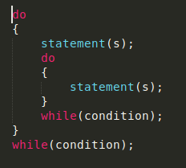

<b>Note:</b> You can put any type of loop inside any other type of loop.
For <b>Example:</b> “for “loop can be put inside a “while “loop or vice versa.

Flow-Diagram for a nested loop:

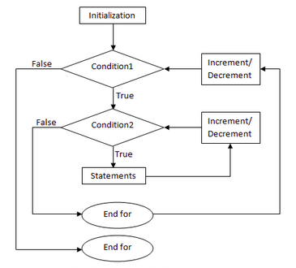

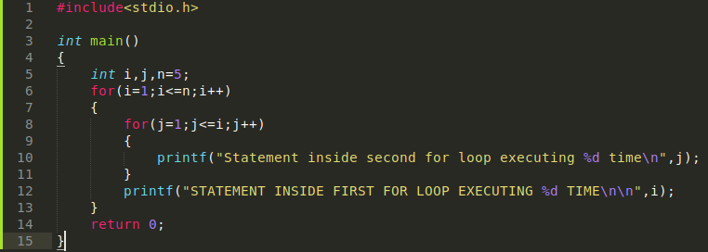

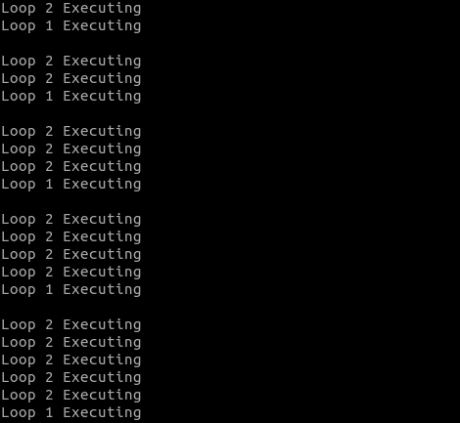

Let’s try to understand what’s happening first of all we have declared variable i, j, and n. Then on line 6 first for loop is initialised with i = 1, condition here is i < = n which means as soon as value of i will become greater than 5 then first for loop will stop executing. Now inside for loop on line 8 there is another for loop and j is also initialised with value j =1 condition here is j <= i which means as soon as value of j becomes more than i second for loop will stop executing.
Condition 1: i <= n
Condition 2: j <= i
Statement 1: Loop 1 executing
Statement 2: Loop 2 executing

Value of n | Value of i | Condition 1 | Value of j | Condition 2 | S 1 / S 2
5 | 1 | True | 1 | True | S1
5 | 1 | False | 2 | False | S2
5 | 2 | True | 1 | True | S1
5 | 2 | True | 2 | True | S1
5 | 2 | True | 3 | False | S2
5 | 3 | True | 1 | True | S1
5 | 3 | True | 2 | True | S1
5 | 3 | True | 3 | True | S1
5 | 3 | True | 4 | False | S2
5 | 4 | True | 1 | True | S1
5 | 4 | True | 2 | True | S1
5 | 4 | True | 3 | True | S1
5 | 4 | True | 4 | True | S1
5 | 4 | True | 5 | False | S2
5 | 5 | True | 1 | True | S1
5 | 5 | True | 2 | True | S1
5 | 5 | True | 3 | True | S1
5 | 5 | True | 4 | True | S1
5 | 5 | True | 5 | True | S1
5 | 5 | True | 6 | False | S2
5 | 6 | False
After Condition 1 becomes False program will terminate.
After Learning about each loop in C language let’s solve some problems

Q. Write a program to print even numbers till a particular number n given by user.
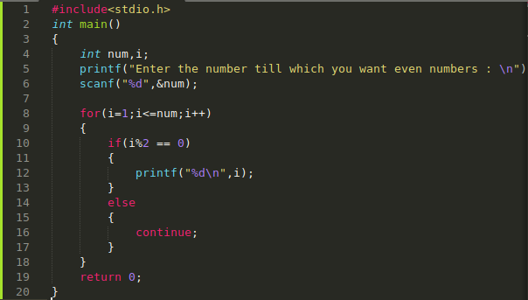

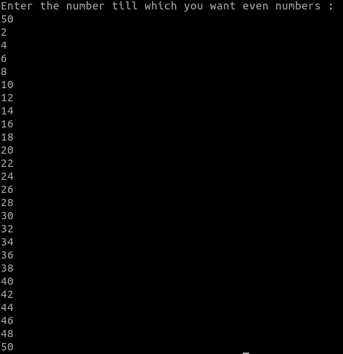

Q. Write a program to print even numbers in reverse order starting from n .
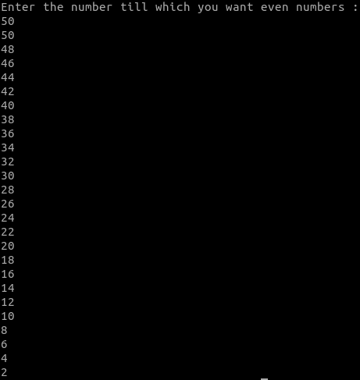
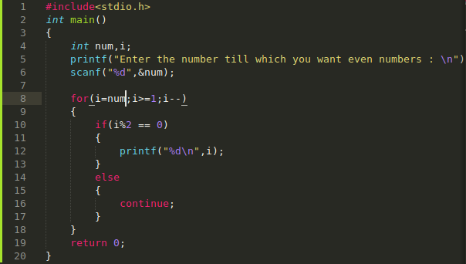

Explanation: We started for loop from i = n and each time checked the condition i >= 1 and decremented i by 1 each time code inside loop executed.

Q. Write a program to print sum of n natural numbers.

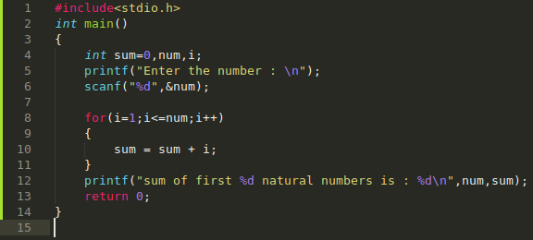

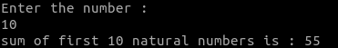

Explanation: Here we used a for loop to iterate through each number i till the user entered number n. And we used a variable to keep track of sum initially sum was 0 but when for loop executed for the first time with i = 1 sum becomes 1 then on second turn when for loop executed with i = 2 sum becomes sum = sum + i (3) in this way this process goes on till value of i is greater than n.

Q.Write a program to find sum of first n even numbers.

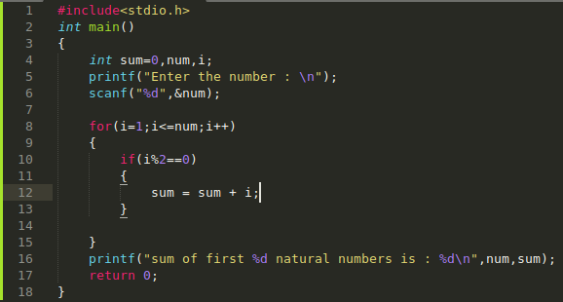

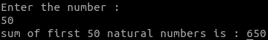

Explanation: Just checked if the number is even or not by modulus operator if it is even then sum will get increased by the number “i “.

Q.Write a program to find product of first n natural numbers.

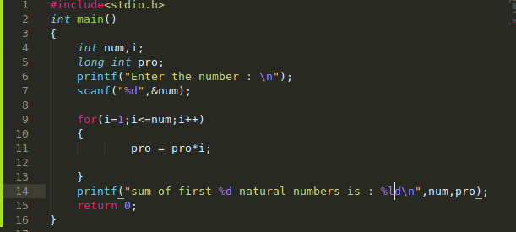

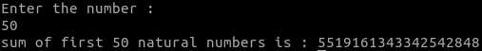

Explanation: This time created a variable pro with initial value 1 so that each time for loop executed pro get multiplied by i and gets a new updated value

For <b>Example:</b>

for i = 1
pro = pro * i = 1 *1;
for i = 2
pro = pro *i = 1 * 2;
for i = 3
pro = pro *i = 2 * 3;
this will go on till i <= n

Here we have use long int type for pro variable because multiplication can lead to large values which int will not be able to handle.

Q. Write a program to find factorial of a number.

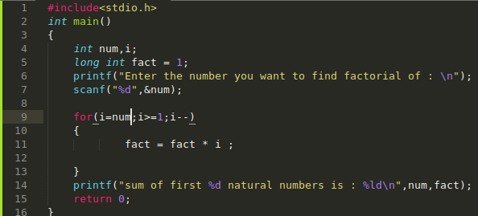

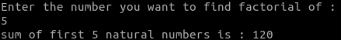

Explanation:

Factorial is n*n-1*n-2......
that is what we have done here started form i = n decremented each time code inside loop executed till i >= 1.

Q. Write a program to calculate x power y. (x = 2 y = 3 and x^y = 8)

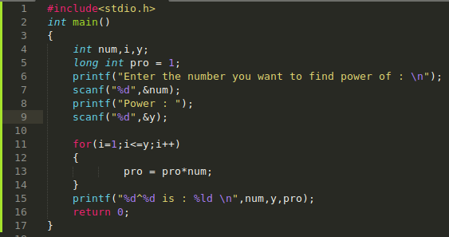

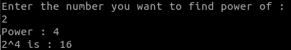

Q. Write a program to sum digits in a given number.

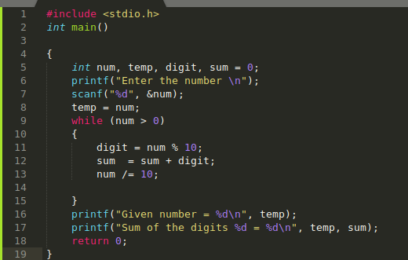

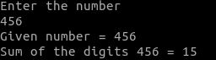

Explanation: num = 456
digit = 456%10 = 6
sum = sum + digit = 0 +6
num = num / 10 = 456 / 10 = 45
again, the same process will happen with num updated to 45 until num becomes zero.

Q. Write a program to reverse a number and check if it is a palindrome or not. Palindrome numbers are those numbers which read same from both the sides such as 121, 454 and many more can be formed.
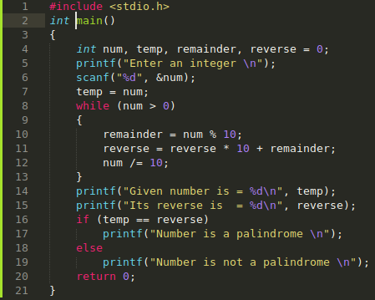

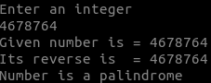

Explanation: let’s suppose number be 121
on line 10 remainder = num % 10 = 121 % 10 = 1
reverse = reverse * 10 + remainder = 0 * 10 + 1 = 1
num = num / 10 = 12

Now, num = 12
remainder = 2
reverse = 12
num = 1

this will go on till num > 0 which.
Just a simple maths formula.

Q.Write a program to find HCF and LCM of two numbers.

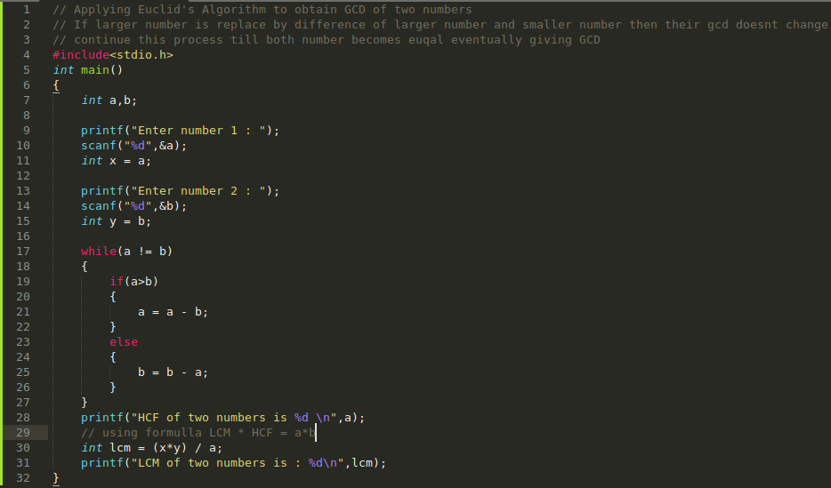
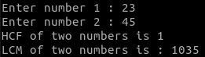

Explanation: Refer comments for explanation.

Q. Write a program to print prime numbers between two given numbers.

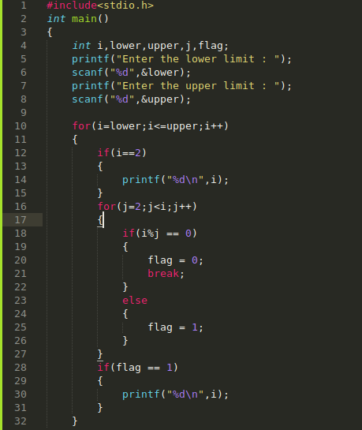
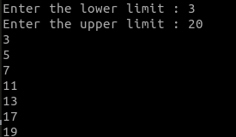

Explanation: here we are checking each number within range from lowercase to uppercase if it is prime or not.
Suppose we have to check for any number 5 then how we will check if it prime or not we will divide with each number before 5 i. e. till 4 if any time 5/n comes zero then it will be composite number because it will have three factors 1,the number n and itself at this time we will break out of the “for “loop which is defined on line 15 and will print composite number since flag will be 1. if there is no such number which will give 5/n == 0 then 5 will be a prime number. And we will print prime number since flag will be equal to 1.

n | 5 | 5 | 5
i | 2 | 3 | 4
n%i | 1 | 2 | 1
Since there is no number till n-1 starting from 2 which is giving result 5%i == 0 5 is a prime number.

let’s check for 25
n | 25 | 25 | 25 | 25 | 25 | 25 | 25 | 25 | 25
i | 2 | 3 | 4 | 5 | 6 | 7 | 8 | 9 | 10
n%i | 1 | 1 | 1 | 0

As you can see for 2,3,4 25%i is coming 1 but for 5 it is zero which means 5 is a factor of 25 so there are total three factor of 25 now 1,5 and the number itself therefore it will not be a prime. So, we have no need to check for any number greater than 5 because we have already proved that the number have more than two factors making it composite this is what “break “is doing on line 21. as soon as there is any number i which is giving result n/i == 0 it will break out from the inner for loop and will print composite number as flag will be zero.

<b>Note:</b> This algorithm is not at all efficient for very large numbers because suppose you want to check for 157383638367398657 (n) if this number is prime or not then you will have to check for each number n-1 the condition if n%1 == 0 or not this will take lots of memory and time. To find if the number n is prime or not you can use another algorithm which is “Sieve of Eratosthenes “ (Google it if interested for the time being this algorithm is good enough).

Q. Write a program to print square star pattern.
* * * * *
* * * * *
* * * * *
* * * * *
* * * * *

First of all, in any star pattern problem we have to identify the pattern or logic otherwise we won’t be able to code.
Let’s try to find the logic here:

Here as we can see it’s a square, if i can fix any row and then iterate through columns each time printing a “* “pattern will do the work here.

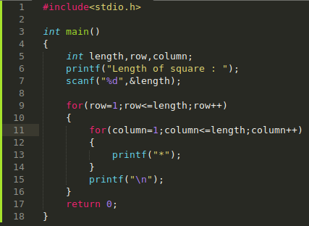

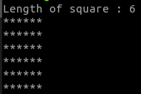

Q. Write a program to print pyramid star pattern.
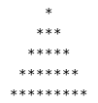

Let’s try to find the pattern here:

The pattern consists of N (5 in this case) rows. Each row contains exactly 2*N - 1 stars. in addition to stars the pattern have leading spaces. Each row contains exactly N – i spaces (where i is current row number).

Now we will make an outer loop to iterate through rows then an another for loop to print spaces with our condition of N-i and then another for loop for star’s with condition 2*N – 1.
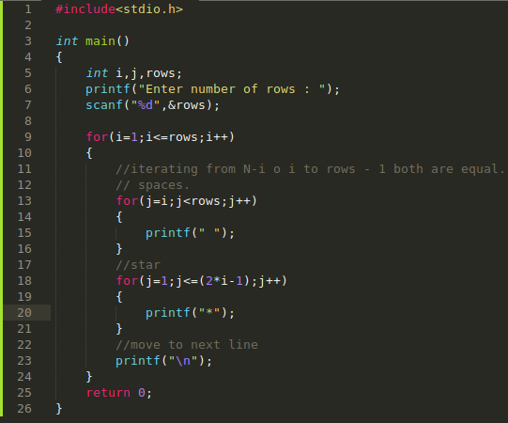

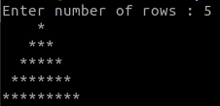

Q. Write a program to print inverted pyramid star pattern.
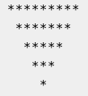

Logic: The above pattern has N (in this case 5) rows. Each row has exactly N * 2 - (i * 2 - 1) stars. in addition, the pattern consists of leading spaces. For each row it contains i - 1 leading space (where i is current row number).
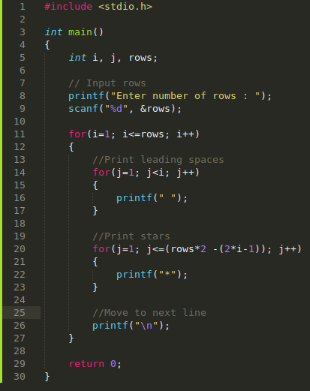

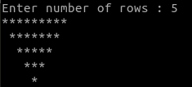

Q. Write a program to print diamond star pattern.
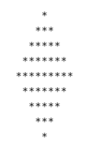

Logic:

The given pattern is a combination of simple pyramid star pattern and inverted pyramid star pattern. it consists of N*2-1 rows (for this case N=5). Each row contain spaces and stars in printed in increasing and decreasing order. Spaces are printed in decreasing order till Nth row. After Nth row spaces are printed in increasing order. Point your mouse cursor over the pattern to count total spaces.

Steps:

input number of rows to print from user (in real number of rows/2). Store it in a variable say rows.
- Declare two variables to keep track of total columns to print each row, say stars=1 and spaces=N-1.
- To iterate through rows, run an outer loop from 1 to rows*2-1. The loop structure should look like for (i=1; i<rows*2; i++).
- To print spaces, run an inner loop from 1 to spaces. The loop structure should look like for (j=1; j<=spaces; j++). inside this loop print single space.
- To print stars, run another inner loop from 1 to stars*2-1. The loop structure should look like for (j=1; j<=stars; j++). inside this loop print star.
- After printing all columns of a row, move to next line i. e. print new line.
- Check if (i < rows) then increment stars and decrement spaces. Otherwise increment spaces and decrement stars.

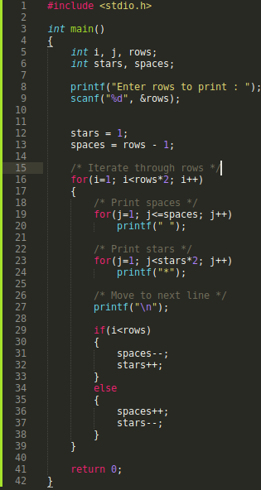
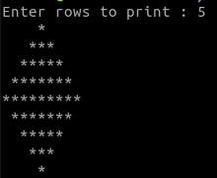

For more star pattern you can visit:
https://codeforwin. org/2015/07/star-patterns-program-in-c.html

ARRAYS

in the previous chapter we have learnt about looping. This chapter will include heavy use of loops. This chapter deals with a very important concept of programming in general. Which is storing Data. To store data, we need Data Structures one such Data Structure is Arrays.here we will learn about how to store data in Arrays, how to read data from arrays and how we can use arrays to store data in efficient ways. Let’s get started then.

What are Arrays?

Have you ever seen a Grocery list? Why do we need it to store information of the items that you want to bring from the market? They are named sequentially starting from 1 till any number n. Array is very much similar to a grocery list. Array is just a fancy name for list in C language.here in C the serial number (we call it index number) of a list (Array) start from “0 “ (Zero). Why Zero? A vague reason would be in Computer Science counting generally start from C. So, Arrays are in general term a list whose index numbers or (serial number) start from 0 (zero).
We can think of index number a unique id assigned to each element in an Array which we can use to access that particular element, do some operations on it or even updating value at that particular index number we will learn each thing after some time.

1. Wheat Flour
2. Pulses
3. Sugar
4. Salt
5. Bread

How will an Array look of above grocery list look like?

index Number | 0 | 1 | 2 | 3 | 4
items | Wheat Flour | Pulses | Sugar | Salt | Bread

As we can see index number vary from 0 to n-1 where n is the total number of items in an Array.

How to define an Array in C?

Syntax of an Array in C is:

data_type name_of_array[size_of_array];

1. data_type: Here we write the data type of the elements which we want to store in the array if we want to store integer in array, we will write int, if we want to store character in an array, we will write char.

2. name_of_array: Name of the array is written.

3. size_of_array: Here we specify the total number of items we want to store in the array.

Some examples would be:
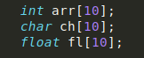

First array will store 10 integer values.
Second array will store 10-character values.
Third array will store 10 float values.

<b>Note:</b> index of the number goes to n-1 only starting from zero.
in case of int arr [10] index number vary from 0 to 9 providing each element a unique number to access it or modify it.

How to initialise an Array?

Method 1:

int arr [5] = {1,2,3,4,5};

index Number | 0 | 1 | 2 | 3 | 4
Elements | 1 | 2 | 3 | 4 | 5

This is an array of size 5 with data type of each element specified which is integer and index number varying from 0 to 4 (5 – 1).

Now how can i access the element of the array well it’s simple suppose i want to access the element number 3 of the list now as we can see element number 3 have index number equal to 2 to access it, we can just write
arr [2] this will return us the 3rd element of the array.
in a more general way, we can say:

name_of_array[index_number_of_element_you_want_to_access]
Let’s take an example to make things clearer:

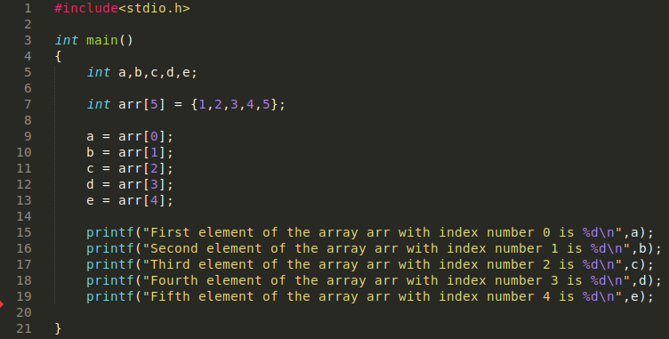
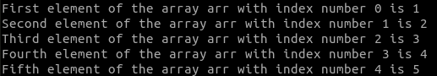

This is a very basic code to show how index of elements can be used to access elements of an array.

Method 2:

in method 2 we can first define an array then initialise the values of array one by one.
How we can do this simple just by accessing the element using index number then providing value one by one.

Let’s look at an <b>Example:</b>

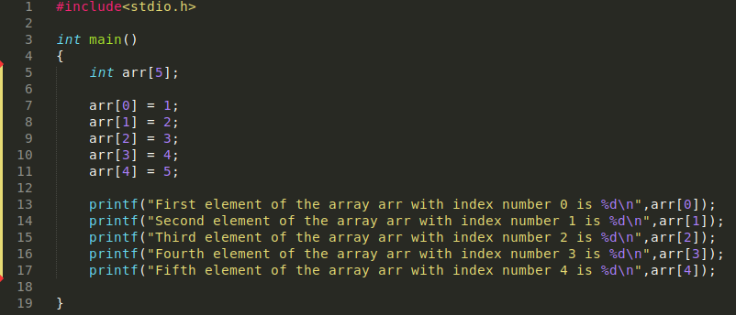

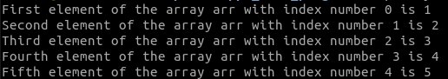

Here we are assigning each element it’s value by our self each element is accessed by its index number then a value is assigned to it.

The important thing here is that index number is used to access element in an array.

Do you remember the program to print first n natural numbers using for loop? Of course, you do. Now if i use arr [i] with array varying from 0 to n-1 we can be able to access each value of array in this way we can take input from user and store it in a array, we will also be able to print all the values of array stored in it.

Let’s understand this with the help of examples:

Q. Write a program to store any 10 random number from user in an array and print it’s 2nd and 7th element.

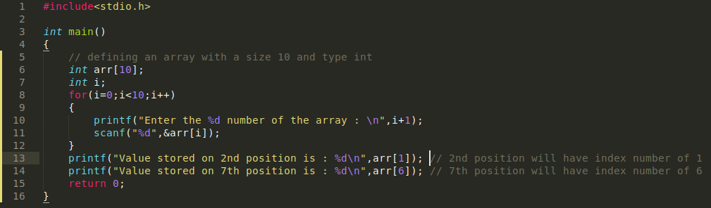
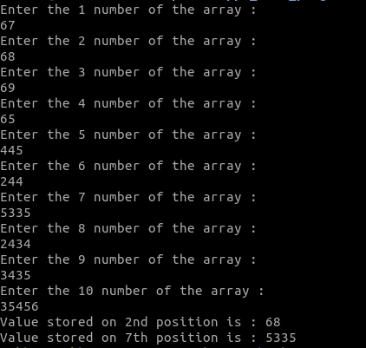

Explanation: First of all, we have defined an array with a type int name arr and size 10. Then an integer i which will iterate from 0 to 9 and will behave as an index number. For this we implemented a for loop so that we can iterate value of i from 0 to 9 then i used &arr [i] initially i will be zero so first value entered by user will be stored in arr [0] then i will get incremented to 1 second value will be stored in arr [1] similarly this process will go on till we reach 9 if we put any condition in for loop which will lead i to go beyond 9 compiler will throw an error.

Q. Write a program to take 5 numbers from users and store it in array and then all the 5 numbers.

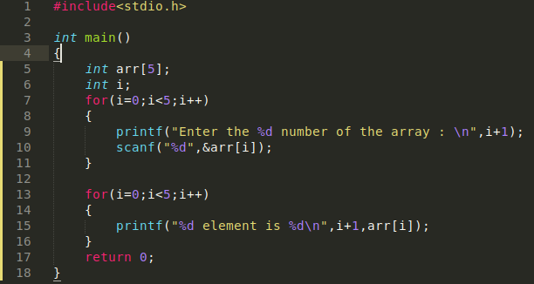

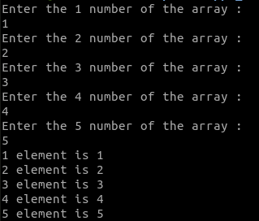

Explanation: Code is same till line 9 as above to print each element we just have to iterate through each element and using index number in same way we iterated to stored them using for loop.
Now after doing two programs above we now know how we can iterate through each element in an array to do this what we need is:
1. A variable which can iterate from 0 to last index which will n-1 n being the size of the array and
2. We need a for loop which will iterate the variable from 0 to n-1.
Then each time we go inside for loop we will access the element y arr [i].

Now Let’s do some programs:

Q. Write a program in which you take n numbers from the user store it in an array and then print their sum.

Hint: Declare array after you have taken total elements from user other wise
initially don’t know what is the size of the array.

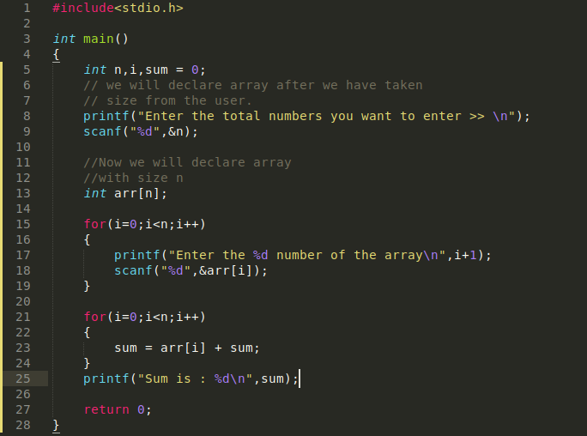

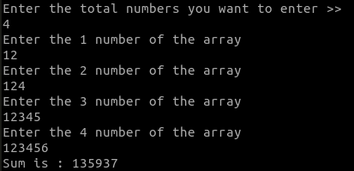

Explanation: First step was to take size of the array from user then we moved to take elements from the user using for loop (on line 15) then after that we made another for loop (on line 21) initially we took a variable sum with a value equal to 0 (zero) then after each for loop each value of element is updating for example when i = 0 ,sum = sum (0) + arr [0] (12) now sum = 12 now again for loop start again now value of sum is 12 therefore now sum = sum (12) + arr [1] (124) now value of sum is equal to 136 in similar way our for loop will iterate through the last element of the array finally giving us the sum of the array.

Q. Write a program to print square of each element of an array.

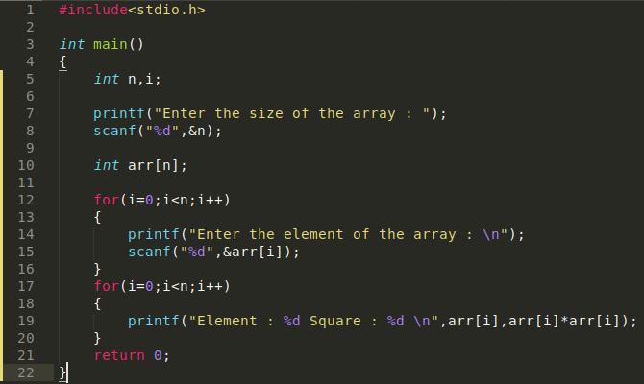

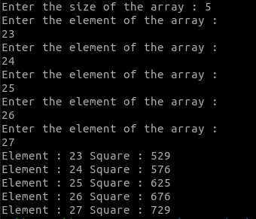

Q. Write a program to take n numbers from user store it in an array and then for each element of array print if the number is even or odd.

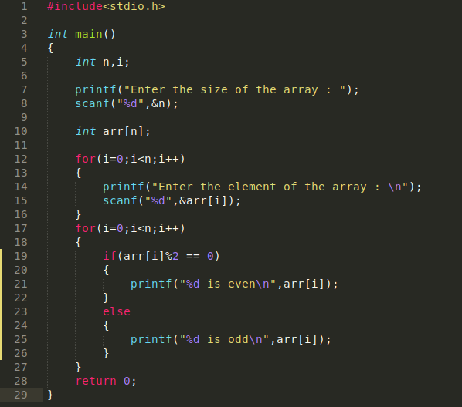

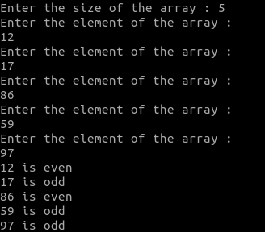

Explanation: Following the same procedure of taking input from user then in second for loop applying a condition to check each element arr [i] for even or odd using arr [i]%2 == 0 if even else odd.

Q. Write a program to take n numbers from user and for each number print if the number is prime or not.

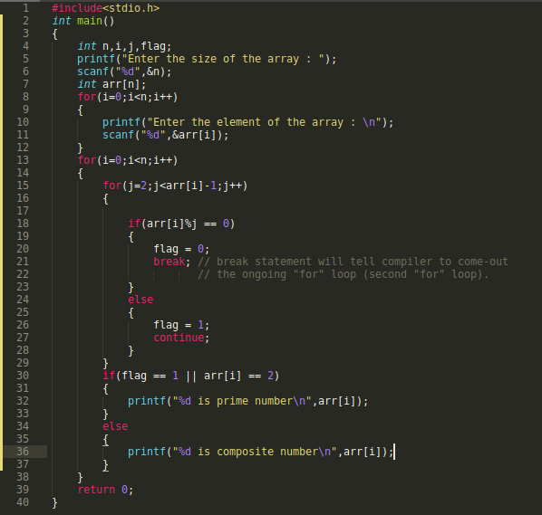

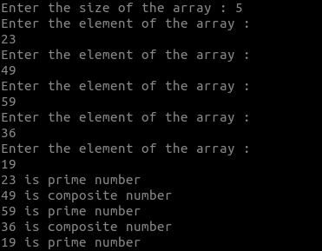

Explanation: Following same procedure of taking input from user then on line 13 creating a “for “loop which will iterate through each element of the array on line 15 creating an another “for “loop which will check if the current element which is fixed by arr [i] is prime or not using a brute force method of checking.
Suppose we have to check for any number 5 then how we will check if it prime or not we will divide with each number before 5 i. e. till 4 if any time 5/n comes zero then it will be composite number because it will have three factors 1,the number n and itself at this time we will break out of the “for “loop which is defined on line 15 and will print composite number since flag will be 1. if there is no such number which will give 5/n == 0 then 5 will be a prime number. And we will print prime number since flag will be equal to 1.

n | 5 | 5 | 5
i | 2 | 3 | 4
n%i | 1 | 2 | 1

Since there is no number till n-1 starting from 2 which is giving result 5%i == 0 5 is a prime number.

let’s check for 25
n | 25 | 25 | 25 | 25 | 25 | 25 | 25 | 25 | 25
i | 2 | 3 | 4 | 5 | 6 | 7 | 8 | 9 | 10
n%i | 1 | 1 | 1 | 0

As you can see for 2,3,4 25%i is coming 1 but for 5 it is zero which means 5 is a factor of 25 so there are total three factor of 25 now 1,5 and the number itself therefore it will not be a prime. So, we have no need to check for any number greater than 5 because we have already proved that the number have more than two factors making it composite this is what “break “is doing on line 21. as soon as there is any number i which is giving result n/i == 0 it will break out from the inner for loop and will print composite number as flag will be zero.

<b>Note:</b> This algorithm is not at all efficient for very large numbers because suppose you want to check for 157383638367398657 (n) if this number is prime or not then you will have to check for each number n-1 the condition if n%1 == 0 or not this will take lots of memory and time. To find if the number n is prime or not you can use another algorithm which is “Sieve of Eratosthenes “ (Google it if interested for the time being this algorithm is good enough).

Q. Write a program to copy all elements from one array to another and print elements on even position only Remember 0 is not even.

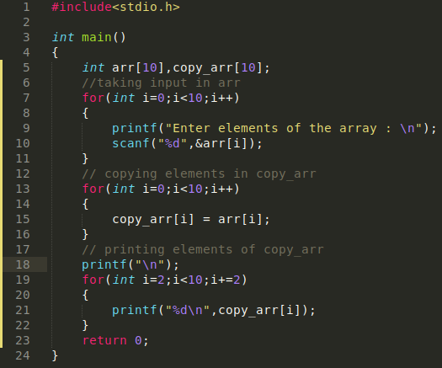

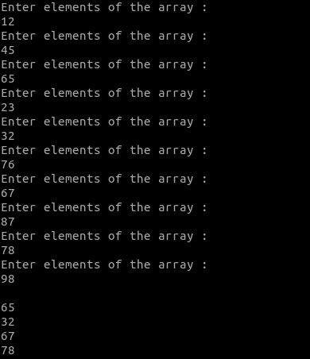

Explanation: For copying , used copy_arr [i] = arr [i] and for printing even position elements started i from 2 in last “for “loop and then used i+=2 which will result in i increasing by 2 each time (2,4,6,8) in this way.

Q. Write a program to find largest element of the array.

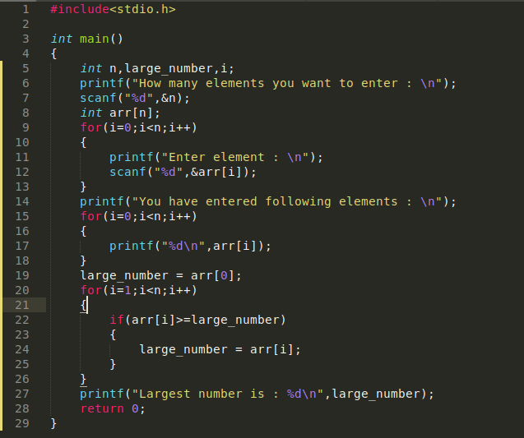

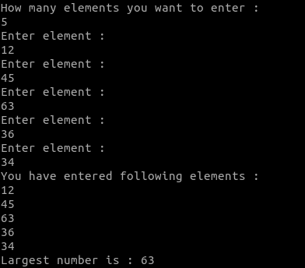

Explanation: initially taking input from the user and storing it in an array then printing the numbers that user has entered. After that on line19 we have considered initially the large_number is first element of the array which is arr [0]. Then on line 20 we have applied a for loop starting from i = 2 what we are trying to achieve is will compare large_number with every other number in the array if the large_number is smaller than the other number we will set value of large_number equal to that other number (this is what we are doing on line number 22 and 24) and finally we will print the value of large number.

Let’s take an <b>Example:</b>

initial value of large number = arr [0] = 1
initial value of i = 1 in “for “loop
we are drawing this table for loop on line 20.
index number | 0 | 1 | 2 | 3 | 4
elements | 1 | 2 | 3 | 5 | 4

Step 1:
i = 1, large_number = arr [0] = 1
i < n: “True “ For will execute: Yes arr [i]>=larger_number: Yes
Updated Value of large_number: arr [1] = 2

Step 2:
i = 2, large_number = arr [1] = 2
i<n: “True “ For will execute: Yes arr [i] >= large_number: Yes
Updates Value of large_number: arr [2] = 3

Step 3:
i = 3, large_number = arr [2] = 3
i<n: “True “ For will execute: Yes arr [i] >= large_number: Yes
Update Value of large_number: arr [3] = 5

Step 4:
i = 4, large_number = arr [3] = 5
i<n: “True “ For will execute: Yes arr [i] >= large_number: No
Therefore value will of large_number will remain same since code inside if statement on line 22 will not execute.

Step 5:
i = 5, large_number = arr [3] = 5
i<n: “False “For will execute: No

Final value of large_number = 5

This is our complete process.

We can similarly find the smallest number in the array. Just change the sign on line number 22.

Q. Write a program to find second largest number in the array.
Hint: First find the largest number and its index of the array entered update the value of large number = 0 then again apply the largest number algorithm on the array. You will get the answer.

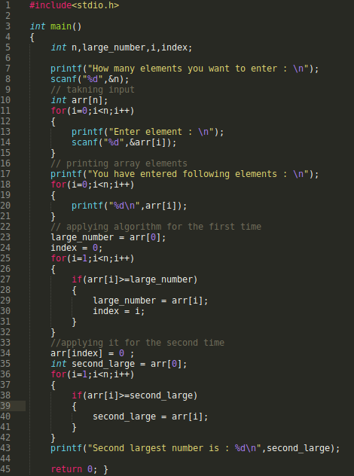

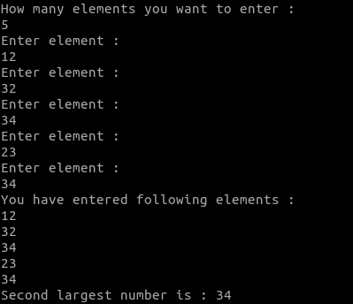

Explanation: Program is same as above till line 32 on line 34 i have updated the largest number value to zero then again, i applied the algorithm to find the largest number again since the first largest number is set to zero then therefore on second time algorithm will eventually give me the second largest number.

Q. Write a program to find if an integer is present in an array or not

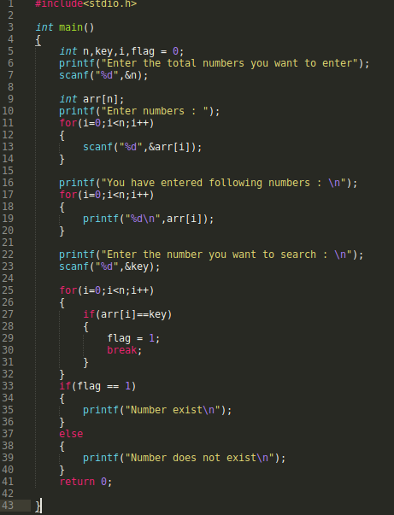

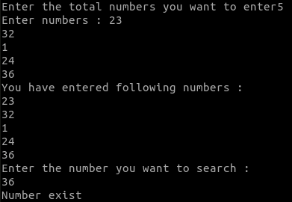

Explanation: On line 25 we have made a for loop so that we can compare if each element of the array with the key provided by the user if it is equal to the key then create flag = 1 and break otherwise loop goes on.

Q.Write a program to sort an array in ascending order.

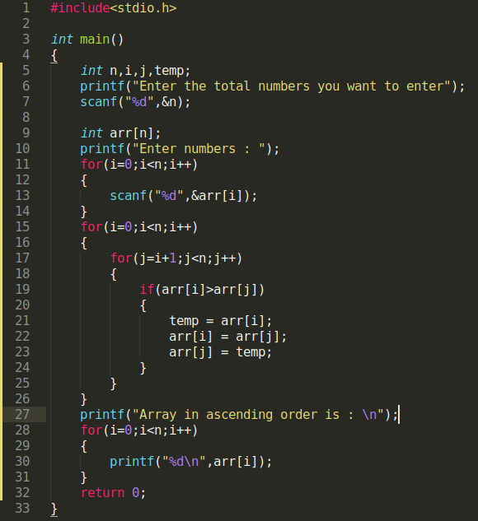

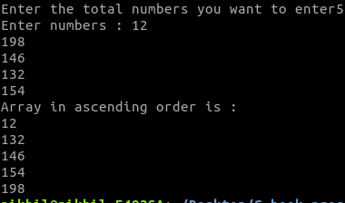

Explanation: First we will take input from the user and store it in an array. Then will take two nested for loop with the outer for loop on line 15 we will fix element ( starting from arr [0] to arr [n-1] ) and then with the help of “for “loop on line 17, we will then compare the fix element with every other element if the condition on line 19 is true then we will swap the elements. Otherwise continue.
For descending order just reverse the symbol on line 19. Try it yourself

Q. Write a program to delete an element from an array.

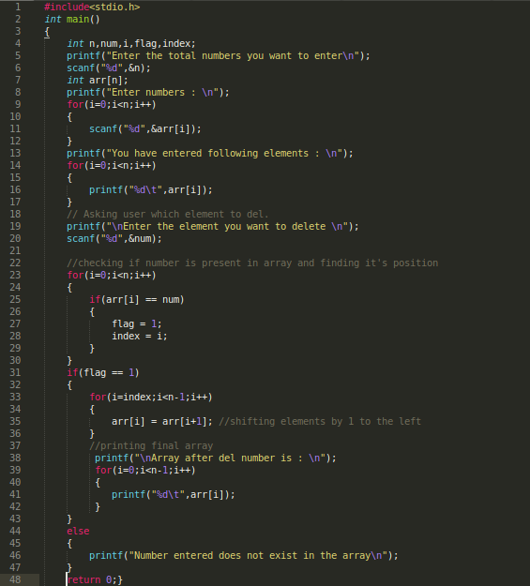

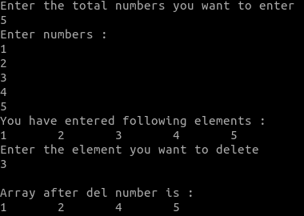

Explanation: Declare an array. Using for loop, define the elements of the array. Now, take a number from user as input, which needs to be deleted.
Run a for loop, comparing each element of the array to that number if both have same magnitude. if the number is present in the array, then save its location. if number is not present in the array, then print appropriate message.
Run a for loop from that saved location to the size of array, shifting each element of the array leftwards by one. This way, the number gets deleted.

Q. Write a program to take n numbers from user then separate them in two arrays on the basis of even and odd.

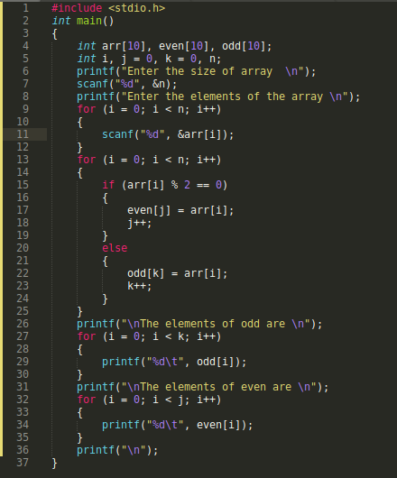

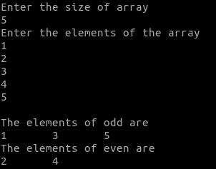

Multidimensional Array

Up till now we were dealing with arrays of int or char or float or other things.
What if we wanted, each element of an array to be an array itself and then that array storing data. You might a seen a matrices or a Grid on consider the graph paper these all things can be represented in a C program using a multidimensional array.

<b>Syntax</b> data_type arr [size1][size2]
Think of multidimensional array as a table of n rows and m column.
int x[rows][column];
int x[n][m];
int x[4][2];

0 | 1 | 2 | 3
  x[0][0] | x[0][1]
  x[1][0] | x[1][1]
  x[2][0] | x[2][1]
  x[3][0] | x[3][1]

As you can see how we are addressing each element: first we are writing the index number for main array then after reaching the element in the main array again we are writing the index number of the array which is there inside element of the main array.

Now let’s see it in form of a matrices:

 | Column 0 | Column 1
Row 0 | x[0][0] | x[0][1]
Row 1 | x[1][0] | x[1][1]
Row 2 | x[2][0] | x[2][1]
Row 3 | x[3][0] | x[3][1]

in this way we can represent a 2-D matrices into matrices form.

Similarly, you can declare a three-dimensional (3D) Array. For example,

int y[2][4][3];

Here, we have two main elements in these 2 main elements we have 4 elements (in each of the main elements) and these 4 elements we have 3 elements (in each).

Here y can hold 24 elements.

How to initialize a multidimensional array?

There is more than one way to initialize a multidimensional array.

initialization of a two-dimensional array:

int arr [2][3] = { { 1, 2 , 3 } , { 4 , 5 , 6 } };

int arr [][3] = { { 1 , 2 , 3 } , { 4, 5, 6 } };

int arr [2][3] = {1,2,3,4,5,6};

Above code are three different ways of initialize a two-dimensional array.

initialization of a three-dimensional array:
You can initialize a three-dimensional array in a similar way like two-dimensional array.here’s example
int arr [2][3][3] = {
{ { 1 , 2 , 3 } , { 4 , 5 , 6 } , { 7 , 8 , 9 } } ,
{ { 10 ,11 ,12 } , { 13 , 14 , 15 } , { 16 , 17 , 18 }
};

<b>Note:</b> in a Multidimensional array it’s not important to give size of the outermost array. For <b>Example:</b> int arr [][4];

Let’s do an example so that we can learn how we can take input in multidimensional array and print it.

Q. Write a program to display temperatures of two cities for a week and display it.

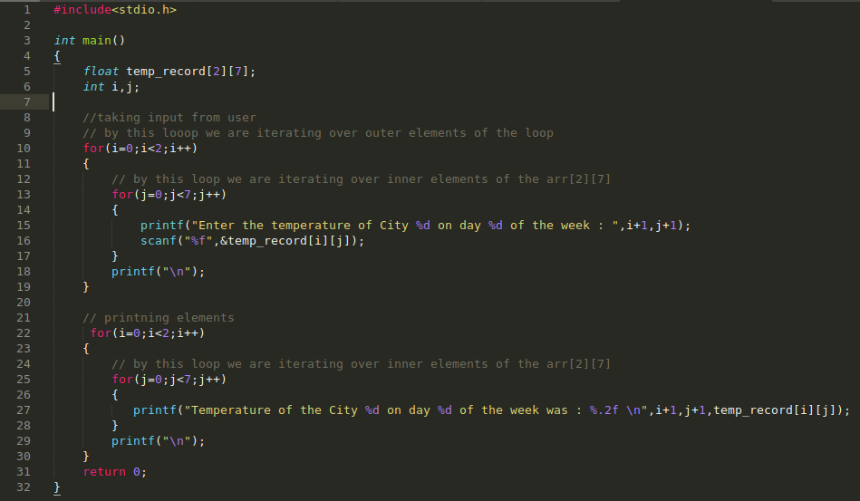
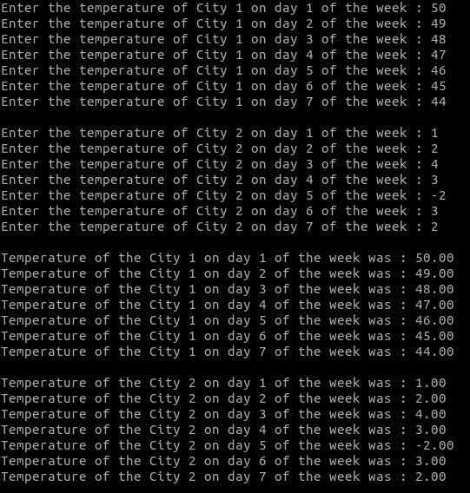

Explanation: To take input we have used nested for loops outer for loop on line 10 is used to fix outer element by fixing value of i on first run then by using loop on line 13 we iterate through j to take input from user. For printing we followed same procedure.

Step 1:
i = 0
i < 2: True For loop will Execute: Yes
j = 0
j < 7: True For loop will Execute: Yes
&temp_record[i][j] = &temp_record[0][0]

Step 2:
i = 0
i < 2: True For loop will Execute: Yes
j = 1
j < 7: True For loop will Execute: Yes
&temp_record[i][j] = &temp_record[0][1]

Step 3:
i = 0
i < 2: True For loop will Execute: Yes
j = 2
j < 7: True For loop will Execute: Yes
&temp_record[i][j] = &temp_record[0][2]

This will go on till j < 7 and in this way for each iteration program will store a value in &temp_record[0][3], &temp_record[0][4], &temp_record[0][5], &temp_record[0][6]
As soon as value of j reaches 7 inner for loop will stop but since i is will increment to 1 outer for loop condition will still be “True “and hence another time nested for loops will execute but this time with i = 1.

To perform operation on matrices we can use 2-D array. Let’s do some problems to know how to deal with them.

Q. Write a program to add two matrices using a 2-D array.

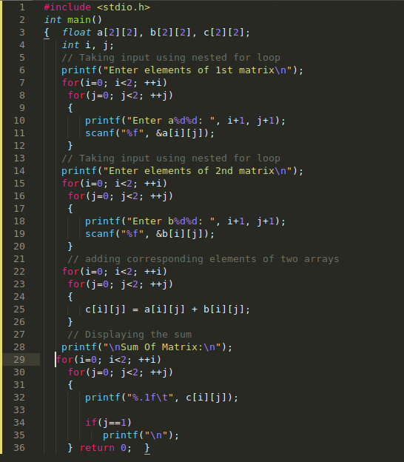

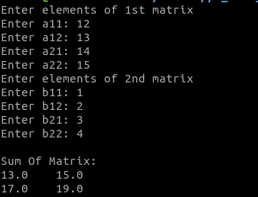

Q. Write a program to multiply two matrices.

Logic:

First step is to take input from user. For taking input we will ask number or rows and columns from user then will create two nested loops one for fixing rows and second for looping around columns.

Second step is to multiply both matrices that we have taken as an input for this we should know how to do matrices multiplication. Below image show the process to multiply two matrices

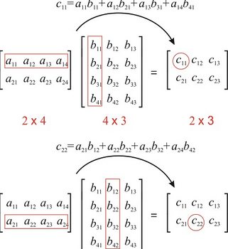

Third step is to print the final matrices.
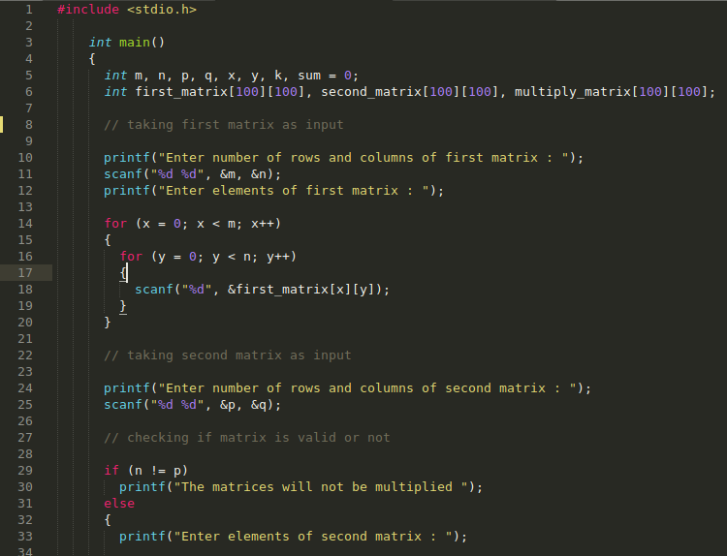

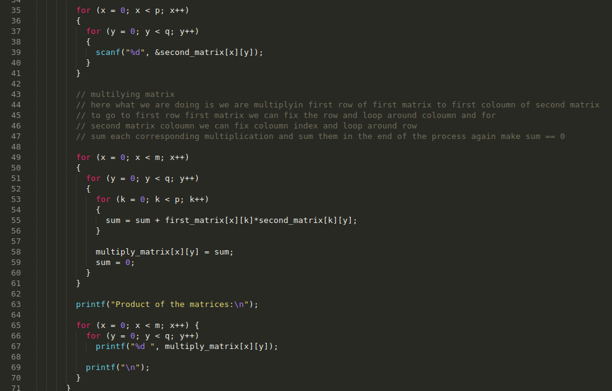

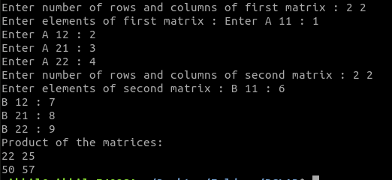

Q. Write a program to check if a matrices is symmetric or not.

Hint: Transpose of matrices should be equal to initial matrices

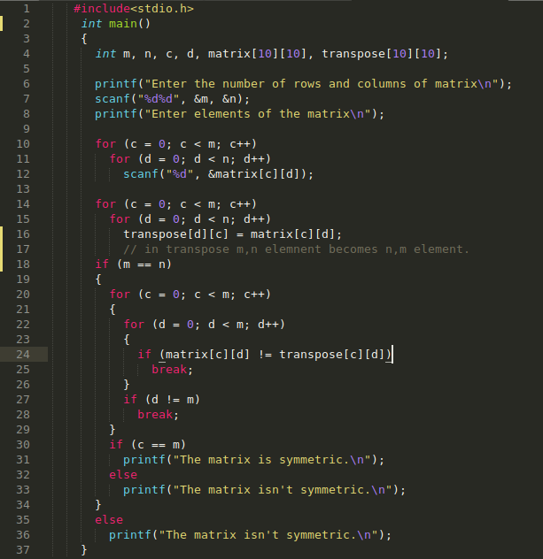

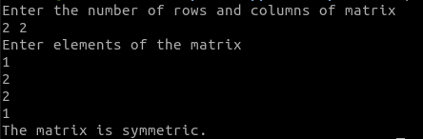

Explanation: Here first we have found out the transpose of the matrices than checked if the transpose is same as the initial matrices or not.
Transpose is changing rows by column and column by rows for <b>Example:</b>
1 2
3 4
Transpose would be:
1 3
2 4
here as we can see n, m element is swapped by m, n element.

Functions:

in ‘C’ we can break our program into further small pieces of code generally known as the functions, they are independent piece of codes written in a well-defined manner typically for using in long, complicated programs and repeatedly using the same function again and again by calling it within a program according to problem.

Calling of function simply means that we need that function to run at that particular place.

Suppose we need to find sum of few numbers but according to the need of our program we need to do this task multiple times within our program so, what we can do is making a function named ‘sum’ and calling it at the place where we want to find the sum of the numbers.

This process as a whole simplifies the program and make it efficient and less vulnerable to the errors, A large program size is a serious problem where the memory space is quite limited, which can be cured by using ‘Functions’.

Coding and testing multiple functions is very easy and efficient rather doing it for a complete big function or a program as a whole.

A Function needs to be start defining before the main () function just after the header files and then called where we need the function to be executed and after completing the program, at last the function is defined with its various attributes like datatype, arguments, return values etc.

Datatype of function and its arguments must always be same.

<b>Note:</b>

You’ve been writing function main () since day 1, but the main () is also a pre-defined function with return type int (int main ()) and which gets defined just after the header files.

Syntax of a function:

<Header Files>
Datatype_of_value_returned_by_function name_of_function (Datatype_of_argument); // function is declared
main ()
{
…….
…….
function_name (variable name); // Function is called
…….
…….
}

// Definition of the Function

Datatype_of_value_returned_by_function name_of_function (Datatype_of_variable variable_name)
{
…..
….. \\ body of function
…..
}

Declaration of a function:

if a function needs to be called it is to be declared before the main function just after the header files.

<b>Example:</b> int sum (int , int);

Calling of a function:

if a function needs to be called it is to be called in the body of the program within the main function as shown in the syntax terminated by a semicolon (;)

<b>Example:</b> sum (a, b);

Defining a function:

A function is defined at the end of the program within the curly braces which have the header of the function, body of the function which is followed by defining the datatype of the returning value, argument of the function, and the name of the variables as shown above in the syntax of the program.

<b>Example:</b> int sum (int a, int b) // Header of function
{
printf (“sum is %d “,a+b); // Body of function
}

Q. Make a simple function which can be used to perform addition.

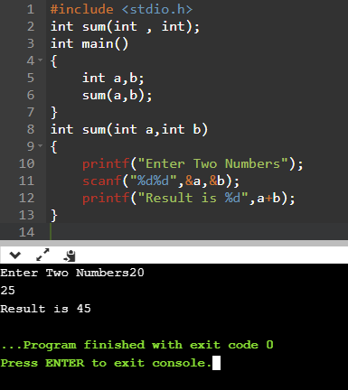

Q. Write a program to check the largest integer using the concept of functions.

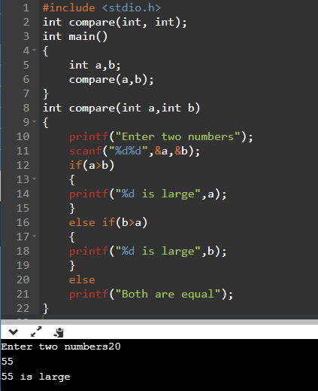

Functions are called using two ways:

1. Call by Value:

Here the values of variables are passed by the calling function to the called function. Suppose if we want to call the function and want the values of the variables to be used in the program, but after executing/running the program we don’t want the original values to be changed, then in such a case call by value is used. And the function is called by the value.

2. Call by reference:

Here the address of the variables are passed by the calling function to the called function. Suppose if we want to call the function and use the values of the variable but does not want to keep the original values instead, we want to upgrade the values and store them permanently by replacing original values at the memory address of the variable, then in such cases function is called by the reference.

Now, let’s understand these topics one by one with the help of examples.

Example for Call by Value:

Q.Write a program to add 10 into a variable using call by value by function.
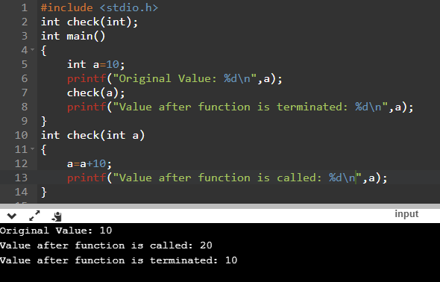

Example for Call by Reference:

Q. Write a program to add 10 into a variable using call by reference by function. (Don’t worry about the code this just an example all things will be covered in detail in next title.)

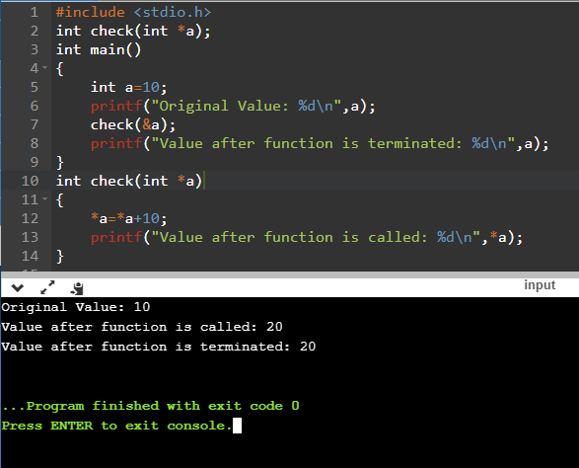

<b>Note:</b> After using the return statement in function definition any code written after return statement will not be executed basically it works as the break; statement but within the function only.

Suppose, if we want to call the function using call by value but do want to change the value, then in such a case we can use the RETURN function.

To Explain this an example has been shown below:

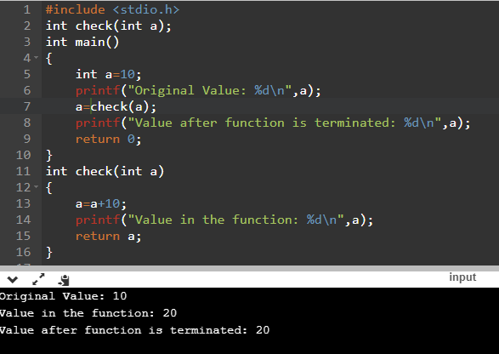:

Call by Reference and Pointers

As we all know that, the programs we are making have variables strings arrays and many other things that we need while running our program. So where are these stores let’s find out:
When we run our program, our program comes in-to the RAM Now all the variables are assigned “Memory “or “Space “in the RAM. So that they can be accessed by the programs when needed. Each memory bit has unique address by which we can access it. These addresses are big and are in hexadecimal system, hexadecimal system have 16 possible value per digit, 0-9 and A-F.
A typical address might look like: 0x2331010 or 0x233A3B1.

Now what we have seen is: on running a program each component gets some memory and each memory have some address. So, if we know the address of the memory in which the component is store, we can also access the value stored at that memory.
An analogous situation would be:
Suppose you have new friend coming to your city. Now you want to meet him or her:
What are the steps that you will take to meet him or her?
1. Call him/her.
2. Ask his/her address and
3. And then go there.
Same can be done in case of variables consider variables your friend you ask him his address and then go to that address and access it or update it.

Remember: Memory is place where an address is assigned to a variable or any other thing if we know the address, we can go their update variable or simple see its value.

Now let’s get back to function:
Up till now we have studies Function its syntax and we have listed two methods of calling it:

1. Call by value.
2. Call by reference.

Now let’s see what happens when we call function by value and what does it mean by “calling by value “:
Calling by value means in general terms means passing the variables name to the arguments of the function.
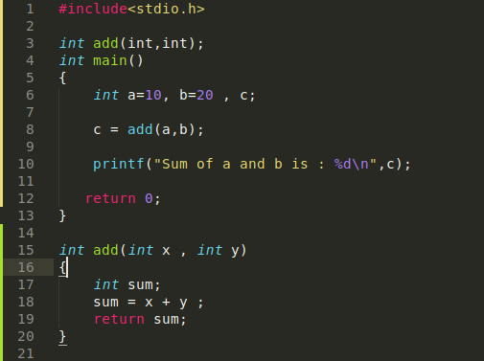

For <b>Example:</b>
Here in this program we are calling function on line 7 add (a, b) by passing the name of the variables in the argument list of the function add (). This is called “call by value “.here we just pass the variable name to the argument list of the function.
Now let’s see what is happening under the hood:
when we call the add () function on line 7, the function add () gets its own copy of variables “a “and “b “and it does all it’s it work on those variables and return us the output.

Let’s see another program to make things clearer:
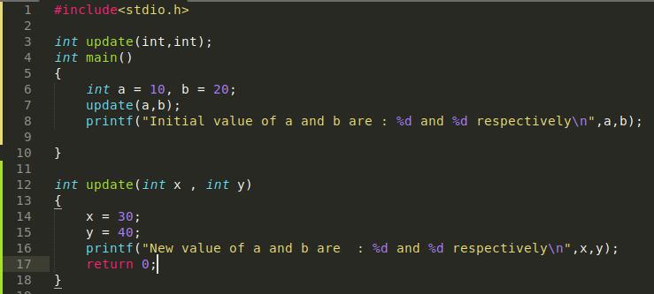
Here i have created a function update () which take two arguments of type int x and y and update their values to 30 and 40 respectively.
But here’s the catch since we are calling the function by value here which means function will get the copy of the original variables and it will perform all the operation on those copy of the variables with no effect on original variables.
So therefore, output of the above code would be:

As you can see here on line 1 of the output we get the updated value of “a “and “b “but since the function call is call by value which means the copy of the original variables have been updated to 40 and 30 respectively with no effect on the original “a “and “b “variables as we have print the values of a and b on 2nd line of the output.
Let’s see a flow diagram:

A and B variables initialized in the memory with their own unique addresses
A: 0x23453
B: 0x22332

Function is called by value now.
Now this function get’s some memory
Now copy of a and copy of b
being generated in the memory
With their own unique address.
CPA: 0x135334
CPB: 0x435533

Update ()
Function does the operation of
updating values but since the copies are
passed to the function so copies get
updates rather than the original variables

Now as we can clearly see here functions get its own copy of variables therefore only the value of the “copy of original values “get updated rather than the original variables itself.

Now this has led us to a problem i. e what if we wanted to update the value of original variables. What can be done in this case?

Consider this if somehow we came to know the address of the original variables in the memory then we can pass those address to the function and then all the operation that function will perform will be done on the variables that are store in that address and on that address what do we have “the original variables “. Sounds like a good idea. Let us summarize this:

1. Get the address of the original variables.
2. Pass it to function so that it can perform all its operation on those variables which are stored in the address that we have passed.
3. Return the values.
Now in the above process we need to get the address of the variables.
how we will get the address of the variables and where we will store it?

Now here comes “Pointers “to our rescue.

Pointers: Pointer’s is a type of a data structure which are used to store the address of the variables. As simple as that.

Now we can use pointers to store the address of the variables how we will get the address of the variables well that is simple we will use “Ampersand “ (“& “) this is the same operator we have been using in scanf function for so long. Ampersand provides the address of the variables.

Now we have a data structure to store the address and a way to get the address.

But before moving on first let’s see the syntax of pointer:
Pointer as we have defined above is a data structure to store the address of the variables.

Let’s understand the syntax of the pointer with the help of an <b>Example:</b>
suppose you want to store the address of the variable “a “which is of “int type “with a value “20 “.

int a = 20;

To store the address of a variable a we need pointer so therefore let’s define a pointer whose name is “k “:

int *k = &a;

Let’s understand this:
1. name of the pointer is “k “
2. “&a “on RHS provide the address of the variable “a “so that we can store it.
3. “* “this is a standard notation needed when defining pointer.
4. What is this “int “is this because since address of a variable is of integer type so therefore we need pointer “k “to be of data type “int “. NO, A BiG NO.

This int here tell us that on reaching the address which we are going to store in “k “we will find an integer on that address.
Let’s understand this:
Since k is a pointer it will store an address of the variable “a “.
Now when we reach the address which is stored by “k “what we will find there an integer because “k is storing address of variable a and variable a have value equal to 20. “

let us define another variable “b “which data type “char “and is storing value equal to “T “and we will also create a pointer to store address of variable “b “

char b = ‘T’; // defining b with value ‘T’.

char *m; //defining a pointer m so that we can store address of //variable “b “Note that we have use here “char “unlike “int “ //in case of pointer “k “above

m = &b; // using pointer “m “to store address of variable “b “.

Now why we have used char *m not int *m because when we reach the address that is stored by pointer “m “. we find a character “T “there.
20
Address: 0x67866

Variable “a “with value 20

Now to store address of variable “a “we will create a pointer “k “which. Let’s create a pointer “k “.

int *k;
we have used int here because we know that the address that will stored by pointer “k “will contain an integer there.

Now using ampersand, we will get the address of variable “a “and will store it in pointer “k “.

k = &a;

it’s done we have stored address of a variable “a “in a pointer “k “.

Let’s take another example of suppose we want to store a variable “c “with type “float “and a value equal to “20. 67 “
20.67
Address: 0x24563

Variable “c “with value 20. 67

Now to store the address of ‘c’ we will create a pointer. Let’s create a pointer ‘z’.

float *z;

Now this time we have used float at place of int because we know that on reaching the address that will stored by pointer z, we will find a “float “value there.

Now we will use ampersand operator to get the address of variable “c “and store it in pointer “z “.

z = &c;

Now Let us define the syntax of pointer now:

x *name_of_pointer;
x is the data type of the value that we will find on reaching the address stored by pointer.

One more thing to note is: that the format specifier to print pointers are: “%x “or “%u “or %p.

Let’s write a code to store the address of a variable and then print it.

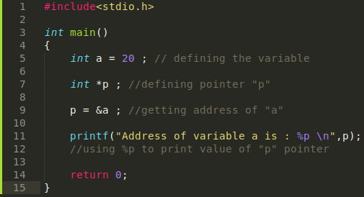

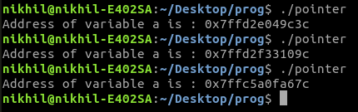

Here i have run the above program three times every time we get a different output. Why because every time the program run the variables get memory with new address each time and as soon as the program stops the memory occupied by the variables gets free.

We have a pointer “p “that we have created in above program to store address of variable “a “. Now what if we need the value stored in that memory address which is stored by pointer “p “.
“p “is a pointer which have a memory address stored in it. What i am asking is what if we need the value stored in the memory address which is stored by pointer “p “.
To get the value stored in a particular memory address what we do is: we just write *nameofpointer that’s it. Let’s quickly see an example to sink this in

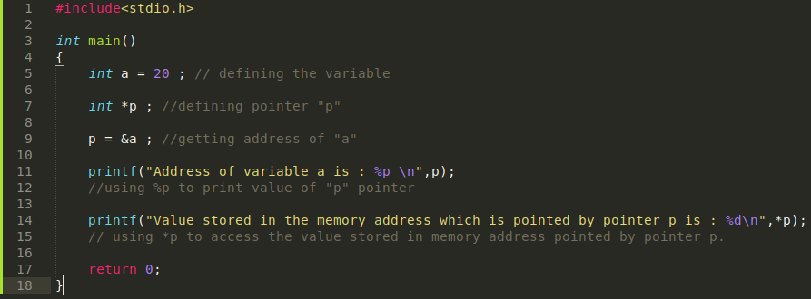
Here we have used *p to access the value stored in the memory address (and this memory address is stored by pointer p).
This is called “Dereferencing “of pointer.

So now we can say that pointer “p “stores the memory address and *p gives the value stored on that memory address.

Relation between pointer and array:

There is a relation between a pointer and array which is:
“The name of the array is the pointer to the first element of the array. “
Let’s understand this statement:
The statement above says the name of the array is the pointer to the first element of the array.
What is pointer a data structure to store memory address.
So, name of the array is pointer which means “name of the array “will store a memory address. Memory address of what “memory address “of first element of the array.

Let’s see how an array look’s like in memory

int arr [5];

index | 0 | 1 | 2 | 3 | 4
Element | 23 | 24 | 25 | 26 | 27
Address | 0x6000 | 0x6004 | 0x6008 | 0x6012 | 0x6016

As we know array gets continuous memory while we run a program.
Since size of “int “data type is 4 bytes therefore we can see in address field in above table each address is 4 bytes more to the previous.

Now what the name of array “int arr [5]” which is “arr” is a pointer to the first element to the array which means “arr “is storing the address “0x6000 “. arr []
Let’s create a program to prove this statement:

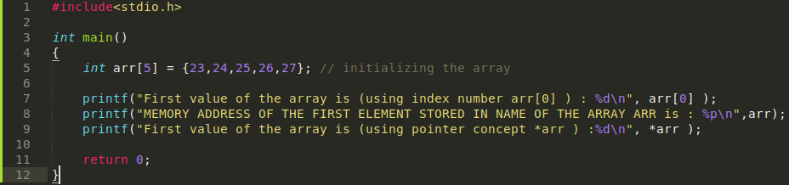
Output:
on line 7 we used the same old concept of printing the value by using index number but on line 8 as we know that name of the array is the pointer to the first element of array which means name of the array in this case “arr “have stored memory address of first element so we have printed the memory address of the first element of the array. Now to access value stored in the memory address stored in “arr “we can dereference it by *arr that is what we have done on line 9. and it comes out that the value is equal to first element of the array which is what this statement says:

“The name of the array is the pointer to the first element of the array “

Suppose if i add 1 in a pointer “k “which stores a memory address. What will happen will compiler through an error? NO by adding 1 to a pointer we jump to the very next memory location in the memory.

k + 1 = next memory location

its application will be in arrays.how?

As we know that arrays get continuous memory as we have also drawn table above and the name of the array is the pointer to the first element of the array. So, if we add + 1 in the name of the array we will jump to the next memory location in the memory and on that memory location what are we going to find the next element of the array.

Let’s create a program to prove this:

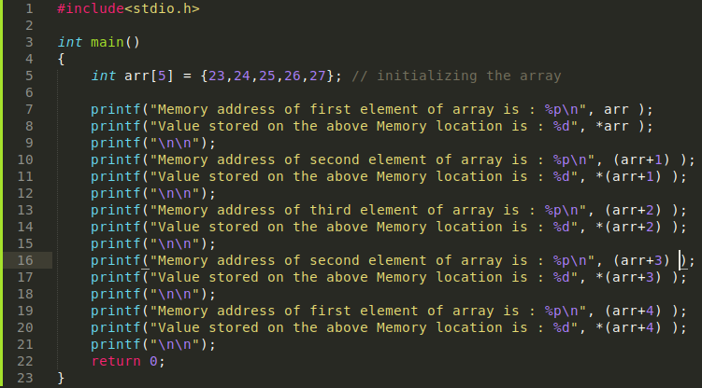
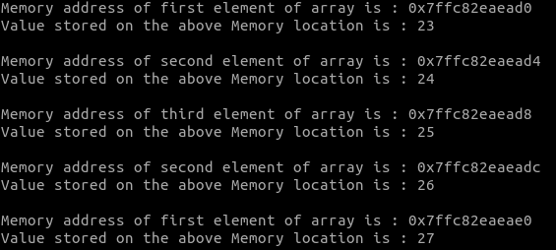

As you can see here on incrementing each time by 1, we go to the next location in the memory and dereference there and find the next value in the array.

We could have also done this by applying a for loop. let’s try:
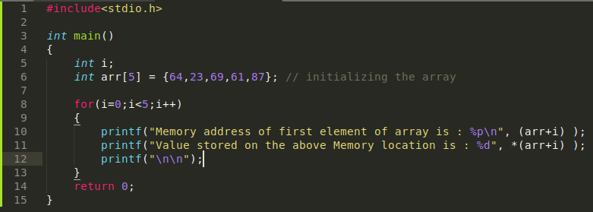
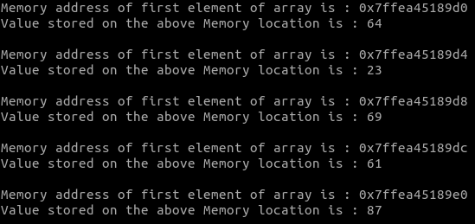

Rather than manually updating values this time we used for loop with a variable “i “iterating from 0 to 5.

Key take away:

On adding 1 to a pointer we jump to very next memory location.
“Pointer k + 1 = address of very next memory location “. On subtracting 1 we jump to previous memory location, but nothing happens when you divide or multiply two pointers.

Q.Write a program to take input from user in an array and then display it using pointers and Output:
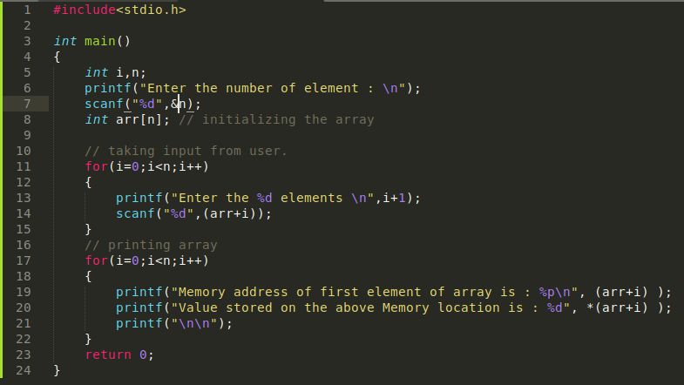

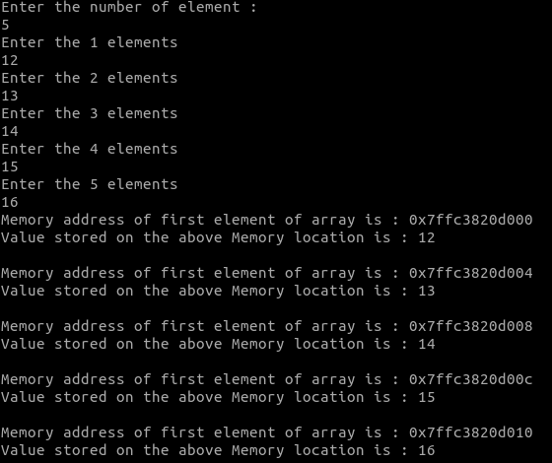

This was all about pointers. Now we should go back to where we left off.
So, we were facing a problem with “Call by value” because it takes the copy of the variables then do operation on that copy. What if we wanted to do operation on the original variables for this, we devised an algorithm which was?

1. Get the address of the original variables.
2. Pass it to function so that it can perform all its operation on those variables which are stored in the address that we have passed.
3. Return the values.

We know now that how we can get the variables address and store it.

Let us see what does “call by reference “means:
in call by reference we pass the “memory location or address “of the variables rather than the variables itself.

And since now we know that a memory location or address is stored by a pointer therefore in “Call by reference “we just pass the pointers of the variables which have stored memory address of that variable.

Let us look an example of call by reference method:

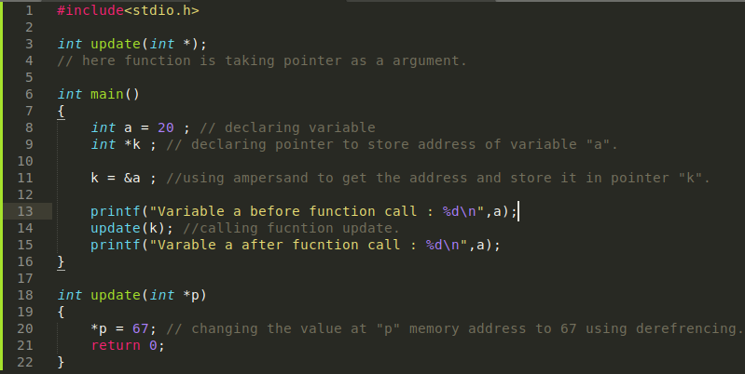
Here as we can see on line 3 declared a function update () which will take a pointer as an argument on. On line 8 declared a variable “a “with value 20. On line 9 declared a pointer “k “which will store address of variable “a “then on line 11 stored address of variable “a “in pointer “k “. on line 13 using printf () function printed the value of “a “before function call on line 14 called the function update () with “k “as the argument. Since we are passing a pointer to the argument therefore it’s a call by reference method. As you can see on line 18 update () what update function does is it update the value to 67 at the memory address which is being passed to it (*p = 67). Now on line 15 we again printed the variable “a “value after function call.
As we have passed memory address of “a “to the function so therefore all the operation is being done on that memory location.
Now let’s see the output of the above code:

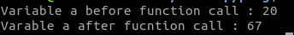

As you can see the original variable “a “gets updated here to 67 after the function call this time unlike in case of call by value method where value of original variable remains same.

CALL BY VALUE CODE:

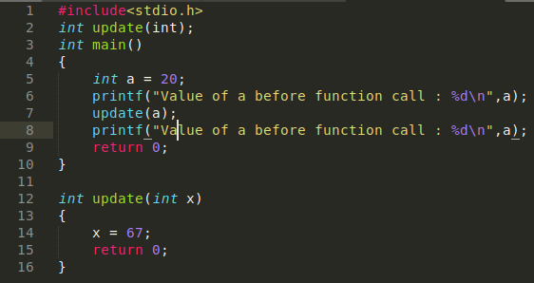
OUTPUT:
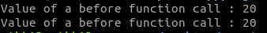

As you can see here value remains same before and after function call because here, we are just passing the variable in the function (on line 7)
not the memory address linked to it.
This is the difference between call by value and call by reference.

Now therefore we have seen here that by passing the address of the variable to the function we can actually change or update or perform different operations on the original variables.

Q. Write a program to swap values of two variables inside main function using a user defined swap function.

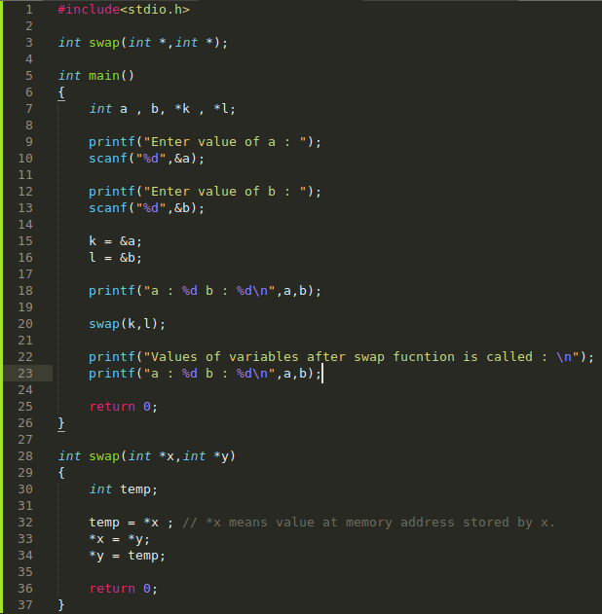

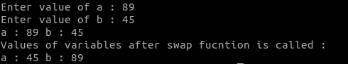

What if we did the same problem without use of the pointers do you think values of the original variables would change let’s see:

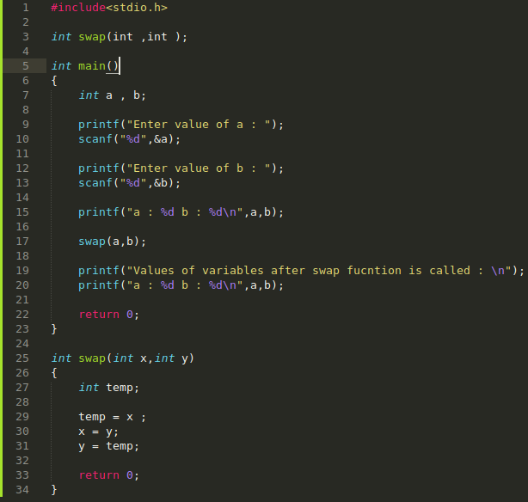

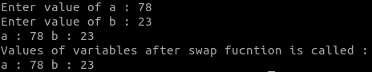

As you can see the value of the ORiGiNAL VARiABLES DOES NOT CHANGED.

Recursive Function:

Recursive function is defined as a function where the function calls itself within the function to solve the problem by breaking the whole problem into smaller problems.

Suppose we have a problem which would be solved if we break the same problem into similar small problems, so what we are doing there is repeating the same steps in smaller processes to solve the big problem as a whole. So, solving problem by breaking the big problem into similar small problem using the concept of ‘function calling itself repeatedly until it reaches the user defined base case’ such a concept is called as Recursive Functions.

The best example to explain recursive function is factorial, suppose we need to find the factorial ‘n’. so, to find its factorial we are supposed to multiply ‘n’ with ‘n-1’ and ‘n-1’ with ‘n-1’-1 until it reaches the base case which is Factorial of 1 which is equal to 1.

Let’s take n=5 in above illustration, so we are supposed to multiply 5 with n-1 i. e, 4 with n-1 i. e, 3 and so on, until it reaches 1. Which gives us result as 120.

Now, Let’s write a code which gives us factorial of a number using the concept of recursive function:

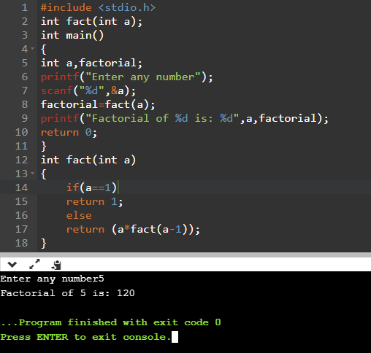

Explanation: After taking input from user for the number for which we want to find the factorial, we will call the function fact (), in the definition of function fact () we have defined a base condition that is when value of a becomes 1 it will return 1.
Else it will return 5* (5-1)* (5-1-1)* (5-1-1-1)* (5-1-1-1-1) and now when value of a becomes 1 it will return 1.
So, output comes as 5*4*3*2*1=120.

Q. Write a program to check the greatest common divisor of two user entered numbers using the concept of recursion.

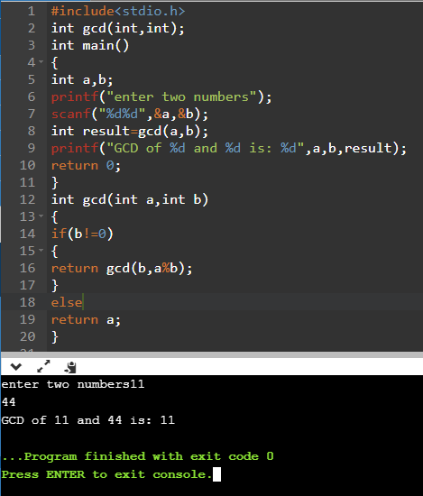

Explanation:

While defining function we have given the base case of when b is not equal to zero because when one of the value becomes zero, simply the other one is returned as the result, but suppose when 11 and 44 are given as input then, next condition will become:
- gcd (11,44) // as ( b=44 and a%b=11%44=11 )
- gcd (11,11) // as (b=11 and a%b=0) which make new value of b=0
- gcd (11,0) // as first condition holds wrong which will return a=11 as result.

Q. Write a program to calculate the exp (x,y) using recursive function.

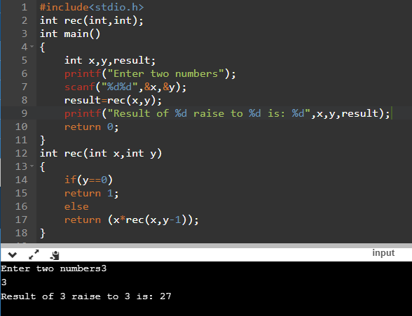

Explanation:

in the defined function rec (int x, int y) we have taken the base case as when the value of y (exponential power) becomes 0, function will return 1 as anything raise to 0 is defined as 1 else it will return (x*rec (x,y-1)). Our program works on the logic that x multiply itself with Y times until the value of y becomes 0 by decreasing one gradually each time function gets called. Let’s take An Example for 3 raise to 3 which will help us in understanding the concept clearly, here x=3 and y=3, now:

- (3*rec (3,2)) // result is stored as 3* (program running)…
- (3*rec (3,1)) // result is stored as 3*3 (program running)…
- (3*rec (3,0)) // result is stored as 3*3*3=27 (program will return 1 as y == 0)

Passing an array to the function:
We can also pass array[] as an argument of the function, to explain this a program has been given below:

Q. Write a function to take input form user and store it in array and also write function to display the elements stored in array.
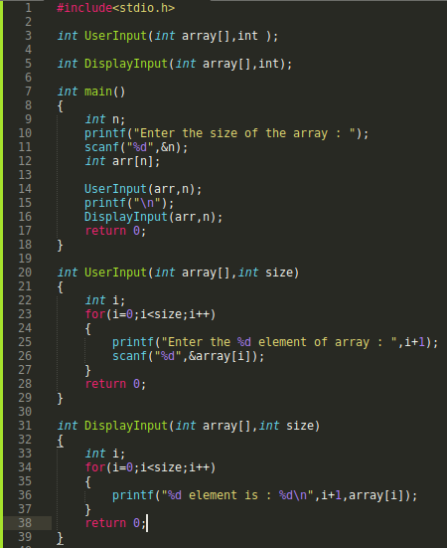
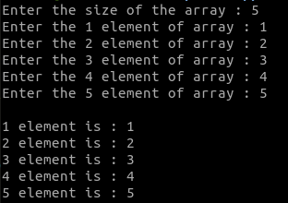

Q. Write a program to print first n natural number using recursive function.
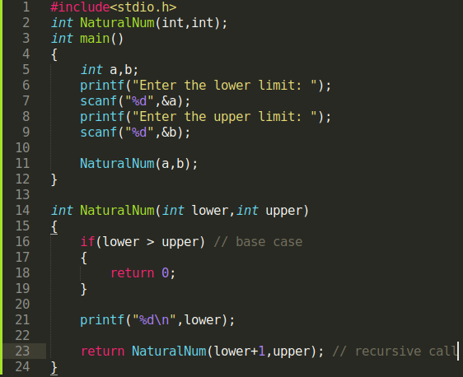
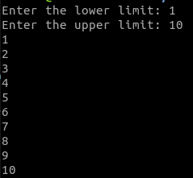

Q. Create a function which can find all prime numbers between two numbers.

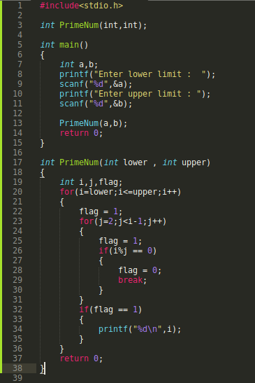
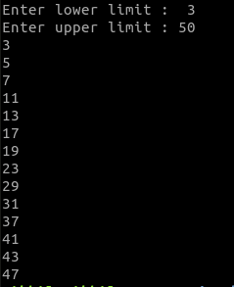

HARD PROBLEM

Q. Write a program to solve the problem TOWER OF HANOi.

TOWER OF HANOi:

Tower of Hanoi is a mathematical puzzle where we have three rods and n disks. The objective of the puzzle is to move the entire stack to another rod, obeying the following simple rules:
1) Only one disk can be moved at a time.
2) Each move consists of taking the upper disk from one of the stacks and placing it on top of another stack i. e. a disk can only be moved if it is the uppermost disk on a stack.
3) No disk may be placed on top of a smaller disk.
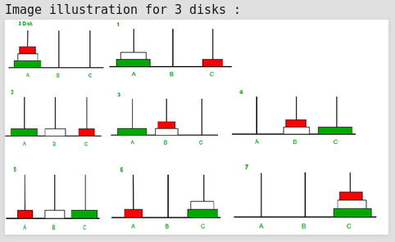

Sample input/Output:
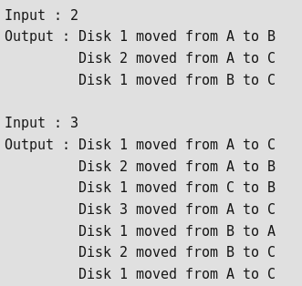

Logic:
There one trivial case which i know always which is to shift 1 disk to another: for this case only 1 step is required.
So now our approach should be to always come down to this case.
To do this what we did is we approached this problem using recursion why?
Because in recursion we can call the same function again and again with in itself how this would help:
let’ see suppose i wanted to shift 3 disks from tower A to tower C how can i do this:
1. i would shift 2 disks from A to B using C
2. Then i would shift Last disk from A to C (this is our trivial case.)
3. Then i would shift 2 disks from B to C using A.

in more general way:
1. Shift n-1 disk from A to B shift using C.
2. Shift last disk from A to C shift.
3. Shift n-1 disks from B to C using A.

Now in the above algorithm we have a new problem with in the problem of shifting “n-1 disk from A to B using C “Now to solve this problem we can again apply the same algorithm but this time our final tower is B instead of C. But there is one condition to be taken care of number of disks should be greater than or equal to 1.

Code:
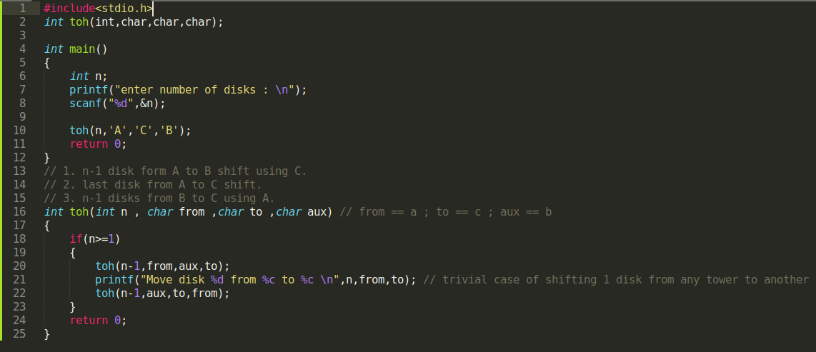
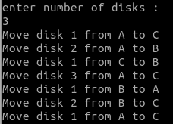

To visualize this solution, refer this website here:

https://www.cs.cmu.edu/~cburch/survey/recurse/hanoiex.html

STRiNGS

Strings are nothing but a special type of array in which each element is a character. Or we can say strings are special type of data structure which is used to store English sentences such as name of an individual in C language.

For an instance if we want to store a name of an individual in C language for example “Nikhil “. As we can see they are nothing but sequence of characters N,i,k,h,i,l we can store it using an array also How?
We will define an array equal to size of the name and with a data type of char.

char name[6];
and we can initialise this array:

name = {‘N’,’i’,’k’,’h’,’i’,’l’};

or we take input from user using for loop:
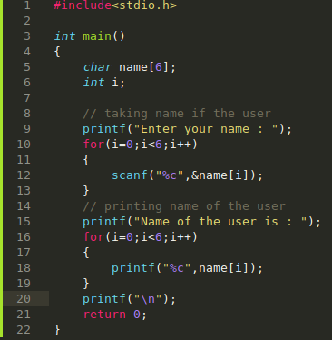
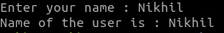

Above code does a pretty good work of storing an string (in this case name of the user). We have not used any concepts of strings up till now but we are able to store a string with our previous knowledge of the arrays. Then why do we need strings answer lies in the above code itself.
in the above code we are treating name as combination of characters, we are not treating it as a “whole “and we are also using “for “loops each time we want to take a string as an input or print a stored string.
Using arrays to store string will be tedious because: each time we want to either store or print a string we will have to use a for loop and will have to consider string as a combination of characters.
To bypass all C language, provide “strings “data type to store strings (such as name sentences etc) (yes name of the data type is same to what it is used for.).

How to use this data type?

Defining string:
<b>Syntax</b> char name[length_of_string];
for <b>Example:</b> char name_user[10];

Format specifier used for string is: “%s “.

Under the hood compiler deals with string as an array only. But just to make our work easy programming godfathers have defined this data type.

Let’ make our first program to store a string and printing it.
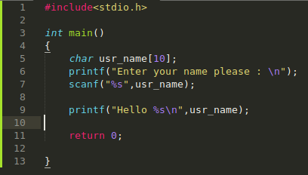

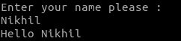

Pretty simple no use of for loops just defining a string and using %s format specifier to tell compiler to expect a string at place of it.

Let’s see what is going on under the hood
On line 5 which is “char usr_name[10] “here compiler will make an array with a size 10 without taking care whether we will deal with as an array or string. it will just create an array of defined size.
Now on line 7 we used scanf () to take input from user, we used %s specifier to tell compiler that user will enter string and store that string in array usr_name. Compiler already knows that string is nothing but sequential array of char under the hood it will be storing a string in the way we have stored earlier using “for “loop only but we need not to worry about it.
One important thing is that after storing the string we have entered in the variable we have defined compiler add a special character ‘\0’ to mark the end of the string.
usr_name in computer memory will look like:

0 | 1 | 2 | 3 | 4 | 5
N | i | K | H | i | L | \0

if a null character is not added then it will be like a normal array and compiler will not be able to differentiate between a string and array.

<b>Note:</b> We have not used “& “before usr_name because the name of the string directly point toward the address of the first memory byte of the array usr_name as soon as compiler knows the first memory byte of the array in which we want to store string it will automatically know that next memory byte is of the same array usr_name because memory is assigned in continuous manner to string and to array.

Finally, on line 9 we have printed the string stored in usr_name.

<b>Note:</b> using scanf () we can only take input such strings which do not have spaces in it.
For <b>Example:</b>
suppose i want to store “My name is Nikhil “i will not be able to do it using

scanf (“%s “,usr_name);

Because scanf function will only read the string till white space is encountered as soon as the white space is encountered scanf will stop reading the input. Now what we should do read string with spaces in it we use:

gets (variable_name);

gets read input till a new line is encountered.

We can modify scanf () to read string until new line is encountered by doing this scanf (“%[\n]s “,usr_name);
now scanf will read input till a new line is encountered.

Key take away points:
1. String is basically an array but we are using it for our convenience.
2. At the end of each string we will compiler automatically add a special character which is called null character “\0 “.
3. During scanning of string using scanf function we don’t use “& “character. Because name of the string will point to the first memory byte of the string.
4. Difference between array and string is at the end of string null character is added always “\0 “.

Let’s do some programs:
Advice: if you know how to deal with arrays string will be a piece of cake for you.
Advice: in most of the programs we need to iterate through each element of string. To do this we will use a for loop but with i = 0 and a condition str[i] != ‘\0’ this is the condition which will ensure, whether we have reached the end of the string or not. Because as soon as str [i] becomes == ‘\0’ this means string has ended.

Q. Write a program to find the length of the string entered by the user.
Hint: ‘\0’ mark the end of the string

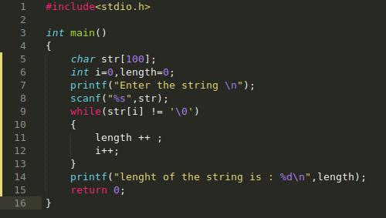

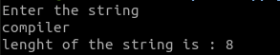

Q. Write a program to find how many characters, words, white space, vowels and consonants are there.
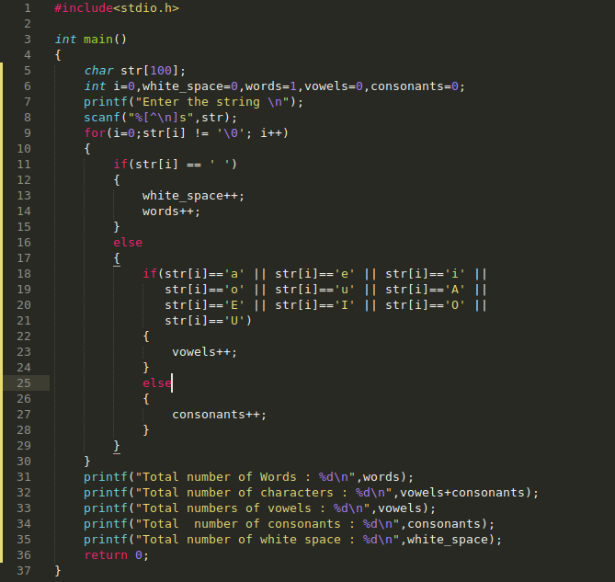
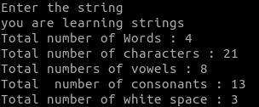

Q.Write a program to for encrypting a message take the key from the user.

Encrypting here means shift each character in string by a particular time.
Key = 2
input: Hi

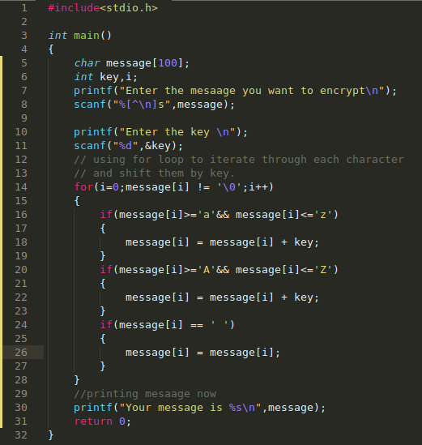

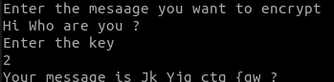

Explanation: Here we are dealing with ASCii values. ASCii values are the numerical values given to each character. ASCii table have 128 characters with values varying from 0 to 127. So now when we do this in C “’a’ + 2 “2 is adding in ASCii value of 2 which will result in ASCii value of ‘c’ therefore our computer will print ‘c’ for expression (“’ a’ +2 “== ‘c’).

Q. Write a program to convert uppercase letter to lower case letters and lowercase letters to uppercase.

Hint: Difference between ASCii values of Uppercase letters and lowercase letters is 32.
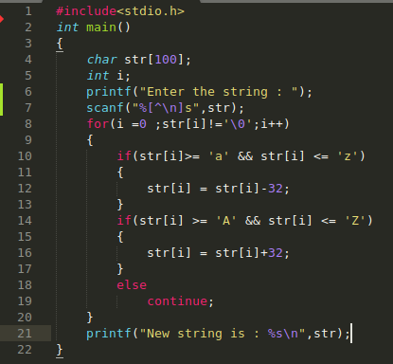

Q.Write a program to reverse a sting.
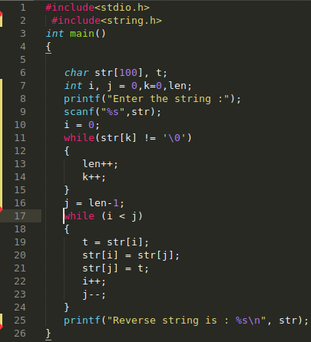

Explanation: on line 11 while loop find out the length of the string “str “using. On line 17 we have created a while loop to swap last value of string to the first value of string we are doing this till we have reached the middle of the string.

Q.Write a program to concatenate two strings.
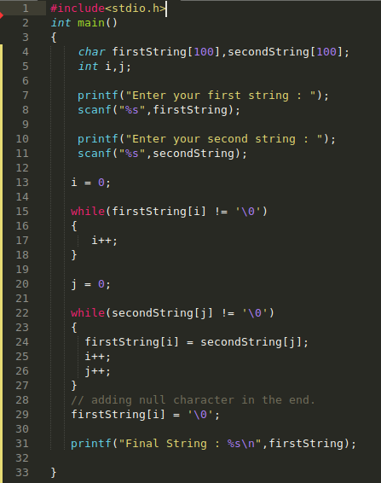

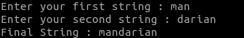

Q. Write a program to check if a string is palindrome or not.

Palindrome are those strings which read same from both the sides.
For <b>Example:</b> MAM, RADAR, CiViC, LEVEL etc

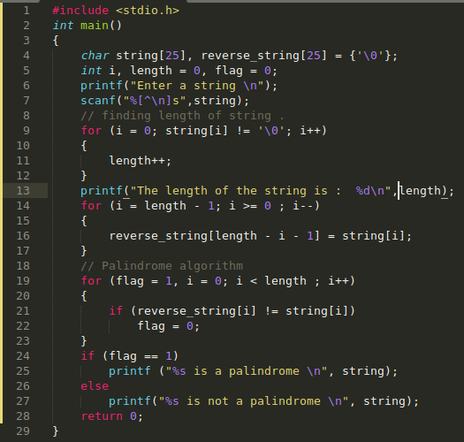

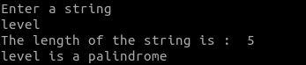

BUiLT iN FUCNTiONS FOR STRiNG

Now let’s learn about a special header file called <string.h>
<string.h> provides many built-in functions to make our work easy. it’s is included in the C program in the same manner in which <stdio.h.> is added.

Let’s see some function provided by <string.h>.
1. strcat: The strcat () function will append a copy of the string2 to the string1.
For <b>Example:</b> string1 = “Nikhil “string2 = “Jain “. On applying strcat on string 1 and string 2 we will get “NikhilJain “.

Strcat function takes two arguments:
a. dest
b. src
<b>Syntax</b> strcat (src, dest) // destsrc
it will append copy of source string in the destination string. The termination character at the end of the dest is replaced by the first character of src.

An <b>Example:</b>

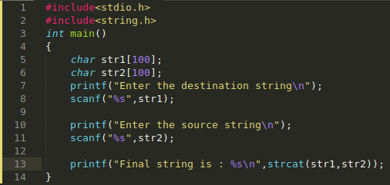

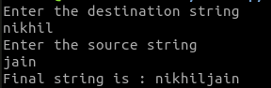

2. strcmp: strcmp () is a built-in library function and is declared in <string.h>
header file. This function takes two strings as arguments and compare these two strings lexicographically or in a dictionary manner.

<b>Syntax</b> int strcmp (const char*leftstr, const char *rightstr);
strcmp return 0 when leftstr is equal to rightstr.

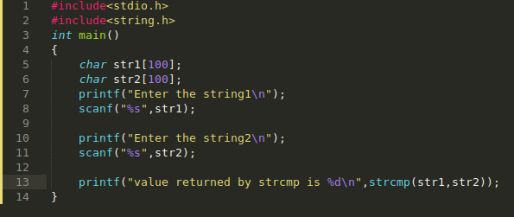

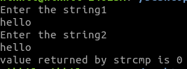
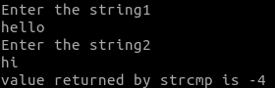
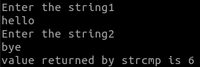

As we can see here if strings entered are equal it will return 0.
Otherwise it will return a negative integer if string1 come after string2 in dictionary and a positive integer if string1 come before string2.
<b>Note:</b> - it will return integer based on the fact that by much difference the first unequal character is ahead or back. Under the hood it will just subtract the ASCii values of first unequal character.

3. strcpy (): strcpy () is used to copy a string to another string variable.
For <b>Example:</b>

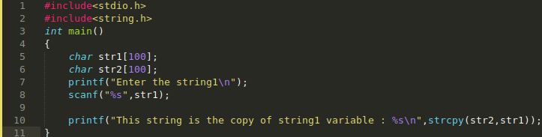

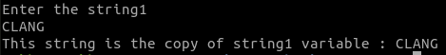

4. strrev (): This built in function is used to reverse the string.
For <b>Example:</b>

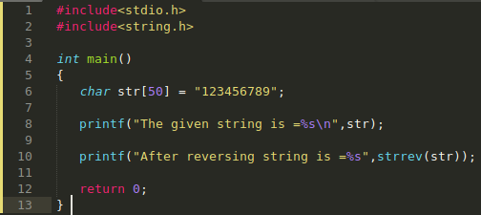

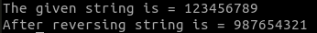

5. strlen (): This is an inbuilt function is <string.h> header file which is used to find the length of the string. it does not count ‘\0’ null character. <b>Example:</b>

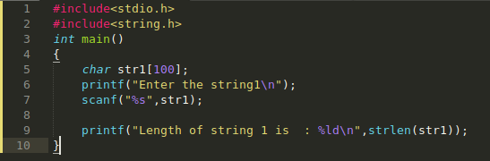

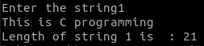

6. strlwr () and strupr (): strlwr function is used to convert string into all lowercase and strupr function is used to convert string to uppercase.

For <b>Example:</b>

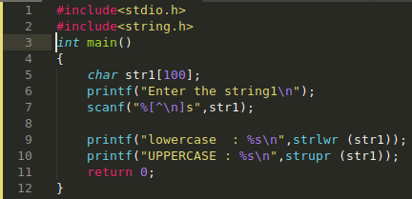

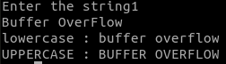

We have learnt some of the common function included in string.h Now let’s do some more programs based on strings.

Q. Write a program to check if a substring is present in string or not.
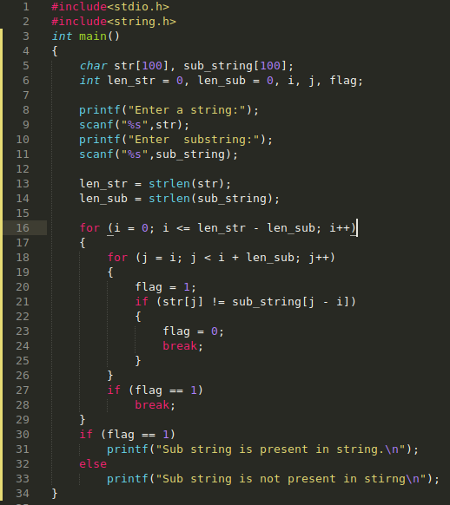

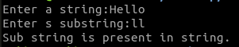

Explanation: Create a Step wise procedure of nested loop to get better understanding.

in this C program, we are reading a string using ‘str’ character variable. We are reading value another string to search using search character variable. To check substring is present in the given string. While loop is used to compute the str [] and search [] array variable value is not equal to null.
if the condition is true then execute the iteration of the loop. increment the values of ‘count1 and count2 variable values. Now we are using two for loops to check if the substring is present in the given string. We are initializing the ‘i’ variable value to 0 and the loop will execute till the condition that ‘i’ variable value should be less than or equal to the difference of count1 and count2 variable values.
if the condition is true, then another for loop will execute by initializing the ‘i’ variable value to ‘j’ variable. And the loop will terminate if the ‘j’ variable value is less than the sum of ‘i’ variable value with count2 variable value if the condition is true.
Then it will execute the loop by assigning the flag variable value as 1 and if condition statement is used to check the str [] array variable value is not equal to search [] with the base index is the difference between ‘j’ variable and ‘i’ variable value. if the condition is true then it will execute the statement and assign flag variable value as 0.
For loop iteration will terminate till the condition becomes false. if-else condition statement is used to check if flag variable value is equal to 1 then print as search successful otherwise if the condition is false then print the statement as search unsuccessful.

Q. Write a program to find the frequency of substring in a string in C.
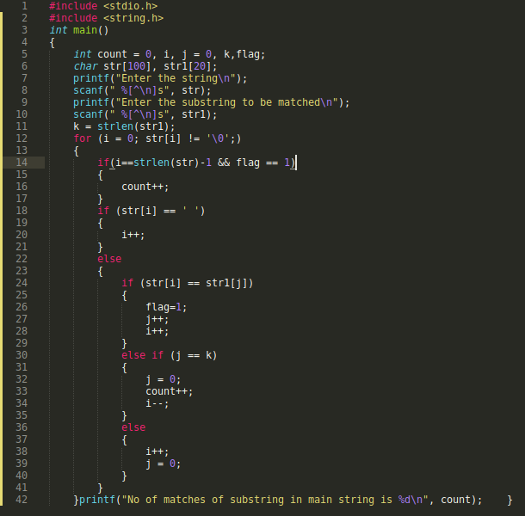

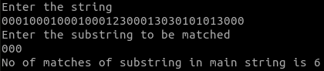

Explanation: First of all, we are taking input from the user then o line 14 we initiated a for loop to iterate through each elements of string. Then inside for loop we have written code to compare each element of str to str1 which is our sub string considering each case i. e. if str[i] on any instance is white space ‘ ‘ then we will just skip through the next character in string str by incrementing i (code on line 17. ) then on line 24 we are checking if each element of str is matching with str1 if all the elements match then j will be incremented to length of str which is k then on line 30 the condition will be true hence we will set j = 0 (so that we can again compare first element of str 1 to next element of str ), count ++ (because substring is found since j has value == k. ) and i-- We will follow this process till we have reached the end of the string
i will again suggest you to draw a step by step procedure of the program.
Refer this site to visualize
http://www.pythontutor.com/c.html
and make sure you provide input with in the program only.

Q. Write a program to convert string to int in C

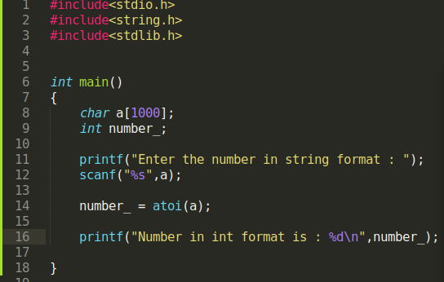

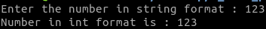

Explanation: atoi function is used to convert str to int in C.

in this way we have completed string also.

STRUCTURE

Up till now we have learnt two types of data structure in C which are Arrays and Strings. Structure is also a data structure but what sets structure apart is that it is a “user defined “data structure.

“A structure creates a data type that can be used to group items of possibly different types into a single type. “

Let’s see what does this mean:
int a;
Here a is a variable which will store a value of type int.
char b;
Here b is a variable which will store a value of type char.

struct data_base c;
Here c is a variable which will store value of type “struct data_base “which we have created.

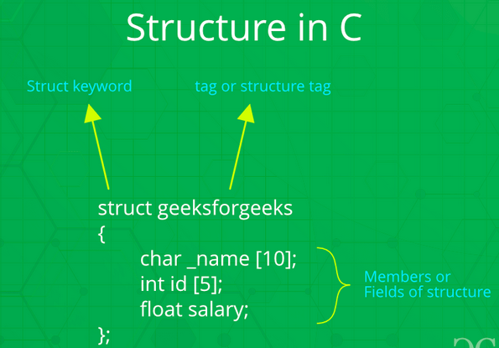
How to create a struct?

Struct struct_name
{
member 1;
member 2;
member 3;
};
an example of struct would be:

struct data_base
{
char name [50];
int id;
float salary;
};

Now here we have defined a data structure “struct data_base “which have three properties char name [50] (this is a string data type), int id (this is an integer data type) and float salary (this is a float data type).

So, we have clubbed three data types to create a new data structure “struct data_base “.

struct data_base

int id
float salary
char name[50]

Here we can see struct data_base have three properties.
let’s see how to access each property individually for this we use (.) dot operator a dot operator is used to access the property or each member of structure.
let’s see an example to make things clearer:
Let’s write a program to store a student record of name roll number and school name.

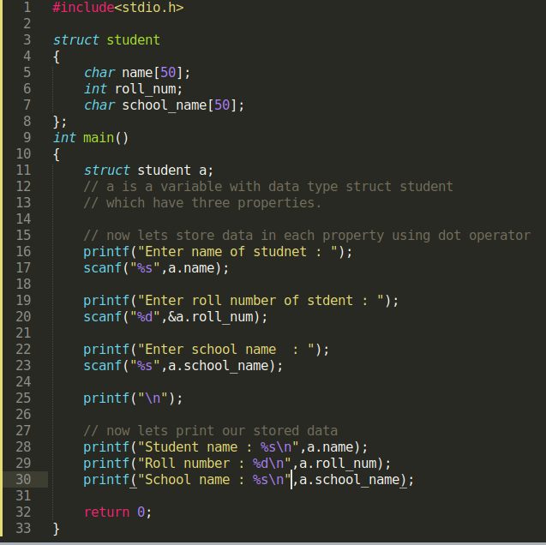

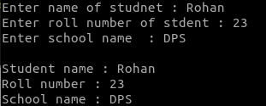

in C we define struct just below header files generally as we have done above.
Then on line 11 we have defined a variable named “a “with data type “struct student “
Now as “a “variable have data type “struct student “so therefore it have three properties now namely name, roll_num and school_name. To access those, we will use dot operator.
As you can see, we have used a. name, &a. roll_num and a. school_name respectively in order to access the memory location of these properties so that we can store data there. Then on line 28-30 we have printed the stored data.

Key points:

1. struct is a user defined data type.
2. struct is defined outside the main function just below header file.
3. dot operator is used to access the properties/members of the struct data type.

Q. Write a program to store employee record of two employees such as name id salary and print it.
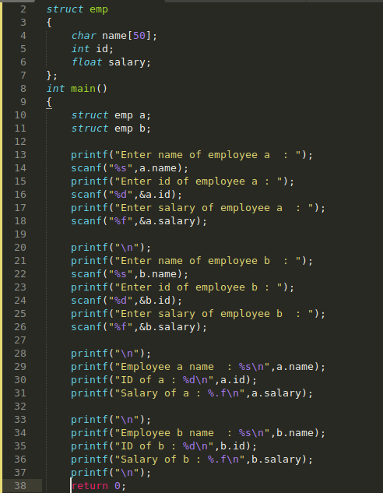
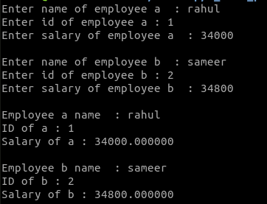

Arrays of struct:

As we can see above to store record of two employees, we have repeated so much code (just replaced the variables names) Now suppose if we wanted to save record of 100 employees or let’s 1000 or 10,000 it will take so much time just to write code for this program.
To overcome this situation, we can make arrays of struct.
let’s see what it is:
int arr [10];
“arr “is an array of size 10 with type int, this means each element in array “arr “will store a value of type integer.

What if we write:
struct emp arr [10];
what does this mean let’s see?
“arr “is an array of size 10 with type “struct emp “, this means each element in “arr “will store a value of type struct emp.

let’s visualise this you will understand it easily:

index | 0 | 1 | 2 | 3 | 4 | 5 | 6 | 7 | 8 | 9
Element’s | arr [0] | arr [1] | arr [2] | arr [3] | arr [4] | arr [5] | arr [6] | arr [7] | arr [8] | arr [9]

Now as we have said earlier each element have a type “struct emp “and as we know struct emp have three properties namely: name, id, and salary.

index | 0 | 1 | 2 | 3 | 4 | 5 | 6 | 7 | 8 | 9
Element’s | arr [0] | arr [1] | arr [2] | arr [3] | arr [4] | arr [5] | arr [6] | arr [7] | arr [8] | arr [9]

Since arr [0] have data type struct so it will have three properties.
Arr [0]
float salary
int id
Char
name[50]

Similarly, for arr [1], arr [2], arr [3] and so on

now if we write this:
arr [0]. name: then by this we mean we are accessing first element of array “arr “(in which each element has data type “struct emp “) and in that first element we are accessing the property of name of the first element arr [0].

Let’s write a program to get a better understanding:

Q. Write a program to store record of 5 students which include name, roll number, branch, gpa.

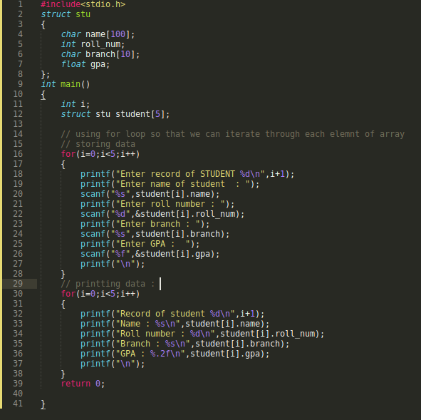

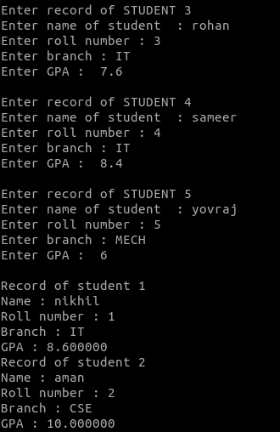

Q. Create an array of student structure to store the roll number name and marks of three subjects. input the details of N students in to array and display roll number name and total marks of each student in decreasing order of total marks.

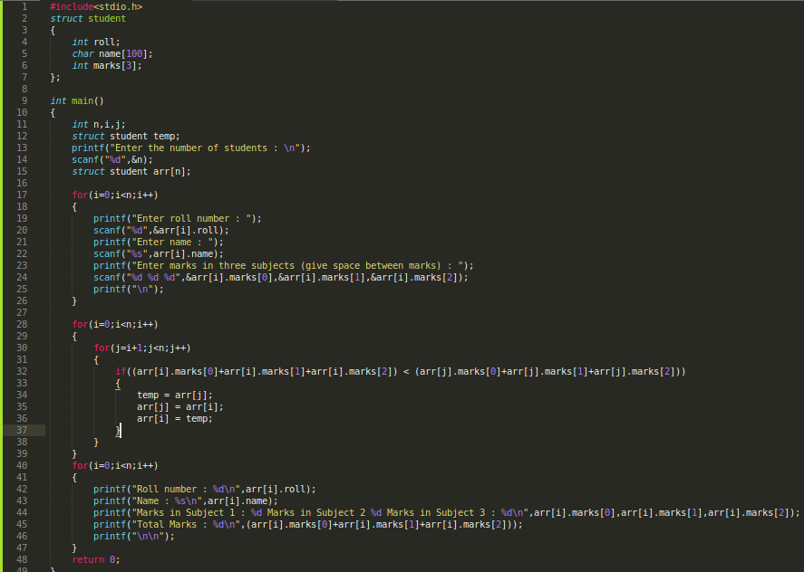
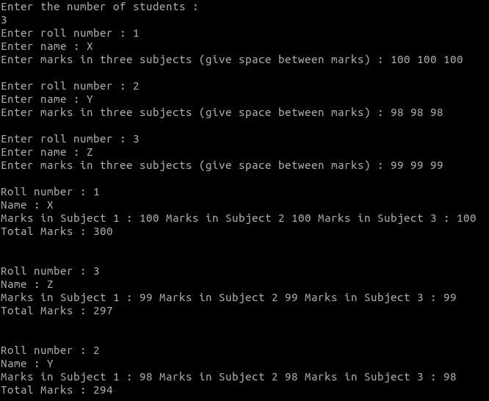

Q. Create an array of employee structure to store emp-no, name, basic salary and hra. input the details of N employee and display emp-no, basic, hra and net salary. Display details of all employees whose net salary is more than average net salary.
Code
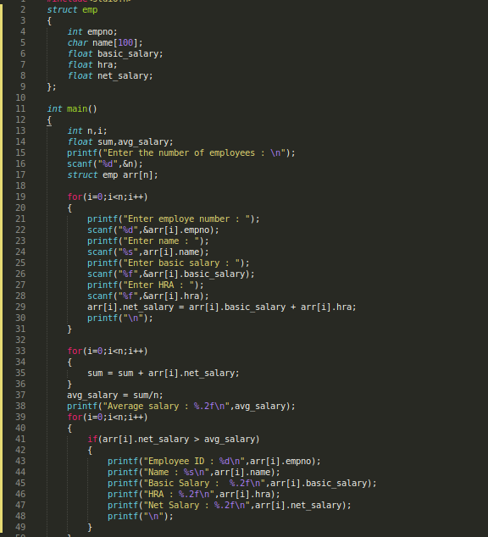

Output
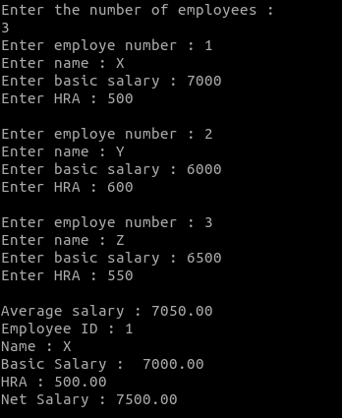

Nested structures
For <b>Example:</b>
struct complex
{
int imag;
float real;
};

struct number
{
struct complex comp;
int integers;
} num1, num2;

Suppose, you want to set imag of num2 variable to 11.here's how you can do it:
num2. comp. imag = 11;

in this way you can deal with nested structures also.

This has led us to the end of Structures.

Now, for practice purpose and illustration we have added 13 Labs below which will help you learn ‘C’ in a structured manner, We Expect you to write down the code for the problems given in the Lab portion, which will also help you in academic preparation.

Lab: - 1
Algorithm’s and Flowchart

Algorithm

a. To write a logical step by step method to solve the problem is called algorithm.
b. An algorithm includes calculations and reasoning.
c. An algorithm can be implemented in more than one programming language.

Characteristics

a. An algorithm should have zero or more defined input.
b. An algorithm should have one or more well defined outputs and it should match the desired output.
c. An algorithm should be written in pseudo-code.

Advantages

a. Easy to write.
b. Algorithm for big programs can be written with moderate efforts.

Disadvantages

a. Difficult to debug.
b. Difficult to show branching and looping.

Flowchart

A flowchart is a graphical representation of an algo with the help of different symbols, shapes and arrows.

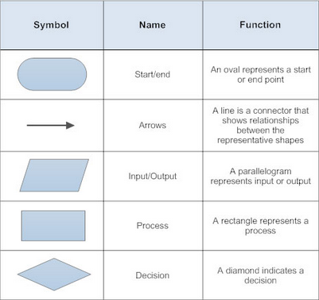

Q. Make a Flowchart to convert Temperature from Fahrenheit to Celsius.
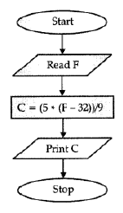

Q. Make a Flowchart to show whether a number is odd or even.

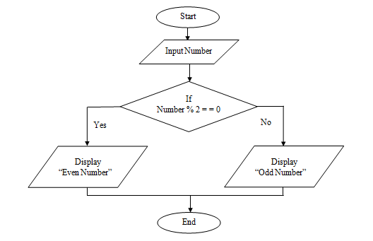

Lab 2
Working with Linux Commands

Linux is the clone of the UNiX Operating System. it has all the features you should expect in a modern Operating System.

Commands

1. pwd — When you first open the terminal, you are in the home directory of your user. To know which directory you are in, you can use the “pwd “command. it gives us the absolute path, which means the path that starts from the root. The root is the base of the Linux file system. it is denoted by a forward slash (/). The user directory is usually something like “/home/username “.

2. ls — Use the “ls “command to know what files are in the directory you are in. You can see all the hidden files by using the command “ls -a “.

3. cd — Use the “cd “command to go to a directory. For example, if you are in the home folder, and you want to go to the downloads folder, then you can type in “cd Downloads “. Remember, this command is case sensitive, and you have to type in the name of the folder exactly as it is. But there is a problem with these commands. imagine you have a folder named “Raspberry Pi “. in this case, when you type in “cd Raspberry Pi “, the shell will take the second argument of the command as a different one, so you will get an error saying that the directory does not exist.here, you can use a backward slash. That is, you can use “cd Raspberry\ Pi “in this case. Spaces are denoted like this: if you just type “cd “and press enter, it takes you to the home directory. To go back from a folder to the folder before that, you can type “cd..” The two dots represent back.

4. mkdir & rmdir — Use the mkdir command when you need to create a folder or a directory. For example, if you want to make a directory called “DiY “, then you can type “mkdir DiY “. Remember, as told before, if you want to create a directory named “DiY Hacking “, then you can type “mkdir DiY\ Hacking “. Use rmdir to delete a directory. But rmdir can only be used to delete an empty directory. To delete a directory containing files, use rm.

5. rm - Use the rm command to delete files and directories. Use “rm -r “to delete just the directory. it deletes both the folder and the files it contains when using only the rm command.

6. touch — The touch command is used to create a file. it can be anything, from an empty txt file to an empty zip file. For example, “touch new. txt “.

7. man & --help — To know more about a command and how to use it, use the man command. it shows the manual pages of the command. For example, “man cd “shows the manual pages of the cd command. Typing in the command name and the argument helps it show which ways the command can be used (e. g., cd –help).

8. cp — Use the cp command to copy files through the command line. it takes two arguments: The first is the location of the file to be copied, the second is where to copy.

9. mv — Use the mv command to move files through the command line. We can also use the mv command to rename a file. For example, if we want to rename the file “text “to “new “, we can use “mv text new “. it takes the two arguments, just like the cp command.

Lab 3
Formula Based C Programs

Q. Program to print “Hello World “.

Code:

#include<stdio.h>

int main ()
{
printf (“Hello World “);

return 0;

}

Explanation: -

#include<stdio.h.h>: - including header file stdio.h (standard input output.h) so that we can use function such as printf and scanf.

int main (): - Calling main function.

printf (): - Using command printf to print a string (in general language a statement) on terminal.

return: - Return is used to “return a value by a function “. it won’t make any difference if we will not use return here. “return 0 “means program has executed successfully.

Q. interchange value of two variable using third variable.

Code:

#include<stdio.h>

int main ()
{
int a = 10 , b = 20;

/* Declaring third variable for interchanging values. *\
int temp_;

temp_ = a;
a = b;
temp_ = b;

return 0;

}

Q. interchange value of two variable without using third variable.

Code:

#include<stdio.h>

int main ()
{
int a = 10, b = 20;

printf (“a: %d b: %d “,a,b);

a = a+b;
b = a-b;
a = a-b;

printf (“a: %d b: %d “,a,b);

return 0;

}

Code Output:

a: 20 b:10

Q. Program to find Distance between two points.

<b>Example:</b>

input:
x1: 78
y1: 98

x2: 90
y2: 100

Output:
Distance between points: 12. 166

Code:

#include<stdio.h>
#include<math.h> // math.h is used for sqrt (square root) function.

int main ()
{
int x ,y;
int x1,x2;
int y1,y2;
float distance;

printf (“Enter value of x1: “);
scanf (“%d “, &x1);

printf (“Enter value of y1: “);
scanf (“%d “, &y1);

printf (“Enter value of x2: “);
scanf (“%d “, &x2);

printf (“Enter value of y2: “);
scanf (“%d “, &y2);

x=x2-x1;
y=y2-y1;

// by using distance formula

distance = sqrt (x*x + y*y);

printf (“Distnace between points is: %. 3f\n “,distance); //. 3f is used to show values up to 3rd decimal.

return 0;
}

Code Output:

Enter value of x1:298
Enter value of y1:3456
Enter value of x2:789
Enter value of y2:567
Distnace between points is: 538. 855

Q. Program to find out area of circle.

<b>Example:</b>

input:
Radius 5

Output:
Area 157. 080

Code:

#include<stdioh.h>

int main ()
{
float radius;
float area_;

printf (“Enter radius of circle: “);
scanf (“%f “, &radius);

area_ = (3. 14 * radius * radius);

printf (“Area of Circle is: %. 4f\n “,area_);

return 0;
}

Code Output:

Enter radius of circle: 1234. 876
Area of Circle is: 4788244. 5000

Q. Write a program to convert a given time (in seconds) to hours, minutes and seconds.

Exapmle:

input:
Seconds: 8450

Output:
Hours: 2
Minutes: 20
Seconds: 50

Code:

#include<stdio.h>

int main ()
{
int sec,minute_,hour_,sec_;
printf (“Enter time in seconds: “);
scanf (“%d “, &sec);

hour_ = (sec/3600);

minute_ = (sec - (3600*hour_))/60;

sec_ = (sec - (3600*hour_)- (minute_*60));

printf (“Hour: %d Minutes: %d Seconds: %d “,hour_,minute_,sec_);
return 0;
}

Code Output:

Enter time in seconds: 45678
Hour: 12 Minutes: 41 Seconds: 18

Q. Write a program to find sum of four digit sum.

<b>Example:</b>

input:
123

Output:
6

Code:

#include<stdio.h>

int main ()
{
int num,first_digit,second_digit,third_digit;

printf (“Enter a three digit number: “);
scanf (“%d “, &num); // let number entered ne 123

first_digit = num/100;

// (123 / 100) this will retun 1 since we are using int data type.

second_digit = (num - (first_digit * 100))/10;

// (123 - 100) / 10 = 2. 3 since using int will retrun 2.

third_digit = (num - (first_digit * 100) - (second_digit * 10));

printf (“Sum of a three digit numbers is: %d “,first_digit+second_digit+third_digit);
return 0;

}

Code Output:

Enter a three digit number: 346
Sum of a three digit numbers is: 13

Q. Program to convert temperature from degree Celsius to Kelvin

<b>Example:</b>

input:
Celsius: 00

Output:
Kelvin: 34

Code:
#include<stdio.h>

int main ()
{
float celsius_,far_;

printf (“Enter Temprature in Celsius: “);
scanf (“%f “, &celsius_);

far_ = (celsius_ * 9 / 5) + 32;

printf (“Temperature in Celsius: %. 3f \n “,celsius_);
printf (“Temperature in Fahrenheit: %. 3f \n “,far_);

return 0;
}

Code Output:

Enter Temperature in Celsius: 34
Temperature in Celsius: 34. 000
Temperature in Fahrenheit: 93. 200

Lab 4
Control Structures Branching

Q. Write a program to check whether a number is odd or even.

<b>Example:</b>

input:
456
Output:
Even

Code:

#include<stdio.h>

int main ()
{
int num_;

printf (“Enter a number to check odd or even: “);
scanf (“%d “, &num_);

if (num_% 2 == 0)
{
printf (“Number is Even “);
}

else
{
printf (“Number is Odd “);
}
}

Code Output:

Enter a number to check odd or even: 567
Number is Odd

Q. Write a program to find absolute value of an integer.

<b>Example:</b>

input:
-67

Output:
67

Code:

#include<stdio.h>

int main ()
{
int integer_;

printf (“Enter an integer: “);
scanf (“%d “, &integer_);

if (integer_ > 0)
{
printf (“Absolute value of an integer is: %d “, integer_);
}

else
{
printf (“Absolute value of an integer is: %d “, (-1*integer_));
}
}

Code Output:

Enter an integer: -65
Absolute value of an integer is: 65

Q. Write a program to check whether a year is leap year or not.

<b>Example:</b>

input:
2019

Output:
Not a Leap Year

Code:

#include<stdio.h>

int main ()
{
int year_;

printf (“Enter a year to check whether a number is leap year or not: “);
scanf (“%d “, &year_);

if (year_ % 400 == 0)
{
printf (“Entered Year is a Leap Year “);
}

else if (year_ % 100 == 0)
{
printf (“Entered year is a leap year “);
}

else if (year_ % 4 == 0)
{
printf (“Entered year is a leap year “);
}
else
{
printf (“Entered year is not a leap year “);
}

return 0;

}

Code Output:

Enter a year to check whether a number is leap year or not: 2020
Entered year is a leap year

Q. Write a program to calculate amount of bill using following criteria.

Unit Charge Per Unit (RS)
1-100 1
101-200 1. 5
201-400 2. 5
401 onwards 3. 5

<b>Example:</b>

input:
Unit consumed 234

Output:
Bill 585

Code:

#include <stdio.h>

int main ()
{

float unit;

printf (“Enter units consumed\n “);
scanf (“%f “, &unit);

if (unit => 1 && unit <= 100)
{
printf (“Bill is %. 3f “, unit*1);
}

else if (unit =>101 && unit <= 200)
{
printf (“Bill is %. 3f “, unit*1. 5);
}

else if (unit => 201 && unit <= 400)
{
printf (“Bill is %. 3f “, unit*2. 5);
}

else
{
printf (“Bill is %. 3f “, unit*3. 5);
}

return 0;

}

Code Output:

Enter units consumed
457
Bill is 1599. 500

Q. Calculate amount of bill using following criteria.

Calls Charge Per Call (RS)
1-150 0
151-250 . 9
251-400 1. 2
401 onwards 1. 5

<b>Example:</b>

input:
Calls: 160

Output:
Bill: 144

Code:

#include <stdio.h>

int main ()
{

float call;

printf (“Enter number of calls\n “);
scanf (“%f “, &call);

if (call >= 1 && call <= 150)
{
printf (“Bill is %. 3f “, call*0);
}

else if (call >= 151 && call <= 250)
{
printf (“Bill is %. 3f “, call* (0. 9));

}
else if (call >= 251 && call <= 400)
{
printf (“Bill is %. 3f “, call*1. 2);
}

else
{
printf (“Bill is %. 3f “, call*1. 5);
}

return 0;

}

Code Output:

Enter number of calls
260
Bill is 312. 000

Lab 5
Branching

Q. Write a program to find roots of quadratic equation using switch statement.

<b>Example:</b>

input:
a = 2
b = 4
c = 2

Output:
Root 1: -1
Root 2: -1

Code:

#include<stdio.h>
#include<math.h>

int main ()
{
float a, b;
float root1, root2;
float discriminant_;
float root1_real, root2_real, imaginary;

printf (“Enter values of a, b, c in a quadratic equation \n “);
scanf (“%f %f %f “, &a, &b, &c);

discriminant_ = (b*b - 4*a*c);

switch (discriminant_ > 0)
{
case 1:
root1 = (-b + sqrt (discriminant_)) / (2*a);
root2 = (-b - sqrt (discriminant_)) / (2*a);

printf (“Two Real roots exist \n Root 1: %. 3f \n Root 2: %. 3f \ n “, root1, root2);

break;

case 0:

switch (discriminant_ < 0)
{

case 1:

root1_real = (-b) / (2*a);
root2_real = (-b) / (2*a);
imaginary = sqrt (-discriminant_)/ (2*a);

printf (“Two complex roots \n Root 1: %. 3f + %. 3fi \n Root 2: %. 3f + %. 3fi \n “, root1_real, imaginary, root2_real, imaginary);

break;

case 0: // This case is valid when D == 0

root1 = root2 = (-b)/ (2*a);

printf (“Root 1: %. 3f \n Root 2: %. 3f “,root1,root2);

break;
}
}
}

Explanation:

Switch: Switch statement is very similar to if else. in switch statment we provide an expression to switch which will evaluate to any numerical value. Then according to that value it will evaluate which case should execute. if you will not use “break “after a case then all the case’s will execute after that case.

Here in this program we are checking discriminant for two different cases.
if Discriminant > 0 then we will get integer 1 as output.
if Discriminant < 0 then we will get integer 0 as output.

in a computer program a true condition evaluates to 1 and a false condition evaluate to 0.

Now after checking for different values for discriminant we have different cases so that we can compute roots of equation using the formula.

Code Output:

Enter values of a, b, c in a quadratic equation
45 34 89
Two complex roots
Root 1: -0. 378 + 1. 355i
Root 2: -0. 378 + 1. 355i

Q. Write a program to find number of days in a particular month.

<b>Example:</b>

input:
5

Output:
31

Code:

#include <stdio.h>

int main ()
{
int month;

printf (“Enter month number 1-12: “);
scanf (“%d “, &month);

switch (month)
{
case 1:
printf (“January have 31 Days “);
break;

case 2:
printf (“February have 28 or 29 Days “);
break;

case 3:
printf (“March have 31 Days “);
break;

case 4:
printf (“April have 30 Days “);
break;

case 5:
printf (“May have 31 Days “);
break;

case 6:
printf (“June have 30 Days “);
break;

case 7:
printf (“July have 31 Days “);
break;

case 8:
printf (“August have 31 Days “);
break;

case 9:
printf (“September have 30 Days “);
break;

case 10:
printf (“October have 31 Days “);
break;

case 11:
printf (“November have 30 Days “);
break;

case 12:
printf (“December have 31 Days “);
break;
}

return 0;
}

Code Output;

Enter month number 1-12: 10
October have 31 Days

<b>Note:</b> We can also do this program with the help of if else if statements.

Q. Write a program to find total number of days for a given number of months counting from January.

<b>Example:</b>

input:
5

Output:
Total Days: 151

Code:

#include <stdio.h>

int main ()
{
int month;

printf (“Enter month number 1-12: “);
scanf (“%d “, &month);

if (month == 1)
{
printf (“31 days “);
}
else if (month == 2)
{
printf (“%d “,28+31);
}
else if (month == 3)
{
printf (“%d “,28+31+31);
}
else if (month == 4)
{
printf (“%d “,28+31+31+30);
}
else if (month == 5)
{
printf (“%d “,28+31+31+30+31);
}
else if (month == 6)
{
printf (“%d “,28+31+31+30+31+30);
}
else if (month == 7)
{
printf (“%d “,28+31+31+30+31+30+31);
}
else if (month == 8)
{
printf (“%d “,28+31+31+30+31+30+31+31);
}
else if (month == 9)
{
printf (“%d “,28+31+31+30+31+30+31+31+30);
}
else if (month == 10)
{
printf (“%d “,28+31+31+30+31+30+31+31+30+31);
}
else if (month == 11)
{
printf (“%d “,28+31+31+30+31+30+31+31+30+31+30);
}
else if (month == 12)
{
printf (“%d “,28+31+31+30+31+30+31+31+30+31+30+31);
}
else
{
printf (“Please enter month number between 1-12 “);
}

}

Code Output:

Enter month number 1-12: 6
181
<b>Note:</b> We are not considering leap year here. Which can also be done by adding 1 to total number of days but after January only.

Lab 6
Looping

Q. Write a program to generate multiplication table of a number up to k terms.

<b>Example:</b>

input:
Table of 2
Up to 8

Output:
2
4
6
8
10
12
14
16

Code:

#include<stdio.h>

int main ()
{
int num_, up to_;
int i;

printf (“Enter number for which you want multiplication table: “);
scanf (“%d “, &num_);

printf (“Enter the digit up to which you want table: “);
scanf (“%d “, &up to_);

for (i = 0; i <= up to; i++)
{
printf (“%d * %d = %d \n “, num, i, (num_*i));
}

return 0;

}

Code Output:

Enter number for which you want multiplication table: 4
Enter the digit up to which you want table: 10
4 * 0 = 0
4 * 1 = 4
4 * 2 = 8
4 * 3 = 12
4 * 4 = 16
4 * 5 = 20
4 * 6 = 24
4 * 7 = 28
4 * 8 = 32
4 * 9 = 36
4 * 10 = 40

Q. Write a program to Display Prime Numbers Between Two intervals.

<b>Example:</b>

input:
2 20

Output:
2
3
5
7
11
13
17
19

Code:

#include<stdio.h>

int main ()
{

int a, b, i, true_;

printf (“Enter range: “);
scanf (“%d %d “, &a, &b);

printf (“Prime numbers between %d --- %d is: \n “, a, b);

while (a <= b)
{
true_ = 0;

for (i = 2; i <= a/2; i++)
{
if (a % i == 0)
{
true_ = 1;
break;
}
}

if (true_ == 0)
printf (“%d \n “, a);

a++;
}

}

Code Output:

Enter range: 456 789
Prime numbers between 456 --- 789 are:
457
461
463
467
479
487
491
499
503
509
521
523
541
547
557
563
569
571
577
587
593
599
601
607
613
617
619
631
641
643
647
653
659
661
673
677
683
691
701
709
719
727
733
739
743
751
757
761
769
773
787

Q. Write a program to convert the given Binary Number into Decimal Number.

<b>Example:</b>

input:
Binary: 101

Output:
Decimal: 5

Code:

#include<stdio.h>

int main ()
{
int num_, binary_value, decimal_value = 0, base_ = 1, rem_;

printf (“Enter a binary number \n “);
scanf (“%d “, &num_);

binary_value = num_;

while (num_ > 0)
{
rem_ = num_ % 10;
decimal_value = decimal_value + rem_ * base_;
num_ = num_ / 10;
base_ = base_ * 2;
}

printf (“binary number: %d \n “, binary_value);
printf (“decimal: %d \n “, decimal_value);

}

Code Output:
Enter a binary number
1001
binary number: 1001
decimal: 9

Q. Write a program to reverse a number.

<b>Example:</b>

input:
235

Output:
532

Code:

#include <stdio.h>
int main ()

{
int number_, reverse_number = 0;

printf (“Enter a number to reverse \n “);
scanf (“%d “, &number_);

while (number_! = 0)
{
reverse_number = reverse_number * 10;
reverse_number = reverse_number + number_ % 10;
number_ = number_ / 10;
}

printf (“reverse number is: %d “, reverse_number);

}

Code Output:
Enter a number to reverse
38508
reverse number is: 80583

Q. Write a program to find the sum of n terms of Sine X series.

Example

input

Enter the value for x: 30
Enter the value for n: 4

Output

The value of Sin (0. 523598) = 0. 50
Code

#include<stdio.h>
int main ()
{
int i, n;
float x, sum, t;

printf (“Enter the value for x: “);
scanf (“%f “, &x);

printf (“Enter the value for n: “);
scanf (“%d “, &n);

x=x*3. 14159/180;
t=x;
sum=x;

for (i=1; i<=n;i++)
{
t= (t* (-1) *x*x)/ (2*i* (2*i+1));
sum=sum+t;
}

printf (“The value of Sin (%f) = %. 2f “, x, sum);
}

Code Output

Enter the value for x: 50
Enter the value for n: 6
The value of Sin (0. 872664) = 0. 77

Lab 7
Looping

Q. Write a program for checking if a number is palindrome number.

<b>Example:</b>

input:
174898471

Output:
Yes, entered number is a palindrome number

Code:

#include <stdio.h>
int main ()
{
int n, reverse_n = 0, original_n;
int x;

printf (“Enter an integer: “);
scanf (“%d “, &n);

original_n = n;

while (n!=0)
{
x = n%10;
reverse_n = reverse_n*10 + x;
n = n / 10;
}

if (original_n == reverse_n)
printf (“it is a palindrome. “);
else
printf (“Not a palindrome. “);

return 0;
}

Code Output:

Enter an integer: 9743578753474# #9
Not a palindrome.

Q. Write a program to find HCF and LCM.

<b>Example:</b>

input:
Number 1: 23
Number 2: 17

Output:
HCF: 1
LCM: 391

Code:

// Applying Euclid's Algorithm to obtain GCD of two numbers
// if larger number is replaced by difference of larger number and smaller number then their gcd doesn’t change
// continue this process till both numbers becomes equal eventually giving GCD

#include<stdio.h>

int main ()
{
int a, b;

printf (“Enter number 1: “);
scanf (“%d “, &a);
int x = a;

printf (“Enter number 2: “);
scanf (“%d “, &b);
int y = b;

while (a! = b)
{
if (a>b)
{
a = a - b;
}
else
{
b = b - a;
}
}
printf (“HCF of two numbers is %d \n “, a);

// using formula LCM * HCF = a*b

int lcm = (x*y) / a;

printf (“LCM of two numbers is: %d “, lcm);

}

Code Output:

Enter number 1: 5
Enter number 2: 10
HCF of two numbers is 5
LCM of two numbers is: 10

Q. Write a program to Convert Octal Number to Decimal

<b>Example:</b>

input:
1732

Output:
986

Code:

#include <stdio.h>
#include <math.h>

int main ()
{
int octal, decimal, i=0;

printf (“Enter number in octal: “);
scanf (“%d “, &octal);

while (octal! = 0)
{
decimal = decimal + (octal%10) * pow (8, i);
octal = octal/10;
i++;
}

printf (“Number in decimal: %d “, decimal);
}

Code Output:

Enter number in octal: 637214
Number in decimal: 212620

Lab 8
1 D Array

Q. Program to Find Largest and Smallest Element in Array.

Example

input

Array Elements: 1, 2, 4, 6

Output

Max 6
Min 1

Code

#include<stdio.h>

int
main ()
{

int a [100], i, n, l, s;

printf (“Number of Elements: “);
scanf (“%d “, &n);

printf (“Enter elements: “);

for (i = 0; i < n; ++i)
{
scanf (“%d “, &a[i]);
}

l = a [0];
s = a [0];

for (i = 1; i < n; ++i)
{
if (a[i] > l)
{
l = a[i];
}

if (a[i] < s)
{
s = a[i];
}
}

printf (“largest element %d \n “, l);
printf (“smallest element %d “, s);

}

Code Output

Number of Elements: 5
Enter elements: 1 2 3 4 5
largest element 5
smallest element 1

Q. Program to reverse an array.

Example
input
input array elements: 1, 2, 65, 35
Output
Array elements after reverse: 35, 65, 2, 1
Code

#include <stdio.h>

int
main ()
{
int arr [1000];
int rev_arr [1000];
int size, i;

printf (“Enter size of the array: “);
scanf (“%d “, &size);

printf (“Enter elements in array: “);
for (i = 0; i < size; i++)
{
scanf (“%d “, &arr [i]);
}

int j = 0;

for (i = size - 1; i >= 0; i--)
{
rev_arr [j] = arr [i];
j++;
}

for (i = 0; i < size; i++)
{
arr [i] = rev_arr [i];
}

printf (“Array in reverse order: “);
for (i = 0; i < size; i++)
{
printf (“%d “, arr [i]);
}

}

Code Output

Enter size of the array: 4
Enter elements in array: 3 6 5 9
Array in reverse order: 9 5 6 3

Q. Program to delete an element from an array.

Example

input

Array: 1, 43, 65, 57, 6
Position of number to delete: 3

Output

Array after del: 1, 43, 57, 6

Code

#include<stdio.h>

int
main ()
{
int a [10000];
int i, size, position;

printf (“Enter size of an array: “);
scanf (“%d “, &size);

printf (“Enter elements of array: “);
for (i = 0; i < size; i++)
{
scanf (“%d “, &a[i]);
}

printf (“Enter position of element to del: “);
scanf (“%d “, &position);

if (position > size)
{
printf (“please enter valid position “);
}
else
{
// copying next element of position to position's index.

for (i = position - 1; i < size - 1; i++)
{
a[i] = a [i + 1];
}
size--;
}

printf (“array after del of particular element is: “);
for (i = 0; i < size; i++)
{
printf (“%d “, a[i]);
}

}

Code Output

Enter size of an array: 5
Enter elements of array: 1 2 5 7 9
Enter position of element to del: 4
array after del of particulate element is: 1 2 5 9

Q. Program to insert an element in an array.

Example

input

Array: 23, 45, 67, 87, 90
Number to insert: 34
Position: 2

Output

Array after insertion: 23, 34, 45, 67, 87, 90

Code

#include<stdio.h>

int
main ()
{
int a [10000];
int i, size, position, number;

printf (“Enter size of an array: “);
scanf (“%d “, &size);

printf (“Enter elements of array: “);
for (i = 0; i < size; i++)
{
scanf (“%d “, &a[i]);
}

printf (“Enter element to insert: “);
scanf (“%d “, &number);

printf (“Enter element position: “);
scanf (“%d “, &position);

if (position > size + 1)
{
printf (“Please enter valid position “);
}

else
{
// shifting each element to a right index by copying it to that i+1 index number

for (i = size; i >= position; i--)
{
a[i] = a [i - 1];
}
}

size++;
a [position - 1] = number;

printf (“Array after insertion: “);
for (i = 0; i < size; i++)
{
printf (“%d\t “, a[i]);
}

}

Code Output

Enter size of an array: 6
Enter elements of array: 43 78 98 42 67 23
Enter element to insert: 70
Enter element position: 2
Array after insertion: 43 70 78 98 42 67 23

Q. Program to Sort the Array in an Ascending Order

Example

input

Array: 12, 78, 56, 34

Output

Array in ascending order: 12, 34, 56, 78

Code

#include<stdio.h>

int
main ()
{
int a [1000];
int size, i, j, t;

printf (“Enter size of an array: “);
scanf (“%d “, &size);

printf (“Enter elements of array: “);
for (i = 0; i < size; i++)
{
scanf (“%d “, &a[i]);
}

// fixing one element

for (i = 0; i < size; i++)
{
// comparing each element with another of the array

for (j = i + 1; j < size; j++)
{
if (a[i] > a[j])
{
// swapping array values

t = a[i];
a[i] = a[j];
a[j] = t;
}
}
}
printf (“array in ascending order: “);
for (i = 0; i < size; i++)
{
printf (“%d “, a[i]);
}
}

Code Output

Enter size of an array: 4
Enter elements of array: 67 34 56 92
array in ascending order: 34 56 67 92

Q. Program to insert element in a sorted manner.

Example

input

Array: 1, 2, 3, 34, 56
Number to be inserted: 23

Output

Array: 1, 2, 3, 23, 34, 56

Code

#include<stdio.h>

int
main ()
{
int a [1000];
int size, i, j, t;

printf (“Enter size of an array: “);
scanf (“%d “, &size);

printf (“Enter elements of array: “);
for (i = 0; i < size; i++)
{
scanf (“%d “, &a[i]);
}

printf (“Enter number to be inserted: “);
scanf (“%d “, &a[size]);

// arranging array in ascending order now

for (i = 0; i < size + 1; i++)
{
for (j = i + 1; j < size + 1; j++)
{
if (a[i] > a[j])
{
t = a[i];
a[i] = a[j];
a[j] = t;
}
}
}
printf (“array in ascending order: “);
for (i = 0; i < size; i++)
{
printf (“%d “, a[i]);
}
}

Code Output

Enter size of an array: 5
Enter elements of array: 12 43 56 78 87
Enter number to be inserted: 23
array in ascending order: 12 23 43 56 78 87

LAB 9
2 D Array

Q. Program to Multiply two matrices.

Example

input

Matrices A: 1 2
3 4

Matrices B: 2 0
1 2

Output

Multiplication Matrices: 4 4
10 8

Logic

First step is to take input from user. For taking input we will ask number or rows and columns from user then will create two nested loops one for fixing rows and second for looping around columns.

Second step is to multiply both matrices that we have taken as an input for this we should know how to do matrices multiplication. Below image show the process to multiply two matrices

Refer comments in program to go through logic

Third step is to store final matrices and show its elements

Code

#include <stdio.h>

int
main ()
{
int m, n, p, q, x, y, k, sum = 0;
int first_matrices [100][100], second_matrices [100][100],
multiply_matrices [100][100];

// taking first matrices input

printf (“Enter number of rows and columns of first matrices: “);
scanf (“%d %d “, &m, &n);
printf (“Enter elements of first matrices: “);

for (x = 0; x < m; x++)
{
for (y = 0; y < n; y++)
{
scanf (“%d “, &first_matrices[x][y]);
}
}

// taking second matrices as input

printf (“Enter number of rows and columns of second matrices: “);
scanf (“%d %d “, &p, &q);

// checking if matrices is valid or not

if (n! = p)
printf (“The matrices will not be multiplied “);
else
{
printf (“Enter elements of second matrices: “);

for (x = 0; x < p; x++)
{
for (y = 0; y < q; y++)
{
scanf (“%d “, &second_matrices[x][y]);
}
}

// multiplying matrices
// here what we are doing is we are multiplying first row of first matrices to first column of second matrices
// to go to first row first matrices, we can fix the row and loop around column and for
// second matrices column we can fix column index and loop around row
// sum each corresponding multiplication and sum them in the end of the process again make sum == 0

for (x = 0; x < m; x++)
{
for (y = 0; y < q; y++)
{
for (k = 0; k < p; k++)
{
sum = sum + first_matrices[x][k] * second_matrices[k][y];
}

multiply_matrices[x][y] = sum;
sum = 0;
}
}

printf (“Product of matrices: “);

for (x = 0; x < m; x++)
{
for (y = 0; y < q; y++)
printf (“%d “, multiply_matrices[x][y]);

printf (“\n “);
}
}

}

Code Output:

Enter number of rows and columns of first matrices: 2 2
Enter elements of first matrices: 1 2 3 4
Enter number of rows and columns of second matrices: 2 2
Enter elements of second matrices: 2 0 1 2
Product of the matrices:
4 4
10 8

Q. Find the Sum of each Row & each Column of a MxN Matrices.

Example

input

Array: 4 4
10 8
Output

Row 1 sum: 8
Row 2 sum: 18
Column 1 sum: 14
Column 2 sum: 12

Logic

For Row sum: -Fix one row iterates through columns to get the element of the row and sum them.

For Column sum: - Fix one column iterates through row to get the elements of the column and sum them.

Code

#include <stdio.h>

int
main ()
{
int array [100][100];
int r, c, m, n, sum = 0;

printf (“Enter row and column of matrices \n “);
scanf (“%d %d “, &m, &n);

printf (“Enter elements of the matrices \n “);

for (r = 0; r < m; ++r)
{
for (c = 0; c < n; ++c)
{
scanf (“%d “, &array[r][c]);
}
}

for (r = 0; r < m; ++r)
{
for (c = 0; c < n; ++c)
{
sum = sum + array[r][c];
}
printf (“Sum of %d row is: %d \n “, r, sum);
sum = 0;
}

sum = 0;

for (c = 0; c < n; ++c)
{
for (r = 0; r < m; ++r)
{

sum = sum + array[r][c];
}
printf (“Sum of %d column: %d \n “, c, sum);
sum = 0;
}
}

Code Output

Enter row and column of matrices
2 2
Enter elements of the matrices
1 2 3 4
Sum of 0 row is: 3
Sum of 1 row is: 7
Sum of 0 column: 4
Sum of 1 column: 6

Q. Program to find trace and norm of a given matrix.

Example

input

Array: 12 34
56 78

Output

Trace: 90
Normal: 102

Code

#include<stdio.h>
#include<math.h>

int
main ()
{
int a [100][100];
int i, j, m, n, sum = 0, sum_ = 0, square = 0, normal;

printf (“Enter rows and column of matrices: “);
scanf (“%d %d “, &m, &n);

printf (“Enter elements of matrices: “);

for (i = 0; i < m; i++)
{
for (j = 0; j < n; j++)
{
scanf (“%d “, &a[i][j]);

square = a[i][j] * a[i][j];

sum_ = sum_ + square;

}
}

normal = sqrt (sum_);

printf (“Normal: %d “, normal);

for (i = 0; i < m; i++)
{
sum = sum + a[i][i];
}

printf (“Trace: %d “, sum);
}

Code Output

Enter rows and column of matrices: 2 2
Enter elements of matrices: 12 34 56 78
Normal: 102 Trace: 90

Q. Program to find occurrence of an element in array.

Example

input

Array: 1,2,2,4
Number to find: 2

Output

2 occurs 2 time in array

Code

#include <stdio.h>
int
main ()
{
int a [1000], size, i, number, count;

printf (“Enter number of elements in array: “);
scanf (“%d “, &size);

printf (“Enter array elements: “);
for (i = 0; i < size; ++i)
{
scanf (“%d “, &a[i]);
}

printf (“Enter number to find Occurrence: “);
scanf (“%d “, &number);

count = 0;
for (i = 0; i < size; i++)
{
if (a[i] == number)
count++;
}
printf (“Count of %d is: %d “, number, count);
}

Code Output

Enter number of elements in array: 4
Enter array elements: 1 2 2 2
Enter number to find Occurrence: 2
Count of 2 is: 3

Q. Write a program to check if a matrix is symmetric or not.

Example

input

Enter number of rows and columns: 2 2
1
2
2
1

Output

Matrices are symmetric

Code
#include<stdio.h>
int main ()
{
int m, n, c, d, matrices [10][10], transpose [10][10];

printf (“Enter the number of rows and columns of matrices\n “);
scanf (“%d%d “, &m, &n);
printf (“Enter elements of the matrices\n “);

for (c = 0; c < m; c++)
for (d = 0; d < n; d++)
scanf (“%d “, &matrices[c][d]);

for (c = 0; c < m; c++)
for (d = 0; d < n; d++)
transpose[d][c] = matrices[c][d];

if (m == n) // check if order is same
{
for (c = 0; c < m; c++)
{
for (d = 0; d < m; d++)
{
if (matrices[c][d] != transpose[c][d])
break;
}
if (d != m)
break;
}
if (c == m)
printf (“The matrices are symmetric. \n “);
else
printf (“The matrices are not symmetric. \n “);
}
else
printf (“The matrices are not symmetric. \n “);

return 0;
}

Output

Enter the number of rows and columns of matrices
2 2
Enter elements of the matrices
1
2
2
1
The matrices are symmetric.

Q. Write a program to check if a matrix is magic square or not

Example

input

4 9 2
3 5 7
8 1 6

Output

Magic Square

Code
#include<stdio.h>
#include<conio.h>

int main () {
int size = 3;
int matrices [3][3]; // = {{4,9,2}, {3,5,7}, {8,1,6}};
int row, column = 0;
int sum, sum1, sum2;
int flag = 0;

printf (“\nEnter matrices: “);
for (row = 0; row < size; row++) {
for (column = 0; column < size; column++)
scanf (“%d “, &matrices[row][column]);
}

printf (“Entered matrices is: \n “);
for (row = 0; row < size; row++) {
printf (“\n “);
for (column = 0; column < size; column++) {
printf (“\t%d “, matrices[row][column]);
}
}

//For diagonal elements
sum = 0;
for (row = 0; row < size; row++) {
for (column = 0; column < size; column++) {
if (row == column)
sum = sum + matrices[row][column];
}
}

//For Rows
for (row = 0; row < size; row++) {
sum1 = 0;
for (column = 0; column < size; column++) {
sum1 = sum1 + matrices[row][column];
}
if (sum == sum1)
flag = 1;
else {
flag = 0;
break;
}
}

//For Columns
for (row = 0; row < size; row++) {
sum2 = 0;
for (column = 0; column < size; column++) {
sum2 = sum2 + matrices[column][row];
}
if (sum == sum2)
flag = 1;
else {
flag = 0;
break;
}
}

if (flag == 1)
printf (“\nMagic square “);
else
printf (“\nNo Magic square “);

return 0;
}

Code Output

Enter matrices: 4 9 2 3 5 7 8 1 6
Entered matrices is:

4 9 2
3 5 7
8 1 6
Magic square

Lab 10
Strings

Q. Program to Count Number of Words in a given Text or Sentence

Example

input

Sentence: My name is Nikhil Jain

Output

Words: 4

Logic

if we have a white space in a string then we have just finished a word.

Code

#include <stdio.h>

int main ()
{
char str [100];
int i, words;

printf (“Enter any string: “);
gets (str);

i = 0;
words = 1;

while (str[i] != '\0')
{

if (str[i]==' ' || str[i]=='\n' || str[i]=='\t')
{
words++;
}

i++;
}

printf (“number of words: %d “, words);
}

Code Output

Enter any string: my name is nikhil jain
number of words: 5

<b>Note:</b> gets is used instead of scanf because scanf read till \n or white space is encountered while gets consider white space as a part of string.

Q. Change all lowercase letter into upper case in a sentence.

Example

input

String: Nikhil

Output

String: NiKHiL

Logic

Each lowercase letter and its equivalent uppercase letter have difference of 32 between them in ASCii code.

Code

#include<stdio.h>

int main ()
{
char str[1000];
int i=0;

printf (“Enter the string: “);
scanf (“%s “, str);

while (str[i]! ='\0')
{
if (str[i]>='a' && str[i]<='z')
{
str[i] = str[i]-32;
}

i++;
}

printf (“string in uppercase is %s “, str);

}

Code Output

Enter the string: Nikhil
string in uppercase is NiKHiL

Q. Program to Reverse a String.

Example

input

String: Man

Output

Reverse String: naM

Logic

Start from swapping first value to last continue do so till we reach to the middle.

Code

#include<stdio.h>
#include<string.h>

int main ()
{

char str [100], t;
int i, j = 0;

printf (“Enter the string: “);
gets (str);

i = 0;
j = strlen (str) - 1;

while (i < j)
{
t = str[i];
str[i] = str[j];
str[j] = t;
i++;
j--;
}

printf (“Reverse string: %s “, str);

}

Code Output

Enter the string: You know nothing Jon Snow
Reverse string: wonS noJ gnihton wonk uoY

Q. Program to check if a given string is palindrome or not.

Example

input

String: MAM

Output:

Yes, it is a palindrome

Logic

if reverse of string is equal to the original string then it is a palindrome.

Code

#include <stdio.h>
#include <string.h>
int main ()
{
char string [25], rstring [25] = {'\0'};
int i, len = 0, flag = 0;
printf (“Enter a string \n “);
scanf (“%s “, string);
for (i = 0; string[i]! = '\0'; i++)
{
len++;
}
printf (“The length of the string '%s' = %d\n “, string, len);
for (i = len - 1; i >= 0; i--)
{
rstring [len - i - 1] = string[i];
}
for (flag = 1, i = 0; i < len; i++)
{
if (rstring[i]! = string[i])
flag = 0;
}
if (flag == 1)
printf (“%s is a palindrome \n “, string);
else
printf (“%s is not a palindrome \n “, string);
}

Code Output

Enter a string to check if it is a palindrome
MAM
Palindrome

Q. Program to concatenate two strings without using strcat

Example

input

String 1: Nikhil
String 2: Jain

Output

NikhilJain

Logic

Take a variable to last index of string 1 (before ‘\0’) now make another variable starting from index 0 of string 2 now copy value of string 2 to string 1 by incrementing both variables.

Code

#include<stdio.h>
#include<string.h>

int main ()
{
char firstString [100], secondString [100];
int i, j;

printf (“Enter your first string: “);
gets (firstString);

printf (“Enter your second string: “);
gets (secondString);

i = 0;

while (firstString[i]! = '\0')
{
i++;
}

j = 0;

while (secondString[j]! = '\0')
{
firstString[i] = secondString[j];
i++;
j++;
}

firstString[i] = '\0';

printf (“Final String: %s\n “, firstString);

}

Code Output

Enter your first string: Nikhiil
Enter your second string: Jain
Final String: NikhiilJain

Q. Program to Find Substring of String Without Using Library Function.

Example

input

programming
4,3

Output

gra

Code

#include<stdio.h>

int main ()
{
char string [100], sub_string [100];
int position, length, i = 0;

printf (“input a string \n “);
gets (string);

printf (“Enter position and length of substring \n “);
scanf (“%d%d “, &position, length);

while (i < length)
{
sub_string[i] = string[position+i-1];
i++;
}
sub_string[i] = '\0';

printf (“Sub string is: %s “, sub_string);

return 0;
}

Code Output

input a string
programming
Enter position and length of substring
4 3
Sub string is: gra

Lab 11
Functions

Q. Create a function to find GCD of two numbers.

Example

input

Enter two number: 10 15

Output

GCD: 5

Logic

Here we are using Euclid’s Algorithm to find GCD.

if we subtract smaller number from larger (we reduce larger number), GCD doesn’t change. So, if we keep subtracting repeatedly the larger of two, we end up with GCD.
Now instead of subtraction, if we divide smaller number, the algorithm stops when we find remainder 0.

Code

#include <stdio.h>

int gcd (int number_1, int number_2);

int main ()
{
int number_1, number_2;
printf (“Enter two positive integers: “);
scanf (“%d %d “, &number_1, &number_2);

printf (“G. C. D of %d and %d is %d. “, number_1, number_2, hcf (number_1, number_2));
}

int hcf (int number_1, int number_2)
{
if (number_2! = 0)
return hcf (number_2, number_1 % number_2);
else
return number_1;
}

Code Output

Enter two positive integers: 15 10
G. C. D of 15 and 10 is 5.

Q. Program to check if a number is prime or not.

Example

input

Number: 16

Output

Not Prime

Code

#include<stdio.h>

int prime (int);

int
main ()
{
int number, result;

printf (“Enter an integer: “);
scanf (“%d “, &number);

prime (number);
}

int
prime (int a)
{
int c;

for (c = 2; c <= a - 1; c++)
{
if (a % c == 0)
{
printf (“Not prime “);
return 0;

}
}
printf (“Prime “);
}

Code Output

Enter an integer: 16
Not prime

Q. Program to find out the maximum number in an array using function.

Example

input

Array: 1,2,3,4

Output

4

Code

#include<stdio.h>

int max (int a [1000], int size);

int main ()
{
int a [1000];
int size, i;

printf (“Enter size of an array: “);
scanf (“%d “, &size);

printf (“Enter elements of array: “);
for (i=0; i<size; i++)
{
scanf (“%d “, &a[i]);
}

max (a, size);

}
max (int x [], int k)
{
int t, i;

t=x [0];

for (i=1; i<k; i++)
{
if (x[i]>t)
t=x[i];
}
printf (“Max is %d “, t);
}

Code Output

Enter size of an array: 4
Enter elements of array: 12 34 56 78
Max is 78

Q. Program to find factorial of a number using recursion.

Example

input

Number: 8

Output

8!: 40320

Code

#include<stdio.h>

long factorial (int);

main ()
{
int number;
int fact = 1;

printf (“Enter a num: “);
scanf (“%d “, &number);

factorial (number);

}

long factorial (int n)
{
int i;
long fac = 1;

for (i = 1; i <= n; i++)
fac = fac*i;

printf (“Factorial is: %ld “, fac);
}

Code Output

Enter a num: 8
Factorial is: 40320

Q. Write a program to generate nth term of Fibonacci series using recursion.

Example

input

n = 8

Output

21

Code

#include<stdio.h>
int fib (int);

int main ()
{
int n;
printf (“Enter the term: “);
scanf (“%d “, &n);
printf (“Number is %d\n “, fib (n));
return 0;
}
int fib (int num)
{
if (num <= 1)
return num;
return fib (num-1) + fib (num-2);
}

Code Output

Enter the term: 9
Number is 34

Q. Check if the string is palindrome or not using string handling functions.

Example

input

MAM

Output

it is palindrome

Code

#include <stdio.h>
#include <string.h>
int main ()
{
char a [100], b [100];

printf (“Enter a string to check if it is a palindrome\n “);
scanf (“%s “, a);

strcpy (b, a); // Copying input string
strrev (b); // Reversing the string

if (strcmp (a, b) == 0) // Comparing input string with the reverse string
printf (“The string is a palindrome. \n “);
else
printf (“The string isn't a palindrome. \n “);

return 0;
}

Code Output

Enter string to check if it is a palindrome
MAM
The string is palindrome.

Q. Write a program to sort list of strings in alphabetical order

Example

input

Van
Rain
Car
Train

Output

Car
Rain
Train
Van

Code

#include<stdio.h>
#include<string.h>

int main ()
{
char string [10][10], original [10][10], temp [10];
int i, j, n;

printf (“Enter the number of names: \n “);
scanf (“%d “, &n);
printf (“Enter names: “);
for (i=0; i<n; i++)
{
scanf (“%s “, string[i]);
strcpy (original[i], string[i]);
}

for (i=0; i<n-1; i++)
{
for (j=i+1;j<n;j++)
{
if (strcmp (string[i],string[j])>0) // greater in Alpha order
{
strcpy (temp,string[i]);
strcpy (string[i],string[j]);
strcpy (string[j],temp);
}
}
}

printf (“\ninput names: \n “);
for (i=0;i<n;i++)
{
printf (“%s\n “,original[i]);
}
printf (“\nSorted names: \n “);
for (i=0;i<n;i++)
{
printf (“%s\n “,string[i]);
}
return 0;
}

Code Output

Enter the number of names:
6
Enter names: bubble
selection
merge
heap
quick
linear

input names:
bubble
selection
merge
heap
quick
linear

Sorted names:
bubble
heap
linear
merge
quick
selection

Lab 13
Structures

Q. Define a structure type, struct personal that would contain person name, date of joining and salary. Using this structure write a program to read this information for one person from the keyboard and print the same on the screen.

Example

input

Enter your name: Nikhil
Enter date of joining: 12-03-2018
Enter salary: 1000000

Output

Name: Nikhil
DOJ: 12-03-2018
Salary: 1000000. 00

Code

#include<stdio.h>
struct personal
{
char name [100];
char doj [10];
float salary;
};

int main ()
{
struct personal t;

printf (“Enter your name: “);
scanf (“%s “, t. name);
printf (“Enter date of joining: “);
scanf (“%s “, t. doj);
printf (“Enter salary: “);
scanf (“%f “, &t. salary);

printf (“Name: %s\n “, t.name);
printf (“DOJ: %s\n “,t.doj);
printf (“Salary: %. 2f\n “,t.salary);

return 0;
}

Code Output

Enter your name: Mukul
Enter date of joining: 13-03-2014
Enter salary: 675768
Name: Mukul
DOJ: 13-03-2014
Salary: 675768. 00

Q. Create an array of student structure to store the roll number name and marks of three subjects. input the details of N students in to array and display roll number name and total marks of each student in decreasing order of total marks.

Example

input

Enter the number of students:
3
Enter roll number: 1
Enter name: Aman
Enter marks in three subjects (give space between marks): 100 1000# # 100

Enter roll number: 2
Enter name: nikhil
Enter marks in three subjects (give space between marks): 98 98 98

Enter roll number: 3
Enter name: Himanshu
Enter marks in three subjects (give space between marks): 99 99 99

Output

Roll number: 1
Name: Aman
Marks in Subject 1: 100 Marks in Subject 2: 100 Marks in Subject 3: 100
Total Marks: 300

Roll number: 3
Name: Himanshu
Marks in Subject 1: 99 Marks in Subject 2: 99 Marks in Subject 3: 99
Total Marks: 297

Roll number: 2
Name: nikhil
Marks in Subject 1: 98 Marks in Subject 2: 98 Marks in Subject 3: 98
Total Marks: 294

Code

#include<stdio.h>
struct student
{
int roll;
char name[100];
int marks[3];
};

int main ()
{
int n,i,j;
struct student temp;
printf (“Enter the number of students: \n “);
scanf (“%d “, &n);
struct student arr [n];

for (i=0;i<n;i++)
{
printf (“Enter roll number: “);
scanf (“%d “, &arr [i]. roll);
printf (“Enter name: “);
scanf (“%s “,arr [i]. name);
printf (“Enter marks in three subjects (give space between marks): “);
scanf (“%d %d %d “, &arr [i]. marks[0],&arr [i]. marks[1],&arr [i]. marks[2]);
printf (“\n “);
}

for (i=0;i<n;i++)
{
for (j=i+1;j<n;j++)
{
if ( (arr [i]. marks[0]+arr [i]. marks[1]+arr [i]. marks[2]) < (arr [j]. marks[0]+arr [j]. marks[1]+arr [j]. marks[2]))
{
temp = arr [j];
arr [j] = arr [i];
arr [i] = temp;
}
}
}
for (i=0;i<n;i++)
{
printf (“Roll number: %d\n “,arr [i]. roll);
printf (“Name: %s\n “,arr [i]. name);
printf (“Marks in Subject 1: %d Marks in Subject 2: %d Marks in Subject 3: %d\n “,arr [i]. marks[0],arr [i]. marks[1],arr [i]. marks[2]);
printf (“Total Marks: %d\n “, (arr [i]. marks[0]+arr [i]. marks[1]+arr [i]. marks[2]));
printf (“\n “);
}
return 0;
}

Code Output

Enter the number of students:
3
Enter roll number: 1
Enter name: nisarg
Enter marks in three subjects (give space between marks): 36 78 98

Enter roll number: 2
Enter name: nishant
Enter marks in three subjects (give space between marks): 45 48 98

Enter roll number: 3
Enter name: sanskar
Enter marks in three subjects (give space between marks): 65 64 23

Roll number: 1
Name: nisarg
Marks in Subject 1: 36 Marks in Subject 2: 78 Marks in Subject 3: 98
Total Marks: 212

Roll number: 2
Name: nishant
Marks in Subject 1: 45 Marks in Subject 2: 48 Marks in Subject 3: 98
Total Marks: 191

Roll number: 3
Name: sanskar
Marks in Subject 1: 65 Marks in Subject 2: 64 Marks in Subject 3: 23
Total Marks: 152

Q. Create an array of employee structure to store emp-no, name, basic salary and hra. input the details of N employee and display emp-no, basic, hra and net salary. Display details of all employees whose net salary is more than average net salary.

Example

input

Enter the number of employees:
4
Enter employee number: 1
Enter name: Starc
Enter basic salary: 70000
Enter HRA: 6000

Enter employee number: 2
Enter name: Finch
Enter basic salary: 80000
Enter HRA: 6000

Enter employee number: 3
Enter name: Smith
Enter basic salary: 90000
Enter HRA: 6779

Enter employee number: 4
Enter name: Warner
Enter basic salary: 78000
Enter HRA: 6987
Output

Average salary: 85941. 50

Employee iD: 2
Name: Finch
Basic Salary: 80000. 00
HRA: 6000. 00
Net Salary: 86000. 00

Employee iD: 3
Name: Smith
Basic Salary: 90000. 00
HRA: 6779. 00
Net Salary: 96779. 00

Code

#include<stdio.h>
struct emp
{
int empno;
char name[100];
float basic_salary;
float hra;
float net_salary;
};

int main ()
{
int n,i;
float sum, avg_salary;
printf (“Enter the number of employees: \n “);
scanf (“%d “, &n);
struct emp arr [n];

for (i=0; i<n; i++)
{
printf (“Enter employee number: “);
scanf (“%d “, &arr [i]. empno);
printf (“Enter name: “);
scanf (“%s “,arr [i]. name);
printf (“Enter basic salary: “);
scanf (“%f “, &arr [i]. basic_salary);
printf (“Enter HRA: “);
scanf (“%f “, &arr [i].hra);
arr [i]. net_salary = arr [i]. basic_salary + arr [i].hra;
printf (“\n “);
}

for (i=0;i<n;i++)
{
sum = sum + arr [i]. net_salary;
}
avg_salary = sum/n;
printf (“Average salary: %. 2f\n “,avg_salary);
for (i=0;i<n;i++)
{
if (arr [i]. net_salary > avg_salary)
{
printf (“Employee iD: %d\n “,arr [i]. empno);
printf (“Name: %s\n “,arr [i]. name);
printf (“Basic Salary: %. 2f\n “,arr [i]. basic_salary);
printf (“HRA: %. 2f\n “,arr [i].hra);
printf (“Net Salary: %. 2f\n “,arr [i]. net_salary);
printf (“\n “);
}
}
return 0;
}

Code Output

Enter the number of employees:
2
Enter employee number: 1
Enter name: nik
Enter basic salary: 23
Enter HRA: 2

Enter employee number: 2
Enter name: ama
Enter basic salary: 23
Enter HRA: 3

Average salary: 24. 00
Employee iD: 1
Name: nik
Basic Salary: 23. 00
HRA: 2. 00
Net Salary: 25. 00

